The Pennsylvania State University

The Graduate School

**ROACHRUNNER: A DESIGN METHODOLOGY FOR A NOVEL**

**INSECT-SCALE INSTRUMENTED TREADMILL**

A Thesis in

Mechanical Engineering

by

Jackson R. Sizer

© 2024 Jackson R. Sizer

Submitted in Partial Fulfillment

Of the Requirements

for the Degree of

Master of Science

March 2024

The thesis of Jackson R. Sizer was reviewed and approved by the following:

Jean-Michel Mongeau

Professor of Mechanical Engineering

Thesis Adviser

**Abstract**

Existing models of hexapedal locomotion in insects are based on precise measurements of ground reaction forces. Specifically, these “template” models are based on how the legs exert forces on the ground in both the sagittal and lateral planes to generate forward motion. These models are based on steady state gait, but how insects adapt their gait in continuously changing environments remains poorly understood. Measurement of ground reaction forces during unsteady locomotion has not yet been fully realized on an insect scale, primarily as a result of technological limitations. In this thesis, I present a design process for a hybridization of insect force plate technology with human-scale instrumented treadmills. These two resources are used together to design a framework for a versatile, controllable, modular, and user-friendly insect-scale instrumented treadmill capable of recording forces and characterizing center-of-mass dynamics of the cockroach *Blaberus discoidalis* during unsteady locomotion.

**Keywords:** Insect gait, force treadmill, hexapod, cockroach, adaptive control, terrestrial locomotion

TABLE OF CONTENTS

List of Figures vii

List of Tables viii

Frontispiece ix

Chapter 1. INTRODUCTION 1

1.1 Overview of the Field 1

1.2 Existing Technology: Overview of Current Methods 3

1.3 Existing Technology: Evolution of Force Plates 5

1.4 Existing Technology: Evolution of Instrumented Treadmills 12

Chapter 2. OVERVIEW OF THE PROBLEM 18

2.1 Introduction to the Problem 18

2.1.1 Initial Problem Statement 19

2.2 Assessment of Needs 20

2.2.1 Gathering Client Input 20

2.2.2 Weighting of Client Needs 20

2.3 Concept Generation and Selection 23

2.4 System Decomposition 27

2.5 Budget Projection, Project Management, and Timeline 34

2.5 35

Chapter 3. COMPREHENSIVE SYSTEM DESIGN 35

3.1 Structures and Mechanisms 35

3.1.1 Treadmill 35

3.1.2 Transducer 35

3.1.3 PCBs 35

3.1.4 PCB Mounts 35

3.2 Circuitry 35

3.2.1 Strain Gage Signal Conditioner 35

3.2.2 Power Panel 35

3.2.3 Motherboard 35

3.2.4 User Interface 35

3.2.5 Motor Control 35

3.2.6 LED Indication Panel 36

3.2.7 SD Card Breakout 36

3.3 Software 36

3.3.1 Embedded Overview 36

3.3.2 Finite State Machine 36

3.3.3 Component Libraries 36

3.3.4 Data Acquisition 36

Chapter 4. FABRICATION AND DEPLOYMENT 36

4.1 3D Printing 36

4.2 Treadmill 36

4.3 Motor 36

4.4 Transducer 36

4.5 PCBs 36

4.6 Software 37

Chapter 5. PERFORMANCE TESTING AND BENCHMARK VALIDATION 37

5.1 Piecewise Circuit Functionality 37

5.2 Prescribed Strain Conversion 37

5.3 Strain Calibration 37

5.4 Triaxial Force Discretization 37

5.5 Natural Frequency 37

5.6 Vibration 37

5.7 Signal Spectral Frequency Content 37

5.8 Live Specimen Testing 37

Chapter 6. CONCLUSIONS AND FUTURE WORK 37

Appendix A: A Closer Look - System Decomposition 39

Appendix B: Bill of Materials (3D Printing) 45

Appendix C: Bill of Materials (Mechanical Parts) 45

Appendix D: Bill of Materials (PCB Components) 45

Appendix E: Bill of Materials (Equipment) 45

Appendix F: Finite State Machine Flowchart 45

Appendix G: Signal Conditioner Schematic 45

Appendix H: Motherboard Schematic 45

Appendix I: Links to Code and Additional Resources 45

Bibliography 46

# List of Figures

[**Figure 1**. A depiction of SLIP [5] (center) and LLS [12] (right) 3](https://d.docs.live.net/d848b3e664b22c28/Documents/My%20Documents/School/Masters%20Thesis%20Docs/Thesis%20Draft/MS%20Thesis%20Draft%20SP23%20V4.docx#_Toc132732203)

[**Figure 2**. A visual for a typical force plate experiment setup [14] 4](https://d.docs.live.net/d848b3e664b22c28/Documents/My%20Documents/School/Masters%20Thesis%20Docs/Thesis%20Draft/MS%20Thesis%20Draft%20SP23%20V4.docx#_Toc132732204)

[**Figure 3**. A depiction of Heglund's force plate design [15] 5](https://d.docs.live.net/d848b3e664b22c28/Documents/My%20Documents/School/Masters%20Thesis%20Docs/Thesis%20Draft/MS%20Thesis%20Draft%20SP23%20V4.docx#_Toc132732205)

[**Figure 4**. A depiction of Full and Tu's cockroach scale force plate design [16] 6](https://d.docs.live.net/d848b3e664b22c28/Documents/My%20Documents/School/Masters%20Thesis%20Docs/Thesis%20Draft/MS%20Thesis%20Draft%20SP23%20V4.docx#_Toc132732206)

[**Figure 5**. A depiction of Lin and Trimmer's force plate array (left) and strain gage configuration (right) [17] 7](https://d.docs.live.net/d848b3e664b22c28/Documents/My%20Documents/School/Masters%20Thesis%20Docs/Thesis%20Draft/MS%20Thesis%20Draft%20SP23%20V4.docx#_Toc132732207)

[**Figure 6**. A depiction of Ji's force plate tower (left) and design for individual sensor (right) [18] 8](https://d.docs.live.net/d848b3e664b22c28/Documents/My%20Documents/School/Masters%20Thesis%20Docs/Thesis%20Draft/MS%20Thesis%20Draft%20SP23%20V4.docx#_Toc132732208)

[**Figure 7**. Depiction of Reinhardt and Blickhan's ultra-sensitive 3D printed force plate [19] 9](https://d.docs.live.net/d848b3e664b22c28/Documents/My%20Documents/School/Masters%20Thesis%20Docs/Thesis%20Draft/MS%20Thesis%20Draft%20SP23%20V4.docx#_Toc132732209)

[**Figure 8**. Reinhardt and Blickhan's force plate [19] under different load conditions. Force applied in x (A), y (B), and z (C) directions independently and simultaneously (D). 10](https://d.docs.live.net/d848b3e664b22c28/Documents/My%20Documents/School/Masters%20Thesis%20Docs/Thesis%20Draft/MS%20Thesis%20Draft%20SP23%20V4.docx#_Toc132732210)

[**Figure 9**. Depiction of Kram's DMFT design [20] 12](https://d.docs.live.net/d848b3e664b22c28/Documents/My%20Documents/School/Masters%20Thesis%20Docs/Thesis%20Draft/MS%20Thesis%20Draft%20SP23%20V4.docx#_Toc132732211)

[**Figure 10**. Depiction of Kram's IMFT design [21] 13](https://d.docs.live.net/d848b3e664b22c28/Documents/My%20Documents/School/Masters%20Thesis%20Docs/Thesis%20Draft/MS%20Thesis%20Draft%20SP23%20V4.docx#_Toc132732212)

[**Figure 11**. Depiction of Paolini's multi-treadmill design [22] 14](https://d.docs.live.net/d848b3e664b22c28/Documents/My%20Documents/School/Masters%20Thesis%20Docs/Thesis%20Draft/MS%20Thesis%20Draft%20SP23%20V4.docx#_Toc132732213)

[**Figure 12**. Reinhardt and Blickhan's force plate [19] 22](https://d.docs.live.net/d848b3e664b22c28/Documents/My%20Documents/School/Masters%20Thesis%20Docs/Thesis%20Draft/MS%20Thesis%20Draft%20SP23%20V4.docx#_Toc132732214)

[**Figure 13**. Heglund's spring blade force plate [15] 23](https://d.docs.live.net/d848b3e664b22c28/Documents/My%20Documents/School/Masters%20Thesis%20Docs/Thesis%20Draft/MS%20Thesis%20Draft%20SP23%20V4.docx#_Toc132732215)

[**Figure 14**. Kram and Griffin's triaxial IMFT [21] 23](https://d.docs.live.net/d848b3e664b22c28/Documents/My%20Documents/School/Masters%20Thesis%20Docs/Thesis%20Draft/MS%20Thesis%20Draft%20SP23%20V4.docx#_Toc132732216)

[**Figure 15**. Anatomy of a skateboard [24] 24](https://d.docs.live.net/d848b3e664b22c28/Documents/My%20Documents/School/Masters%20Thesis%20Docs/Thesis%20Draft/MS%20Thesis%20Draft%20SP23%20V4.docx#_Toc132732217)

[**Figure 16**. Brown and Peterson's cockroach force plate [14] 24](https://d.docs.live.net/d848b3e664b22c28/Documents/My%20Documents/School/Masters%20Thesis%20Docs/Thesis%20Draft/MS%20Thesis%20Draft%20SP23%20V4.docx#_Toc132732218)

[**Figure 17**. Block diagram for a standard computer architecture 25](https://d.docs.live.net/d848b3e664b22c28/Documents/My%20Documents/School/Masters%20Thesis%20Docs/Thesis%20Draft/MS%20Thesis%20Draft%20SP23%20V4.docx#_Toc132732219)

**Figure 18**. A CAD rendering of the full assembly of RoachRunner, excluding cabling and power supplies 27

[**Figure 19**. A macro-view of the system decomposition design tree that models the full assembly of RoachRunner 28](https://d.docs.live.net/d848b3e664b22c28/Documents/My%20Documents/School/Masters%20Thesis%20Docs/Thesis%20Draft/MS%20Thesis%20Draft%20SP23%20V4.docx#_Toc132732221)

**Figure 20**. The 5 developmental stages of design for RoachRunner 33

# List of Tables

[**Table 1.** Comparative table listing properties for state-of-the-art force plate designs 11](https://d.docs.live.net/d848b3e664b22c28/Documents/My%20Documents/School/Masters%20Thesis%20Docs/Thesis%20Draft/MS%20Thesis%20Draft%20SP23%20V4.docx#_Toc132732278)

[**Table 2**. Comparative table listing properties for state-of-the-art instrumented treadmill designs 17](https://d.docs.live.net/d848b3e664b22c28/Documents/My%20Documents/School/Masters%20Thesis%20Docs/Thesis%20Draft/MS%20Thesis%20Draft%20SP23%20V4.docx#_Toc132732279)

**Table 3**. A list of project needs for development of the insect-scale instrumented treadmill 20

[**Table 4**. AHP pairwise comparison matrix for weighing project needs in the scope of the main objectives 21](https://d.docs.live.net/d848b3e664b22c28/Documents/My%20Documents/School/Masters%20Thesis%20Docs/Thesis%20Draft/MS%20Thesis%20Draft%20SP23%20V4.docx#_Toc132732281)

**Table 5**. Generalized project timeline 34

**Table 6**. An approximated expenditure breakdown representing the primary expenses for RoachRunner 35

# Frontispiece

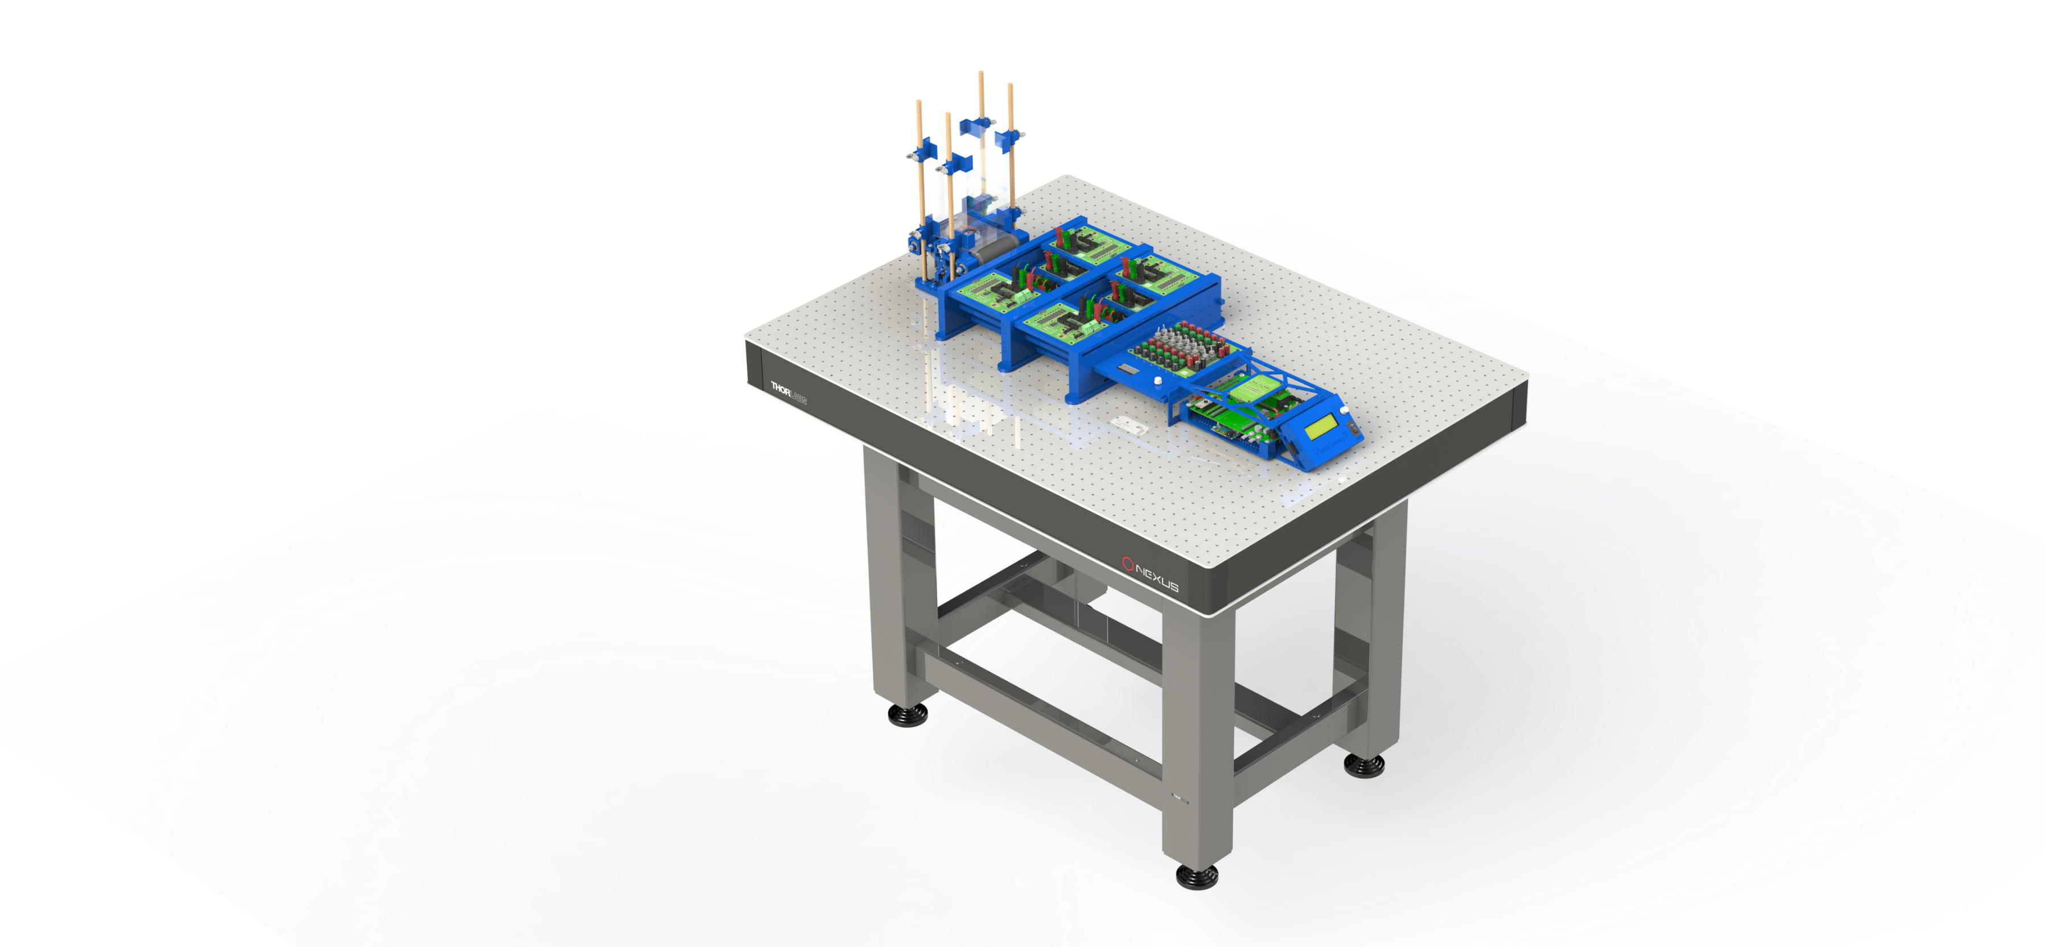

This Thesis is dedicated to <*a* *certain person>* for <*a* *certain reason>*

# Chapter 1. INTRODUCTION

## Overview of the Field

In the realm of mobile terrestrial robotics, there is a strong need for robust maneuvering on uneven terrain. However, despite concentrated efforts, engineers have not been able to develop a robot that can traverse environments with complex terrain with agility comparable to that of an animal. Biology can provide inspiration to design the next generation of mobile robots, as animals have evolved diverse strategies to negotiate complex terrain. For instance, the cockroach has been a source of inspiration for highly maneuverable hexapedal robots. Cockroaches can run over rough terrain with minimal neural feedback [1], perform rapid inversion maneuvers [2], quickly maneuver over or around obstacles [3], and seamlessly transition from running to climbing with negligible loss in speed [4]. Cockroaches are an ideal study animal because they have well characterized locomotor dynamics and there are detailed existing mathematical control models that capture their walking and running dynamics [5]. However, these models are based on steady-state dynamics where the velocity is constant, and the ground is level. Cockroaches’ ability to adapt seamlessly to different terrain is not captured by current models and challenges the most maneuverable robot to date. To better understand the adaptive control strategies used by cockroaches to maneuver in complex environments, we must decipher how each leg exerts forces on the ground during gait transitions. In the next section I will discuss design considerations from existing technologies for measurement of ground reaction forces and will set the stage for the design of a novel versatile instrument capable of continuously collecting triaxial ground reaction force data representing center-of-mass dynamics for a cockroach under variable and controllable environmental conditions, such as running speed and orientation relative to a global Cartesian plane.

The high-order running dynamics of cockroaches can be simplified with low-dimensional models termed “templates”. Templates of cockroach locomotion have already been shown to be a valuable reference for agile mobile robots. Cockroaches’ hexapedal alternating tripod running gait is highly robust to rough and unpredictable terrain [6]. As a result, large scale running robots have been designed with a strong semblance to running cockroaches, such as: Rhex [7], an autonomous hexapedal robot capable of navigating hostile environments; DASH [8], or *Dynamic Autonomous Sprawled Hexapod*, which is a 16 g rapid insect-scale microrobot; and SPRAWL [9], a running robot that uses timed actuation of six pneumatic pistons as legs to establish a sprawled hexapedal posture, where “sprawl” refers to the inclination angle of each leg. Additionally, a team of engineers designed a climbing robot named RISE (Robots in Scansorial Environments) that utilized claw-like hooks, similar to the claws at the end of cockroach limbs, mounted in arrays on contact patches to traverse vertical surfaces using hexapedal gait [10]. Existing models of cockroach locomotion have already served as a valuable source of inspiration for robotics. However, cockroach bio-inspiration could be further developed by gathering a more thorough understanding of how cockroaches’ limbs directly interact with the ground during unsteady locomotion.

Currently, there are two predominant low-dimensional models, or *templates*, applied to understanding cockroach ground locomotion and a third depicting cockroach climbing. A highly prevalent model used to describe cockroaches’ running gait is the *Spring Loaded Inverted Pendulum* model, orSLIP[11]. In this model, when walking, the body weight is vaulted rigidly over a fixed point on the ground, and then transferred to another leg, where the process repeats. When running, the leg compresses like a spring while the weight vaults over the fixed point, then releases the stored energy as a forward thrust applied to the center of mass. The second most prevalent template is the *Lateral Leg Spring* model, or LLS[12]*.* Whereas the SLIP model showed how leg forces act in the sagittal plane, the LLS model shows how they act in the horizontal plane. This perspective adds a third degree of freedom to the system, allowing for the determination of the body’s yaw angle. This is useful for understanding how turns are executed. Most of the existing models study the steady state behavior of running, but none have been able to yet address the transition stage that occurs while switching from one steady state gait to another. Finally, climbing gait is represented by a template that is a variant of SLIP. As shown by Goldman et al. [13], all legs contribute positive fore-aft forces on the cockroach forward up the wall. However, the front legs pull the head towards the wall, whereas the rear legs push the abdomen away. The relative magnitudes and force patterns of each leg during steady state climbing were measured. However, the force distribution during the transition from running to climbing has not yet been studied sufficiently to inspire reliable adaptive controllers for this class of running robots. Taken together, how insects modulate ground reaction forces during unsteady locomotion remains poorly understood. Filling this gap requires new force platform technologies at the insect scale.

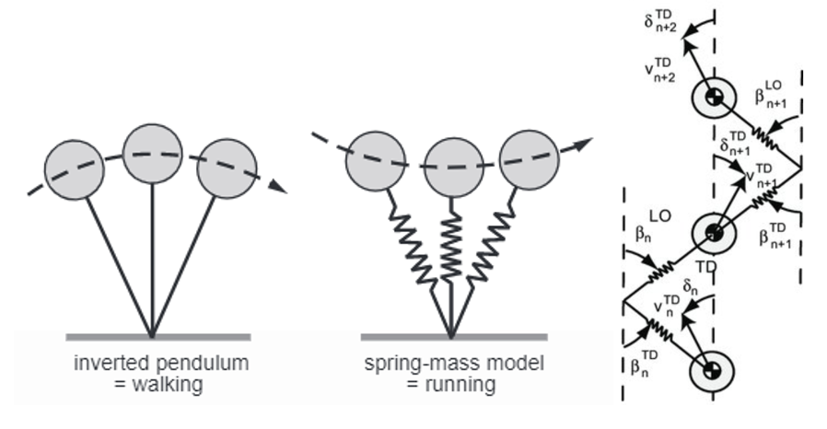

**Figure 1**. A depiction of SLIP [5] (center) and LLS [12] (right)

## Existing Technology: Overview of Current Methods

The current state of research in cockroach locomotion relies primarily on the use of force plates to measure ground reaction forces. The typical experiment setup using such a force plate consists of placing a cockroach specimen at a start point before the force plate, stimulating it to move in the desired style across the force plate to an end point while collecting measurements, retrieving the cockroach, and conducting as many trials as needed until adequate data has been obtained, as shown in Brown and Peterson’s force plate arena as an example [14]. As is inherent in this experiment design, these force plates generally can only be used to capture forces from the steady-state status of insect gait and cannot capture forces that occur during transitions. This is because the specimen will have already reached its steady state gait by the time contact occurs with the force plate. Testing conditions, such as angle of pitch or roll of the running surface, are generally difficult to vary and some attributes, such as subject speed, are nearly impossible to control. Additionally, since the probability of landing a successful foot-strike under the exact desired conditions is very low, data collection can be an extremely time-consuming process.

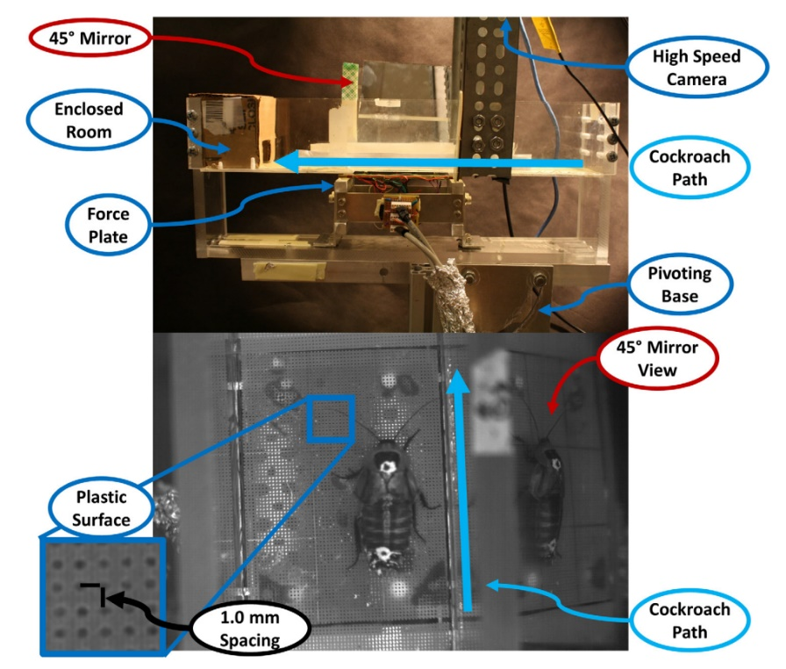

**Figure 2**. A visual for a typical force plate experiment setup [14]

In order to address the gap in transitional gait and decipher the subtleties of the control strategies used in cockroach gait, a new method for gait force data acquisition is needed. Ideally, this would be a versatile instrument capable of capturing the full range of ground reaction forces in insect gait under controlled settings. While adaptive human gait can be measured using an instrumented treadmill to collect ground reaction force data under controllable conditions, no such instrument yet exists at the insect scale. By combining existing insect scale force plate design concepts with scaled down instrumented treadmill design concepts, the process for collecting and advancing our knowledge could be greatly expediated. Additionally, by making the design open source and available to other scientists and engineers working in similar disciplines, this instrument could greatly benefit the field as a whole. With recent advancements in 3D printing, rapid prototyping, and semiconductor strain gauge technology, the capability for rapid and low-cost design fabrication allows for increased design potential previously considered impossible. In the next two sections, I will review existing force plate and instrumented treadmill technology to inspire the design of a cockroach scale instrumented treadmill. Analyzing the measurement and design methods implemented in these instruments will help establish a foundation for design of an insect scale hybridization of insect scale force plates and human scale instrumented treadmills.

## Existing Technology: Evolution of Force Plates

As previously discussed, one of the primary mechanisms for obtaining ground reaction forces in animal gait dynamics is through a force plate. One of the first designs applied in a biological setting was Heglund’s bi-planal force plate [15], which used strain gauges mounted to cantilevered beams to acquire forces in the vertical and lateral planes. This design was established to be scalable to any biological application. In his design, Heglund outlined eight key aspects that created a framework for an ideal force plate: (1) able to resolve the vertical, forward, and lateral components of the force; (2) have low crosstalk between the measured components of the force; (3) have sufficient sensitivity and resolution for the subject of interest; (4) have a linear response; (5) have a response independent of where on the plate the force is exerted; (6) have a high natural frequency of oscillation; (7) have sufficient safety margin to protect both the plate and the subject from damage due to failure; (8) be simple and inexpensive.

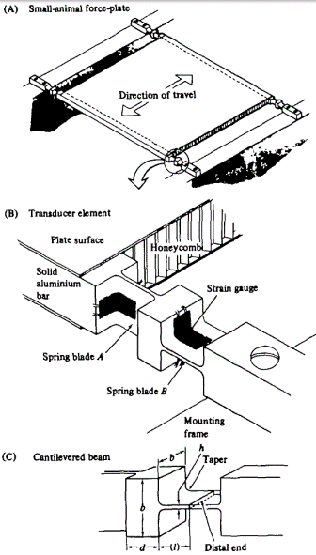

**Figure 3**. A depiction of Heglund's force plate design [15]

The design Heglund developed to meet these needs was a rigid aluminum plate with a honeycomb interior, which was suspended at each corner by cantilevered spring blades that deformed vertically and forward-aft horizontally. Heglund provided a scaling procedure to adjust his design to be more or less sensitive, depending on the scale of the size or sensitivity required of the intended application. Although this design was limited to measurements in only 2 axes, the architecture provided an excellent framework for innovation of similar technologies.

Using Heglund’s scalable force plate as a framework, Blickhan et al. [16] designed a force plate to capture ground reaction forces and dynamics of the center of mass involved in the running gait of cockroaches. To determine whether terrestrial arthropods exhibited the SLIP model of locomotion, they situated Blickhan’s force plate within a narrow running track to measure ground reaction forces exerted by cockroach legs when running. The force plate itself consisted of a simply supported balsa wood plate fixed on top of a brass frame with four cantilevered beams loaded in bending at each corner. These beams were affixed with semiconductor strain gauges that measured vertical and forward-aft horizontal forces. The force data was filtered and synced with video footage, which allowed determination of center of mass kinematics. This design, however, was not able to isolate individual leg ground reaction forces and was limited to measurements in two axes. Additionally, due to the low probability of successful footfalls and resultantly high number of necessary trials needed to collect valuable data, these experiments could be highly time consuming.

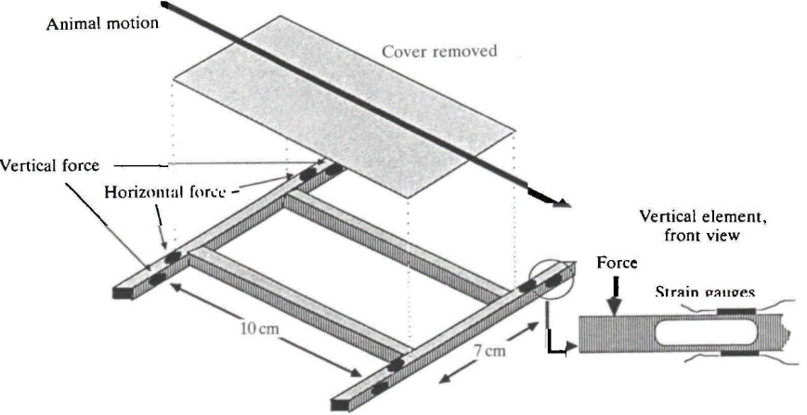

**Figure 4**. A depiction of Full and Tu’s cockroach scale force plate design [16]

The force plate design consisting of strain gauges mounted to cantilevered beams became a default in the practice of biomechanical force measurements. By designing compact sensor configurations that allowed for tight packaging of adjacent force plates, force plates could be implemented in arrays, as in the case of the more recent design constructed by Lin and Trimmer [17]. In their study of the ground reaction forces exerted by a caterpillar and a caterpillar-like soft robot, Lin and Trimmer developed a force plate network consisting of two adjacent arrays of thin acrylic beams loaded in bending. However, based on geometry, mounting strain gauges on the horizontally-loaded sides of the beam was not possible. So, rather than mounting strain gauges on all four sides of the beam, as is typically done in bi-planal force measurements, Lin and Trimmer developed a custom strain gauge configuration that was able to acquire vertical and horizontal forces via strain gauges mounted to the top and bottom of the beam. This configuration was essentially a full Wheatstone bridge embedded within a half Wheatstone bridge, which allowed for bi-axial measurements from a single mounting plane without a need for additional strain gauges or second beams. This strain-gauge design is valuable for sensor designs where surface space for mounting is limited or not uniformly compliant for strain gauge adhesion.

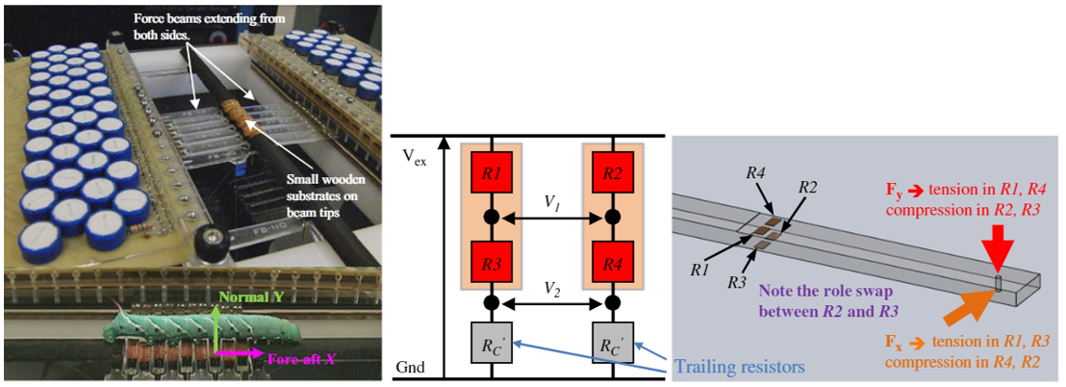

**Figure 5**. A depiction of Lin and Trimmer's force plate array (left) and strain gauge configuration (right) [17]

While the previous force plate array design provided insight into a unique method for resolution of forces, the design of Ji et al. [18] provides insight into a sensor design that can easily be implemented as a dense grid of force plates. This design consists of flat force plates, following the design of Zhang 2007, arranged in a quasi-cylindrical tower. Each force plate consists of a 30mm x 30mm Perspex platform mounted atop a T-shaped aluminum frame. These force plates are small enough to be able to isolate contact patches and 3D ground reaction forces of individual limbs. Data was selected by observing the paired video footage and extracting measurements obtained throughout the duration of the foot-strike. Because this sensor design is compact and can easily be arranged in a dense sensor array, it serves as a valuable source of insight for design of a sensor array capable of supporting the full array of treadmills.

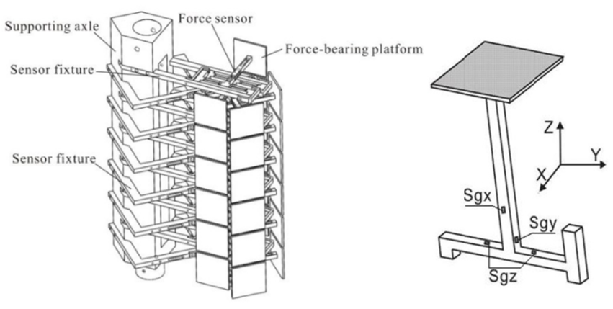

**Figure 6**. A depiction of Ji's force plate tower (left) and design for individual sensor (right) [18]

The final force plate design that will be discussed in this section is the ultra-miniature force plate designed by Reinhardt and Blickhan for resolving triaxial forces in the micronewton range from the legs of ants [19]. This design played a crucial role in the inspiration for this project because it provided a framework for an ultrasensitive force plate that could be constructed with strain gauges rather than MEMS devices, which are known to be very fragile and typically have a very narrow measurable force range (± 200 μN) [19]. Additionally, this design is one of the first notable successful applications of 3D printing in insect-scale ground reaction force sensing. Plastic is commonly thought to be a poor choice for strain-gauge-based

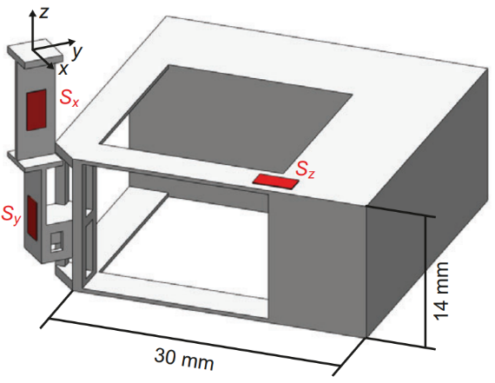

**Figure 7**. Depiction of Reinhardt and Blickhan's ultra-sensitive 3D printed force plate [19]

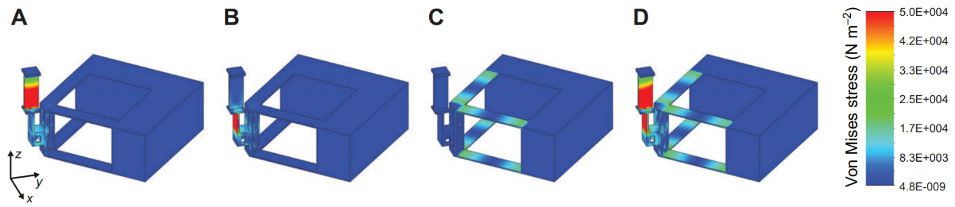

**Figure 8**. Reinhardt and Blickhan's force plate [19] under different load conditions. Force applied in x (A), y (B), and z (C) directions independently and simultaneously (D)

force detection due to its typically nonlinear elastic region and thermal insulation, which together make accurate measurement of forces a major challenge. However, plastic has the appeal of having a lower modulus of elasticity than most metals, which improves sensitivity to acting forces due to amplified strain resulting from an applied force. This design was able to exploit all the advantages of plastic while minimizing the disadvantages primarily through adequate material selection. For this design, polycarbonate was the material of choice. Polycarbonate is a brittle, glass-like polymer that is very linearly-elastic in the elastic region. Additionally, polycarbonate is a commercially available resin commonly used in stereolithography (SLA) 3D printing that can be printed to layer resolutions of 25 μm, allowing for production of intricate, custom beam geometries with nearly perfect homogeneity and negligible grain boundaries between printed layers (in the context of mounting strain gauges to smooth surfaces). Layer grain residual from 3D printing can introduce shear planes that increase the risk of snapping, but this type of failure can be avoided through the proper selection of print orientation. Finally, this design provides a unique beam design for discretizing applied 3D force vectors into nodes of amplified strain with minimal crosstalk. Each of the discussed force plate designs are summarized in **Table 1**.

**Table 1**. Comparative table listing properties for state-of-the-art force plate designs

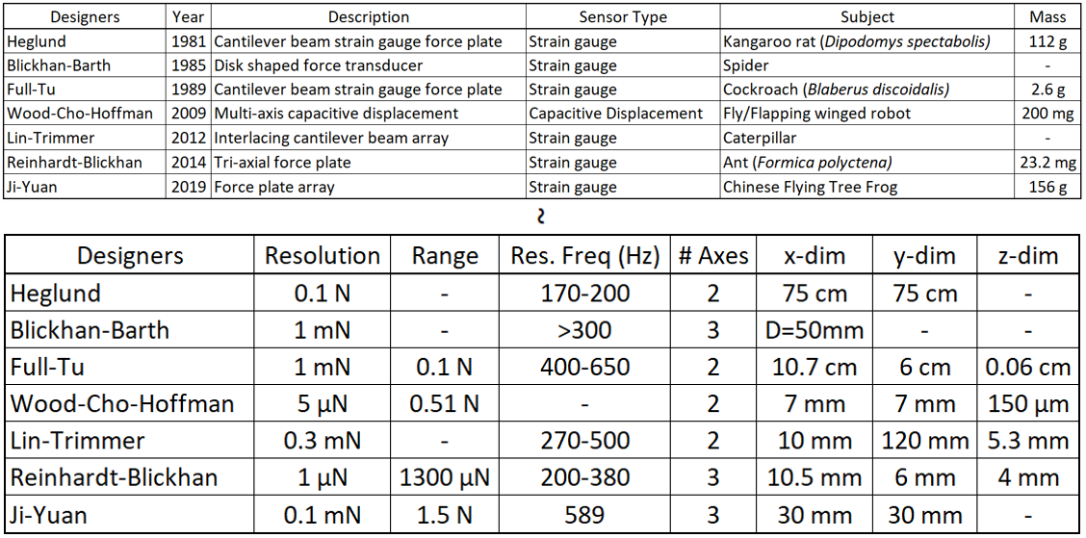

## Existing Technology: Evolution of Instrumented Treadmills

A more time-efficient application of the Force Plate is the Instrumented Treadmill. Instrumented treadmills are self-contained devices capable of measuring ground reaction forces exerted by a subject as it traverses a moving belt. There are two fundamental designs: DMFTs (Direct Measurement Force Treadmill) and IMFTs (Indirect Measurement Force Treadmill). A DMFT utilizes a force-plate mounted directly underneath the belt and an IMFT consists of an entire treadmill assembly mounted atop a force platform or platforms. Both of these will be discussed in greater depth in the following section.

One of the initial designs for an instrumented treadmill was a human-scale DMFT designed by Kram [20]. The motivation for the design was a need for a device capable of measuring 1) vertical ground reaction forces from the course of the contact phase; 2) joint, muscle, and bone forces; 3) center of mass dynamics in the vertical plane; and 4) the contact time of each foot strike. Since these data needed to be obtained and compared over a large range of speeds, and the process of gathering these data can be time consuming, designing an instrumented treadmill was predicted to help streamline the process of data collection. This treadmill consisted of a commercially available force platform mounted directly underneath the belt. The strain-gauge implemented force platform was selected in part due to the fact that it was longer than the

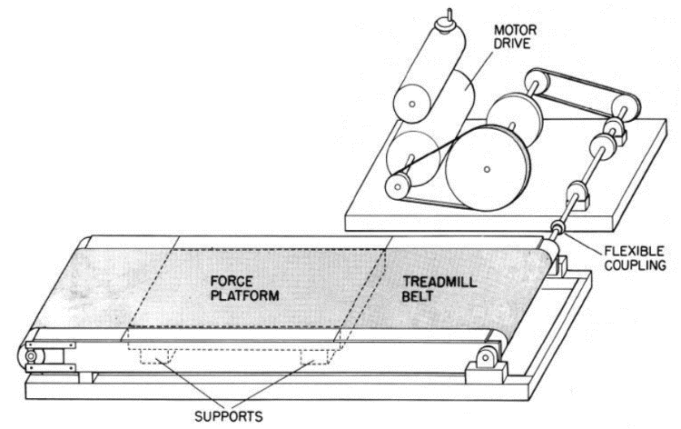

**Figure 9**. Depiction of Kram's DMFT design [20]

maximum distance travelled by the foot during contact, ensuring that the full contact patch was recorded. Through the design of the treadmill, Kram identified three key potential issues that must be considered: mechanical crosstalk from friction forces between the belt and platform that can interfere with the vertical force sensing elements; erroneous force readings due to tension in the belt from the motor either exerting upward vertical forces on the subject or downward vertical forces on the platform; and motor and belt induced noise. By mounting the force platform directly underneath the belt, which minimized the weight supported by the force platform, the unloaded natural frequency of the platform was preserved at a substantially high value (~160 Hz) to reduce the risk of prevalence of vibration-induced noise in measurements. However, this configuration restricted force observation to be solely in the vertical plane, preventing acquisition of the total ground reaction force vector. Additionally, Kram found that using the existing design, it would be impossible to obtain anteroposterior shear ground force data due to the force exerted by the motor changing throughout the duration of contact period.

Kram later designed a force treadmill with a modified force plate configuration capable of measuring 3-dimensional forces and moments in human gait [21]. In this design, the full mass of the treadmill assembly was mounted directly on top of a ground-mounted force plate, which made this design an IMFT. By utilizing a flywheel, belt speed was maintained at a more uniform value. Vibrational noise was reduced both by coating the treadmill bed with a thin Teflon sheet to reduce friction and by driving up the natural frequency

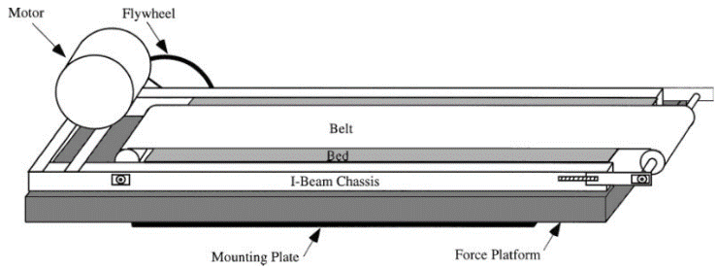

**Figure 10**. Depiction of Kram's IMFT design [21]

by reducing the mass of the treadmill assembly and increasing flexural stiffness. After making these adjustments, the observed forces and moments could be measured accurately enough so that the point of static-force application could be triangulated to within 0.5 cm in the y-axis (direction of travel) and 0.6 cm in the x-axis. However, since a single force platform was used, horizontal forces of individual feet and points of force application could not be separated from data obtained during the double support period.

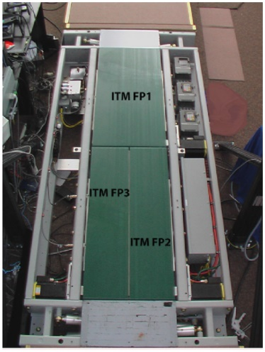

**Figure 11**. Depiction of Paolini's multi-treadmill design [22]

An example of a multi-treadmill design is Paolini’s tri-instrumented treadmill [22]. This design could isolate individual feet and their associated ground reaction forces by modifying the existing IMFT design to be modular and then building a small array of instrumented treadmills, each with an independently loaded force-plate. Specifically, one large treadmill occupied the forward half of the ground plane, and two adjacent treadmills divided the back end of the walking plane into a left side and a right side. The large force plate was used for obtaining large forces during running, and the back two forces plates isolated ground reaction forces in each foot during walking. To maintain cohesion in measurements collected between all three force plates, an extensive investigation was performed in 1) characterizing belt speed variation; 2) linearity; 3) repeatability of measurements and crosstalk; 4) instrumental noise; 5) natural frequency; 6) moving parts motion effect; 7) sensor drift; and 8) noise characteristics during locomotion tasks.

The belt motors were configured as a master and 2 slaves, with speed variations between belts ranging from 3.14% to 11.65%. The authors did not identify a method for reducing this discrepancy. Linearity was tested by placing dead weights at known coordinates and comparing the calculated coordinates from the generated linearity equation with the known coordinates. Using similar methods, Paolini et al. tested repeatability of measurements by placing dead weights at 3 set locations 5 times on each instrumented treadmill and calculating the maximum percent difference for each instrumented treadmill from its associated average value. After identifying the spectral power densities of the motors, force plates, and other associated components, testing showed that motors were not a source of noise as predicted and instrumental noise was a negligible source of error. Natural frequencies of each instrumented treadmill were determined by dropping a wooden ball on the surface of the treadmill and observing frequencies that emerged in the power spectral densities. Experiments testing noise generated by moving parts showed that greater vibrational noise was generated by the belt at lower speeds. It was predicted that at lower speeds, the frictional forces between the belt and the platform were closer to the force exerted by the motor, allowing friction to contribute a greater disturbance. Finally, sensor drift was detected to be of greater scale on the independent foot treadmills, due to imbalanced loading leading to uneven sensor heating. This drift was compensated via an implemented software routine that removed the detected force during the unloaded swing phase from the following contact phase.

Bundle’s [23] 2015 instrumented treadmill design sought to optimize common design concepts involved in IMFTs such that maximum performance is achieved. This design optimized various characteristics of instrumented treadmills primarily by reducing the unladen weight, increasing flexural stiffness, increasing natural frequency, and reducing friction. Each of these modifications work together to reduce vibrational noise and mechanical crosstalk, allowing the treadmill to operate at high speeds, upwards of the limits of human gait. A key aspect involved in increasing the natural frequency of the treadmill is “light-weighting” the design wherever possible. Since, in order to obtain forces and moments in all axes, the full weight of the treadmill assembly must be supported by the force plate, stripping away this weight allows the treadmill to be operated at higher speeds. One method of weight reduction was the design of a high-strength, low-weight sandwich style treadmill bed with a honeycomb interior. Additionally, the motor was mounted on a separate surface from the treadmill and was connected via a flexible line shaft, which removed the weight of the motor from the supported chassis, while still allowing drive torque distribution to the belt. Although internal forces such as friction cancel out upon force detection, friction does cause mechanical crosstalk, which can cause vertical forces to be measured as horizontal forces. This crosstalk can translate into vibrational noise as well as torque disturbances to the motor. This friction-induced crosstalk was reduced in this design by applying a low viscosity silicon-based lubricant to the mating surface of the treadmill bed. Additionally, belt speed disturbances were accommodated by a motor controller. In past designs, belt speed was maintained by implementing flywheels. In this design, the weight of an added flywheel was removed and replaced with software implemented control.

The development of a versatile and controllable insect scale instrumented treadmill will help close the gap in our understanding of the adaptive control of terrestrial gait in insect locomotion. Since this technology does not yet exist, future design will require a creative hybridization of both existing biological force plate and instrumented treadmill technology. Each of these instrumented treadmill designs are summarized in **Table 2**.

**Table 2**. Comparative table listing properties for state-of-the-art instrumented treadmill designs

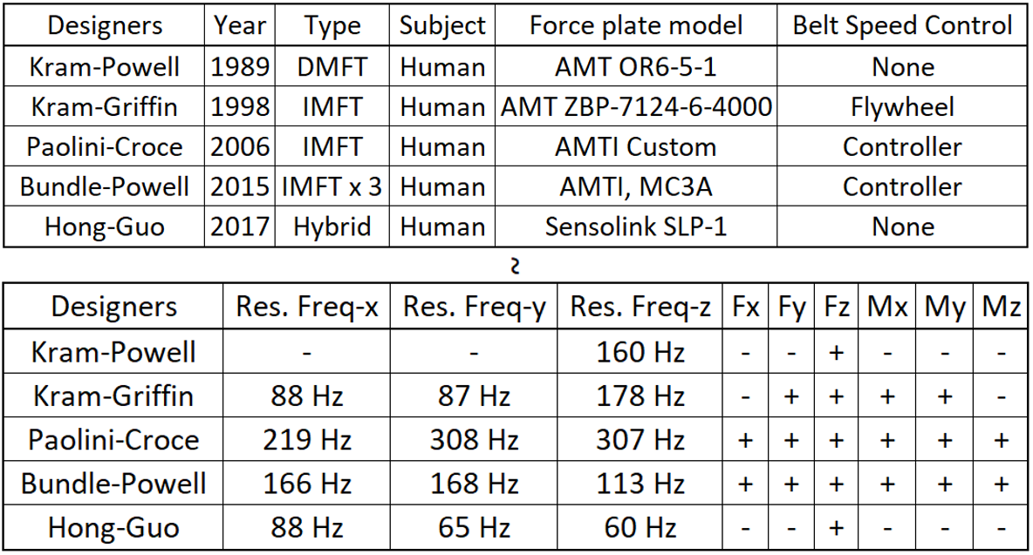

# Chapter 2. OVERVIEW OF THE PROBLEM

This chapter focuses on the preparation, drafting, and management of the design process for the insect-scale instrumented treadmill design framework. The purpose of this design project is multi-faceted and can be represented by the following list of purposes:

1. Establish “proof-of-concept” for overcoming the signal-to-noise-ratio barrier that is currently viewed to be rendering an instrumented treadmill capable of reconstructing 3D force data from insect locomotion an unsolved challenge.
2. Provide a thorough system-wide analysis of all design choices to give context to obstacles encountered and the best-fit solutions identified in the pursuit of purpose 1.
3. Provide a step-by-step assembly guide that can be used as a reference for future researchers using this device, acting as a set of instructions for construction and usage.
4. Indicate points of improvement and designed flexibility that will help future researchers tweak the design to better meet their specific experimentation needs.

## 2.1 Introduction to the Problem

Current instrumentation for measuring ground reaction forces exerted by limbs of insects is currently limited to variations of the instrumented force plate. This static, passive tool has proved highly effective in studies investigating triaxial force profiles of insect gait under steady state conditions, but falls short of providing insight into live gait adaptation. The goal of this thesis is to design an instrumented treadmill at the insect scale to continuously measure the coupled kinetics and kinematics of insect locomotion. Understanding adaptive gait control in insects could inspire more robust and versatile robotic runners and climbers that are better equipped to navigate uncertain, demanding, and potentially dangerous environments.

### 2.1.1 Initial Problem Statement

The Bio-Motion Systems Laboratory is seeking a cockroach-scale force treadmill that is able to measure 3D forces resultant from cockroach gait with resolution of ~1 mN. A priority is to minimize any vibrational noise induced by the belt motor while maximizing sensitivity to small magnitude forces generated by cockroach limbs. The measurements collected during experimentation should be repeatable, with low drift. Calibration of the devices should be a straightforward and fast process. It is desired that it be modular and easily modified to adapt to specific experimental constraints and needs. This force-treadmill should be easy and intuitive to operate to keep overall experiment duration minimized, as well as preserve the accessibility of the device such that a typical researcher would be able to use it with minimal training. Similarly, attempts shall be made to keep the production cost low such that the device will be accessible and valuable to any other research laboratories interested in building their own. Since this device shall be built by the end user and shall be modular to fit customized needs, fabrication of this device should be possible by hand with consumer grade equipment and not dependent on expensive commercial industrial equipment.

## 2.2 Assessment of Needs

### 2.2.1 Gathering Design Input

A list of project needs was generated by Jackson Sizer and Dr. Jean-Michel Mongeau, as shown below in **Table 3**:

**Table 3**. A list of project needs for development of the insect-scale instrumented treadmill

|  |  |
| --- | --- |
| Need | Description |
| Fx | Able to measure lateral forces (perpendicular to the motion of the belt) |
| Fy | Able to measure longitudinal forces (parallel to the motion of the belt) |
| Fz | Able to measure vertical forces (normal to the surface of the belt) |
| Modular | Constructed of discrete, interchangeable parts |
| Minimal Vibration | Vibrational modes and frequencies from motor and belt friction are addressed to not interfere with measurements |
| Minimal Crosstalk | Measures are taken to prevent transformation of forces from one axis into another |
| Sensitive | Forces are detectable to resolution < 1 mN |
| Durable | Parts resist wear and can be used repeatably without destruction |
| Maintainable | Individual parts can be easily replaced or repaired without destruction or replacement of an entire system |
| Low Cost | Cost is minimized to produce the cheapest functional design possible |
| Compact | Usage of space is optimized and well organized |
| High Natural Frequency | Treadmill natural frequency is sufficiently higher than cockroach running frequency such that it can be digitally filtered out post collection via LPF |
| Lightweight | The treadmill is the lightest achievable weight |
| Controllable | Speed and orientation can easily be modified on the fly |
| User Friendly | A clear, simple interface is provided to streamline usage to be as easy as possible |
| Accessible | Can be built by anyone as long as they have access to the designs and schematics |

### 2.2.2 Weighting of Design Needs

Once established, the provided needs were then assigned weights for degree of importance to the overall design. These weighted needs were used to guide future design choices such that features and components addressed each need on a basis of priority. This helps to keep the context of the main design goals for the project relevant such that the best choices are made in the effort of producing a project that delivers the desired outcomes. These weights were established using an Analytic Hierarchy Process (AHP) scoring matrix shown in **Table 4**.

**Table 4**. AHP pairwise comparison matrix for weighing project needs in the scope of the main objectives

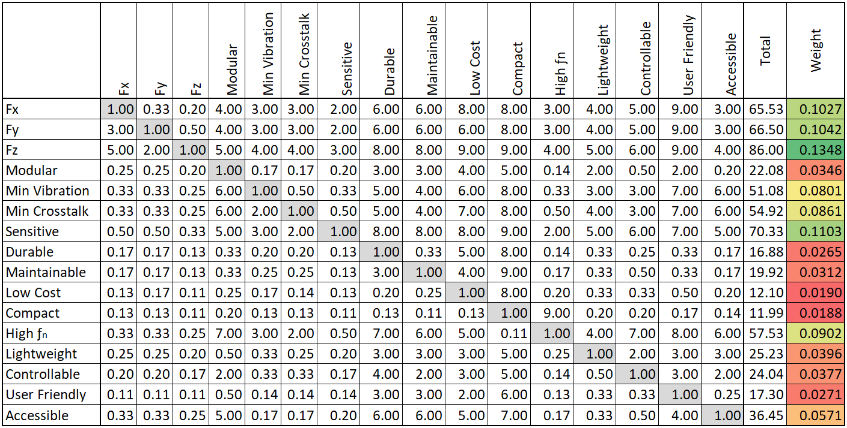

The identified needs listed in order of priority were determined to be:

1. Fz
2. Sensitive
3. Fy
4. Fx
5. High ƒn
6. Minimal Crosstalk
7. Minimal Vibration
8. Accessible
9. Lightweight
10. Controllable
11. Modular
12. Maintainable
13. User Friendly
14. Durable
15. Low Cost
16. Compact

## 2.3 Concept Generation and Selection

In order to adequately address all listed needs, the design for this device will combine concepts from insect-scale force platform technology and human-scale instrumented treadmill technology. Here, a breakdown of the problem into broad functions and pertinent concepts as they relate to the project needs is developed:

1. Force Transducer
   1. Reinhardt and Blickhan’s 3D printed triaxial force plate [19] (see **Figure 7**)
      1. Discretizes triaxial forces into xyz components with minimal crosstalk
      2. 3D printable
      3. Highly sensitive
      4. More durable than MEMS alternative
   2. Heglund’s spring-blade design [15] (see **Figure 3**)
      1. Discretizes forces into xz components
      2. Force plate design that can support a treadmill
      3. Can achieve high ƒn
2. Treadmill
   1. Kram and Griffin’s IMFT design [21] (see **Figure 10**)
      1. Reveals IMFT: the only force treadmill configuration capable of measuring Fx, Fy, Fz, Mx, My, and Mz
      2. Condenses treadmill design down into a compact, modular assembly that can be mounted atop a force plate
   2. Anatomy of a skateboard [24] 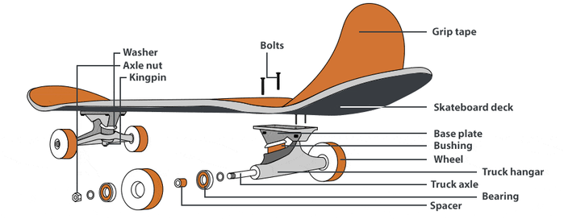

**Figure 12**. Anatomy of a skateboard [24]

* + 1. Anatomy of skateboard wheels and trucks is a very helpful reference for designing smooth, low vibration belt rollers
    2. Central axle sets alignment between axis of rotation for wheels and bearings
    3. Bearing spacers prevent axis misalignment when bearings experience radial load and reduce friction during rotation
    4. Soft, rubbery wheels grip the ground, reducing slip, and help to maintain continuous rotation. Helpful for driving belt without slip.

1. Arena
   1. Brown and Peterson’s enclosed gyroscopic force platform [14] (see **Figure 2**)
      1. Acrylic walls create an enclosed track for a cockroach to run across
      2. Force plate is embedded within arena
      3. Arena can be rotated in pitch and yaw to manipulate running trajectory
      4. Usage of mirrors allows for simultaneous observation of dorsal and lateral views
2. Signal Conditioning
   1. Typical architecture of a computer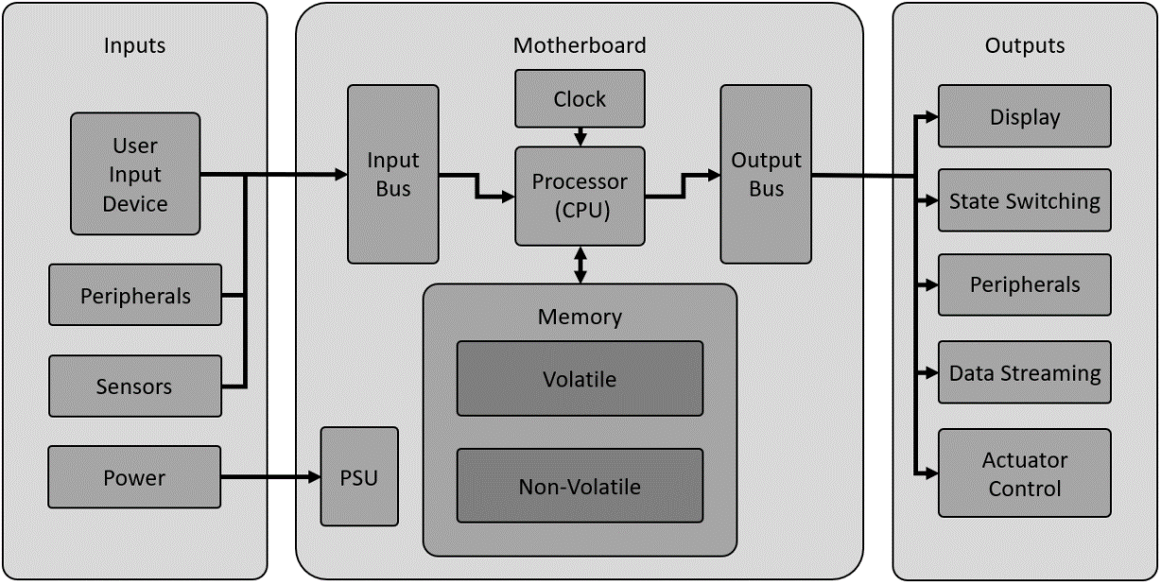

**Figure 13**. Block diagram for a standard computer architecture

* + 1. Large network of required signal conditioning circuits and actuators that all need to be independently addressed and controlled can be designed easier if the system is treated as a computer.
    2. Calibration and configuration of the system will require some live user I/O, which means a user interface will be needed
    3. Analogous systems can be compared as such:
       1. Processor (CPU) 🡪 Microprocessor (Arduino)
       2. Clock 🡪 400 GHz Arduino Giga Clock, SCLK, ADC MCLK
       3. Volatile 🡪 Arduino SDRAM
       4. Non-Volatile 🡪 Arduino Giga Flash Storage + SD Storage
       5. Input Bus 🡪 Multiplexer + Cables
       6. Output Bus 🡪 Multiplexer + Cables
       7. User Input Device 🡪 Encoder with Button
       8. Peripherals 🡪 Wi-Fi based Receiver Client - PC
       9. Sensors 🡪 Encoders, Accelerometer, Signal Conditioner Board Measurements
       10. PSU 🡪 Linear DC Regulated Benchtop Power Supplies, Switches
       11. Display 🡪 LCD Screen, LED State Indicator
       12. State Switching 🡪 Function Output, Procedure Cycling
       13. Peripherals 🡪 Network Configuration, Gains, Component Registers
       14. Data Streaming 🡪 Serial Bus for Data Acquisition on PC
       15. Fans 🡪 Treadmill Belt Motor
       16. Motherboard 🡪 Custom Arduino Shield Motherboard

## 2.4 System Decomposition

This section provides an exhaustive preliminary system decomposition of the design for the insect-scale instrumented treadmill down to the component level constituents. This step yields a diverse collection of benefits, as listed below:

1. Deconstructs a large, complicated problem down into more easily addressed components
2. Seamlessly transitions from system planning into feature and system integration design
3. Helps identify efficient functional pathways to link codependent divergent systems
4. Can bring attention to potential design flaws before they occur
5. Useful for establishing design priority and a hierarchy of developmental dependencies

The system decomposition begins at the head, with the device represented as the grand coalescence of all systems, designs, and functions involved. This head has been given the name “RoachRunner”. The first subdivision of RoachRunner is into domains, which can be classified as “Structures and Mechanisms”, “Circuitry”, and “Software”. The following will illustrate the complete system decomposition map from the top down to the lowest abstraction. This map also indicates the framework for Chapter 3. A preview of the final design is provided below in **Figure 14** to assist visualization of each system throughout the system decomposition.

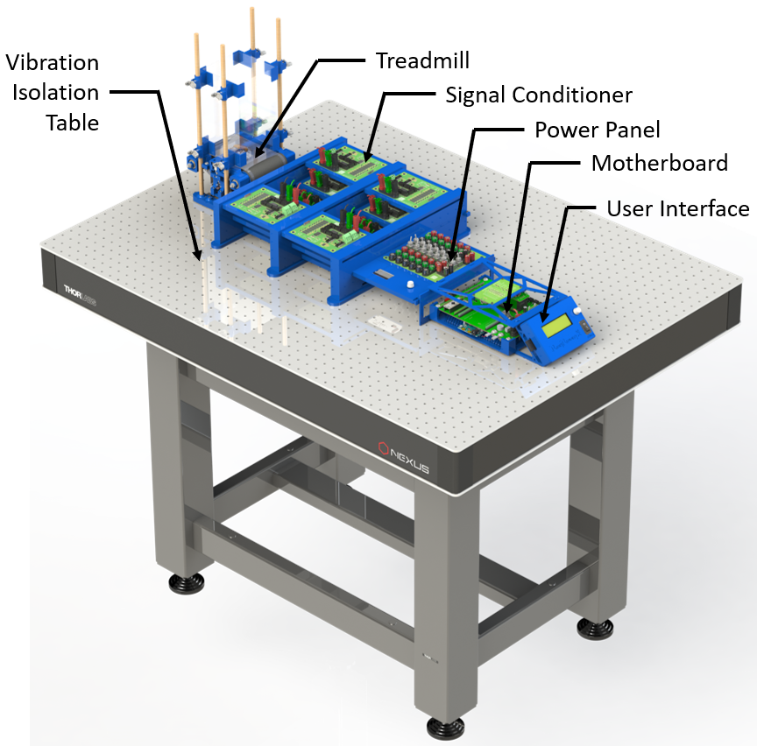

**Figure 14**. A CAD rendering of the full assembly of RoachRunner, excluding cabling and power supplies

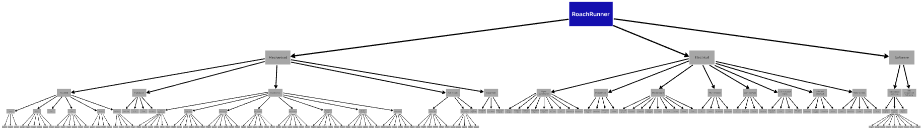

**Figure 15**. A macro-view of the system decomposition design tree that models the full assembly of RoachRunner

To see a more detailed version of the system decomposition, go to **Appendix A**. To access a zoomable and navigable version of the system decomposition diagram in Figure 19, follow the link for “System Decomposition Model” listed in **Appendix I**. A textual itemization of the system decomposition is listed below:

1. Structures and Mechanisms
   1. Treadmill
      1. Chassis
         1. Roller Struts
         2. Crossarms
         3. Nuts + Bolts
      2. Rollers
         1. Roller Shell
         2. Axle
         3. Bearing
         4. Bearing Spacer
         5. Speed Washer
         6. Bushing
      3. Belt
      4. Driver
         1. Driver Shell
         2. Motor
         3. Encoder
         4. Ring Bearing
         5. Bushing
         6. Nuts + Bolts
      5. Tensioner
         1. Motor Mount
         2. Encoder Mount
         3. Tensioner Screw
         4. Nuts + Bolts
      6. Enclosure
         1. Cage
         2. Clamps
         3. Dowels
         4. Base
   2. Transducer
      1. Sensor Arm
      2. HUB
      3. Frame
      4. Nuts + Bolts
   3. Electronics (Mechanical)
      1. Signal Conditioner
         1. Footprints + Packages
         2. Solder Stencil
         3. Accessibility
         4. Physical Connections
         5. Planes, Vias, and Holes
         6. Signal Traces + Gerber Generation
      2. Power Panel
         1. Footprints + Packages
         2. Solder Stencil
         3. Accessibility
         4. Physical Connections
         5. Planes, Vias, and Holes
         6. Signal Traces + Gerber Generation
      3. Motherboard
         1. Footprints + Packages
         2. Solder Stencil
         3. Accessibility
         4. Physical Connections
         5. Planes, Vias, and Holes
         6. Signal Traces + Gerber Generation
      4. IMU + Encoder Breakout
         1. Footprints + Packages
         2. Solder Stencil
         3. Accessibility
         4. Physical Connections
         5. Planes, Vias, and Holes
         6. Signal Traces + Gerber Generation
      5. User Interface
         1. Footprints + Packages
         2. Solder Stencil
         3. Accessibility
         4. Physical Connections
         5. Planes, Vias, and Holes
         6. Signal Traces + Gerber Generation
      6. LED Indication Panel
         1. Footprints + Packages
         2. Solder Stencil
         3. Accessibility
         4. Physical Connections
         5. Planes, Vias, and Holes
         6. Signal Traces + Gerber Generation
      7. SD Card Breakout
         1. Footprints + Packages
         2. Solder Stencil
         3. Accessibility
         4. Physical Connections
         5. Planes, Vias, and Holes
         6. Signal Traces + Gerber Generation
      8. Motor Control
         1. Footprints + Packages
         2. Solder Stencil
         3. Accessibility
         4. Physical Connections
         5. Planes, Vias, and Holes
         6. Signal Traces + Gerber Generation
   4. PCB Mounts
      1. Board Trays
         1. Signal Conditioner Tray
         2. Signal Conditioner Tray Rack
         3. Power Panel Tray
         4. Motherboard Tray
         5. LED Indicator Panel Tray
         6. Secondary LCD Tray
      2. User Interface
         1. Faceplate
         2. Encoder Knob
         3. Faceplate Strut
         4. Encoder Wedge
         5. Chassis Mount
      3. Miscellaneous Components
   5. Equipment
      1. PCB Reflow Oven
      2. Prusa i3 MK3S
      3. Power Supplies + Cabling
2. Electronics (Electrical)
   1. Signal Conditioner
      1. Supply Voltages
      2. Wheatstone Bridge
      3. Calibration Network
      4. Common Mode Buffer
      5. Instrumentation Amplifier
      6. ADC Driver (Fully Differential Amplifier)
      7. ADC
      8. Communication
      9. State Selection
   2. Power Panel
      1. Supply Voltage Input
      2. Remote Sense
      3. Board Output Array
      4. Switches
   3. Motherboard
      1. Arduino Due Shield
      2. CS Network
      3. SPI Network
      4. Signal Conditioner Board Network
      5. LCD Driver
      6. Motor Driver
      7. Encoders
      8. Buzzer
      9. Power
   4. IMU + Encoder Breakout
      1. SPI
      2. Inverter
      3. IMU Headers
      4. Cable Headers
   5. User Interface
      1. LCD
      2. Power Switch
      3. Encoder
      4. SD Card Slot
   6. LED Indicator Panel
      1. Binary Ripple Counter
      2. Clock
      3. LEDs
      4. LED Power Gates
   7. SD Card Breakout
      1. SD Card Slot
      2. Voltage Regulator
      3. Tri-State Buffer
      4. Inverter
   8. Motor Control
      1. Motor
      2. Motor Driver
      3. Battery
      4. Kill-Switch
      5. Cabling
3. Software
   1. Embedded Software (Drivers)
      1. Finite State Machine
      2. Function Macros
      3. Component Libraries
         1. ADC
         2. Multiplexer
         3. Signal Conditioner Board
         4. LCD
         5. Digipot
         6. IMU
         7. Encoder
         8. BLDC Motor
         9. SD Card
   2. Data Acquisition

## 2.5 Project Management

Since no current version of this device existed at the time of conception to provide estimates for planning, any foresight regarding budget or timeline was purely speculative. The scope of work required to make this project a success evolved with time as benchmark tests revealed performance metrics that indicated whether or not redesign was necessary throughout various stages of the project. As such, since a key purpose of this thesis is to serve as a guide for future researchers who are interested in planning, designing, and building their own version of RoachRunner, it would not be beneficial to those interested parties to list the naïve expectations and broad goals laid out at the onset of this project. Instead, I will provide a record of the actual budget and timeline that represent the experienced trajectory of this project. From a broad perspective, this project can be broken down into 5 categorical stages: 1) Research; 2) Design; 3) Deployment; 4) Testing; and 5) Reporting.



**Figure 16**. The 5 developmental stages of design for RoachRunner

### 2.5.1 Timeline

Here, a general outline of the timeline is depicted, shown below in **Table 5**. Multiple prototype stages are identified. A trend that can be seen is that when a design phase of a system ends, the deployment phase begins. After a deployment phase ends, a brief testing phase occurs. In prototype stages, the findings from these testing phases typically identifies an unforeseen issue that must be corrected, which leads back to an extensive research phase to find a viable solution that can then be implemented in a new design phase. This cycle typically loops until all issues are corrected and all benchmarks are satisfied. Performing an in-depth preliminary system decomposition helps significantly to reduce the number of design cycles.

**Table 5**. Generalized project timeline

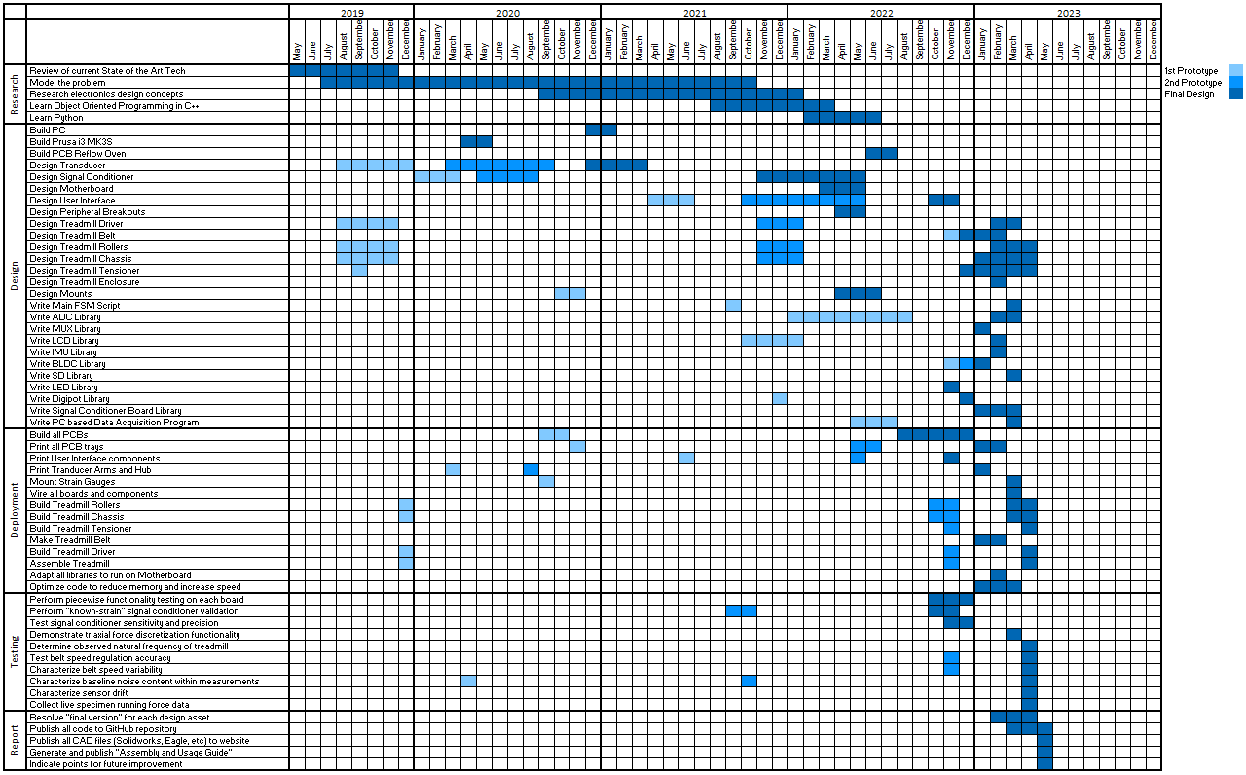

### 2.5.2 Budget

In this section, a broad summary of expenses, as well as financial justifications for certain design choices, is provided. The values reported in this section for goals and expenses are approximated and are intended to serve only as overview. Detailed itemization and cost for printed parts, mechanical parts, PCB components, and tools and equipment can be found in **Appendices B, C, D, and E**. The collection of these Appendices serves as the Bill of Materials (BOM) for the full assembly of RoachRunner. Keep in mind when viewing that these BOMs reflect the products and costs available at the time of design. This thesis does not guarantee that these components will remain available in production or at the listed pricing at the time of a future build. An overview of expense is provided below in **Table 6**:

**Table 6**. An approximated expenditure breakdown representing the primary expenses for RoachRunner

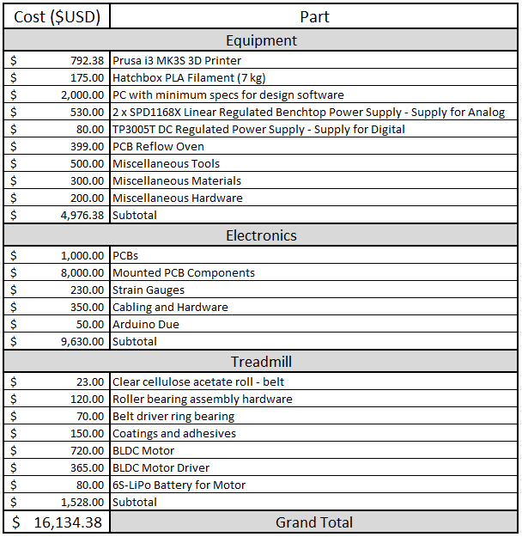

As indicated in **Table 6**, the greatest expenditure for RoachRunner was the custom electronics. Although perhaps not inherently obvious from **Table 5**, the design and fabrication of the custom electronics was also the most time-demanding aspect of this project. These two characteristics are indicators of the most important design challenge and impactful tradeoff that resulted from a roadblock that could have been the end of forward progress for this project. This roadblock was the “barrier-to-entry” magnitude of cost for the necessary strain gauge signal conditioning amplification instrumentation based on commercially available equipment from manufacturers that offered these specialized solutions. Comparing options and packages from the industry standard manufacturers for this type of device, such as Micro-Measurements (A Vishay Company) and National Instruments, the minimum cost per channel for instrumentation that met all our project needs was estimated to be approximately $10,000.00 USD. This value matched an estimate provided by a Vishay sales representative during a product inquisition. Since our system has a minimum of 12 strain signals that need to be simultaneously observed, that put the minimum cost of strain gauge signal conditioning amplification instrumentation at around $120,000.00 USD. If future designs were interested in measuring ground reaction forces for each limb independently, a 12 strain gauge equipped force platform would be required for each limb to be independently measured, which, at $120,000.00 USD per limb, would elevate the cost to $720,000.00 USD for instrumentation alone.

Not surprisingly, this exorbitant cost of strain gauge signal conditioning amplifier instrumentation was thorough persuasion to find alternative means to the problem at hand. At this point, a tradeoff was made in the sense that an investment of time to research, design, fabricate, and implement an open-source custom strain gauge signal conditioning amplifier electronic system would be made to circumvent this exceedingly high investment of capital necessary to provide a sufficient means of accurately sampling these very small magnitude forces in an active setting. This decision to pursue the design of a lower cost, open-source alternative to the current market options that existed in what was essentially a noncompetitive market was made primarily in the interest of future researchers interested in using RoachRunner to conduct similar research. Keeping the cost as low as possible maintains a low barrier-to-entry to our fellow researchers and helps to keep the flow of information accessible to a larger swath of academia.

# Chapter 3. COMPREHENSIVE SYSTEM DESIGN

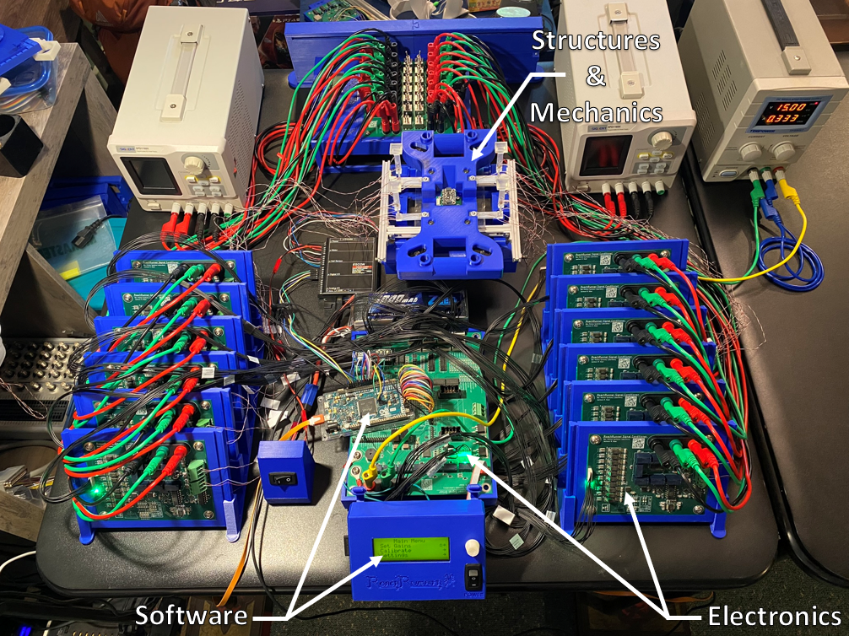

This chapter dives into the System Decomposition mapped out in Section 4 of Chapter 2 to provide an in-depth analysis of the theory behind the designs that make up RoachRunner. This chapter can be seen as the “How does it work?” section of the design analysis and Chapter 4 can be seen as the “How do you build it?” section. As mentioned before, RoachRunner is grouped into three primary domains: Structures and Mechanisms, Circuitry, and Software. The developmental focus of each of these is Mechanical Engineering, Electrical Engineering, and Software Engineering. Maintaining synergy and interconnectivity between these domains, rather than hierarchy, helps to prevent cascading problems by designing with function of each domain considered simultaneously, rather than as a reaction to design choices made independently in other systems.

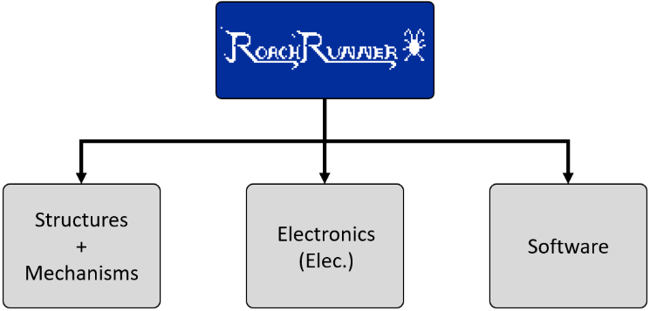

**Figure 17**. The three primary domains of design composing RoachRunner

## 3.1 Structures and Mechanisms

This section analyzes the mechanical engineering aspects of the design. The “Structures and Mechanisms” domain is broken up into five systems: 1) Treadmill; 2) Transducer; 3) Electronics (Physical); 4) PCB Mounts; and 5) Equipment. This is reflected in **Figure 18**. The first system that will be discussed is the Treadmill.

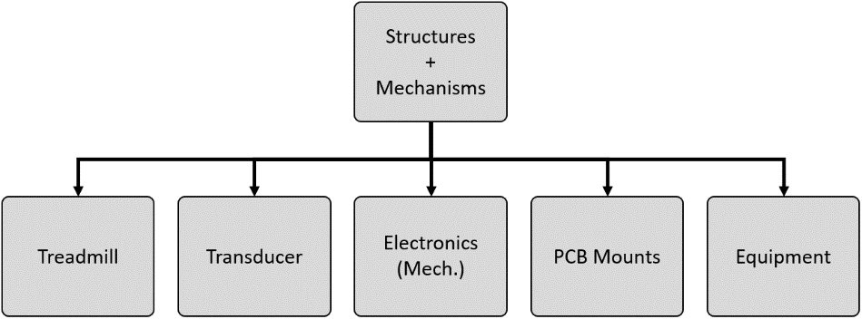

**Figure 18**. Subdivisions of "Structures and Mechanisms"

### 3.1.1 Treadmill

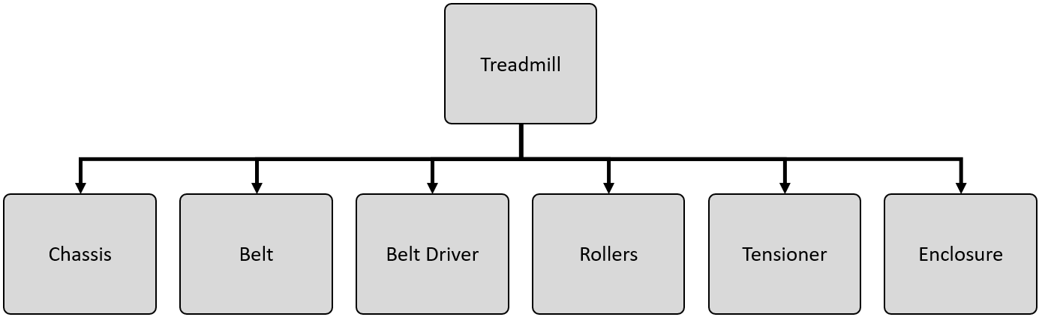

Here, a view of the treadmill, as it interfaces with the transducers and cockroach enclosure, can be seen. Note that the entire treadmill assembly is supported by the transducer to establish it as an IMFT configuration. The cockroach enclosure and the treadmill are mechanically isolated from each other, aside from both being mounted to the same T-slot framing base. The walls of the enclosure are fixed just above the chassis of the treadmill with small enough clearance to prevent a cockroach crawling under the gap, but still avoiding transmission of forces between the treadmill and the enclosure. The interactions between the treadmill, enclosure, and transducer will be shown and discussed in greater detail in later sections of this chapter.

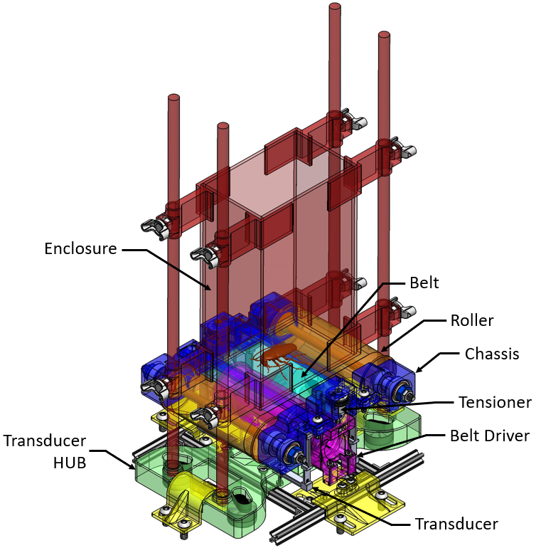

The treadmill assembly is composed of the following subsystems: 1) Chassis; 2) Belt; 3) Belt Driver; 4) Rollers; 5) Tensioner; and 6) Enclosure. The design analysis for the treadmill starts with a brief discussion of the chassis.

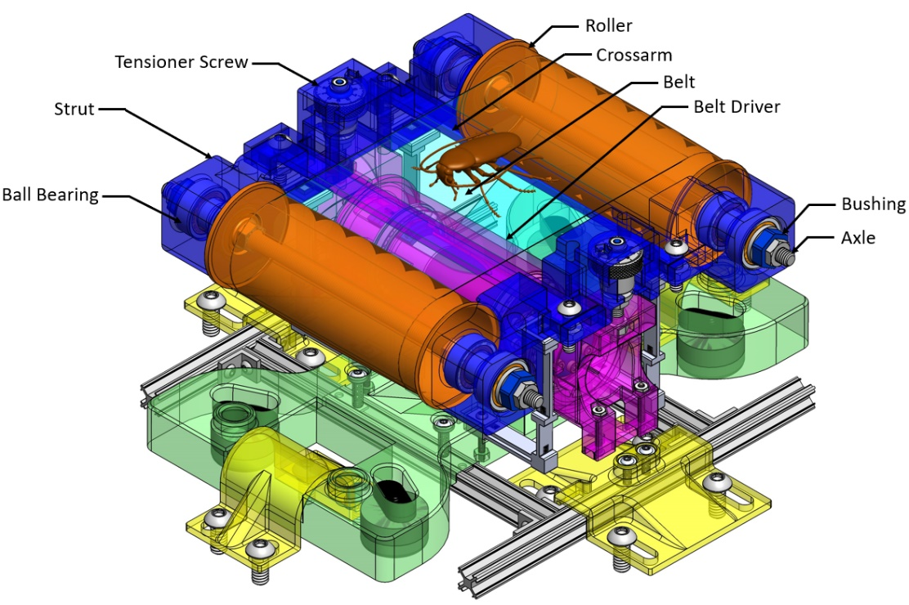

**Chassis**

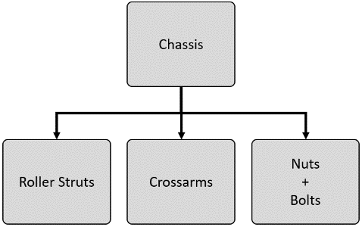

The chassis of the treadmill is comprised of three part types: roller struts, crossarms, and hardware (“nuts + bolts”). This subsystem acts as the rigid frame that defines certain critical dimensions and supports other dynamic subsystems of the treadmill. At the core of the chassis is the pair of roller struts that mount to the transducer and that all other treadmill components originate from. Also included in the chassis are the crossarms, which are linkages that define the width of the belt area. The “Driver Stabilizer” crossarm prevents the tensioner mounts from pinching in on the belt driver during rotation by rigidly fixing the distance of the gap to a value greater than the width of the belt driver. The roller struts are also the connection point between the treadmill and the transducer arms. The roller struts interface with the transducer arms via square-shaped feet that fit snuggly into square-shaped cavities at the junction point of the transducer arm.

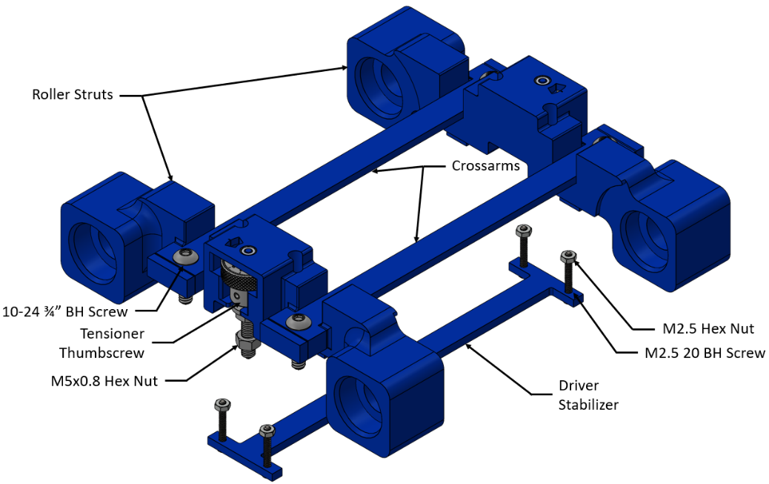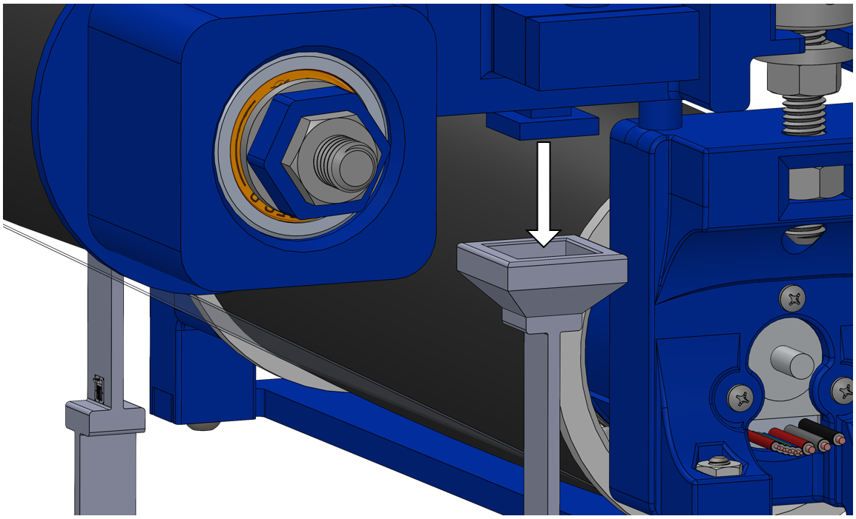

**Belt**

Next discussed is the treadmill belt. This component is commonly a primary source of noise and crosstalk in instrumented treadmill designs. In all existing instrumented treadmill designs, the belt is designed to be used in combination with a “bed”. The bed of a treadmill is a rigid plate mounted directly underneath the belt that supports the subject as they run, providing a simulated experience that is more similar to walking or running across the ground. While beds are critical for heavier specimens to prevent springy deformations in the belt, the frictional interaction between the belt and the bed is a major source of vibration and crosstalk via transformation of vertical forces into longitudinal forces. Prior instrumented treadmills addressed this problem through application of lubricants, but this only reduced the magnitude of this type of error rather than removed it. At the insect scale, this type of error, even at small magnitudes, could be enough to entirely mask all traces of valuable ground reaction force data that are of extremely small magnitude. Fortunately, the comparatively miniscule mass of a cockroach exposes a major design simplification of removing the belt-bed-error-compensation entirely by simply removing the bed from the treadmill anatomy. Here, instead of supporting the weight of the cockroach with a rigid load-bearing platform, the weight of a cockroach can be supported entirely by sufficient tension in the belt. By pulling a belt under such high tension that it doesn’t deform noticeably during application of forces in the range of 0-100 mN, the belt can be considered a sufficient simulated solid surface which the cockroach moves across.

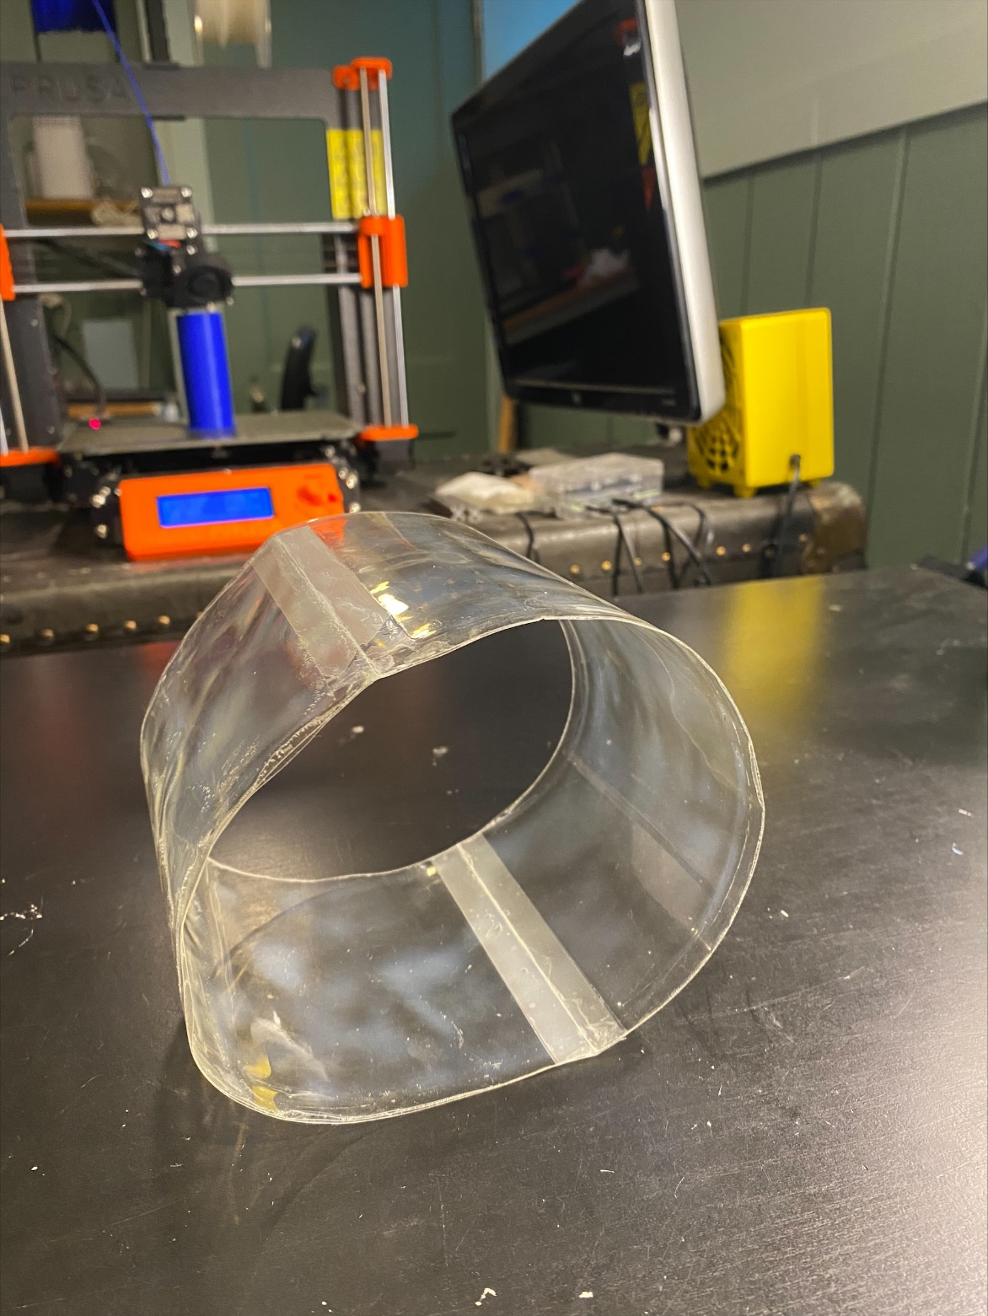

In order to achieve this tension-simulated-surface in the belt, the belt must be relatively inelastic in tension, but flexible enough to bend around the rollers without damage. Typical treadmill belts are made out of silicone-rubber, which is flexible, but very stretchy, so this material does not suffice. Instead, cellulose acetate, a thin plastic film, is chosen due to it’s relatively high Modulus of Elasticity (1.00 - 4.00 GPa) and low Flexural Modulus (0.08 – 2.62 GPa). Another benefit of this material is that it is clear, which allows for observing gait from the underside of a cockroach.

**Belt Driver**

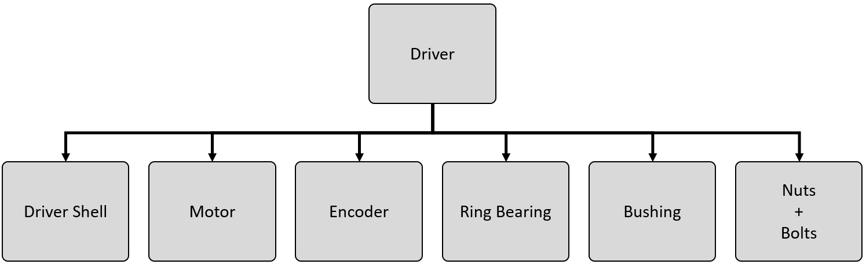

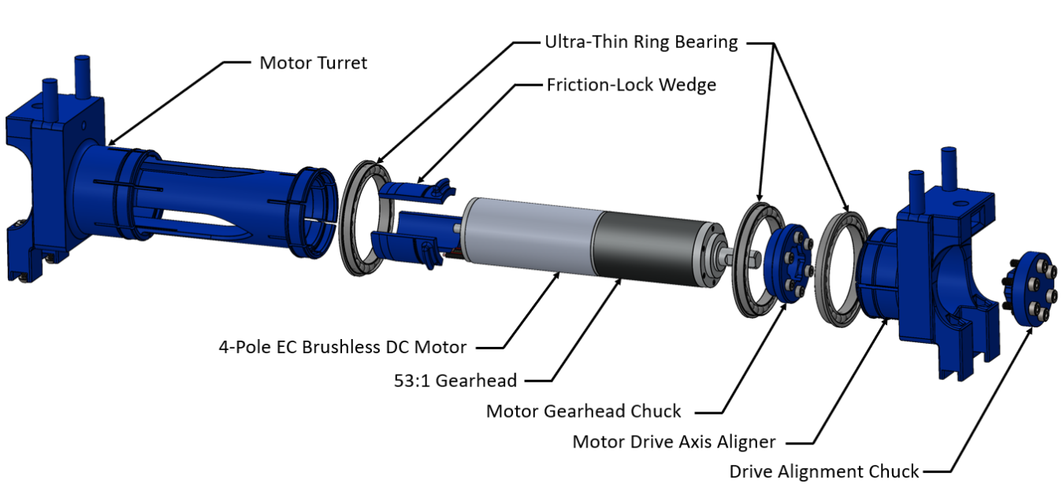

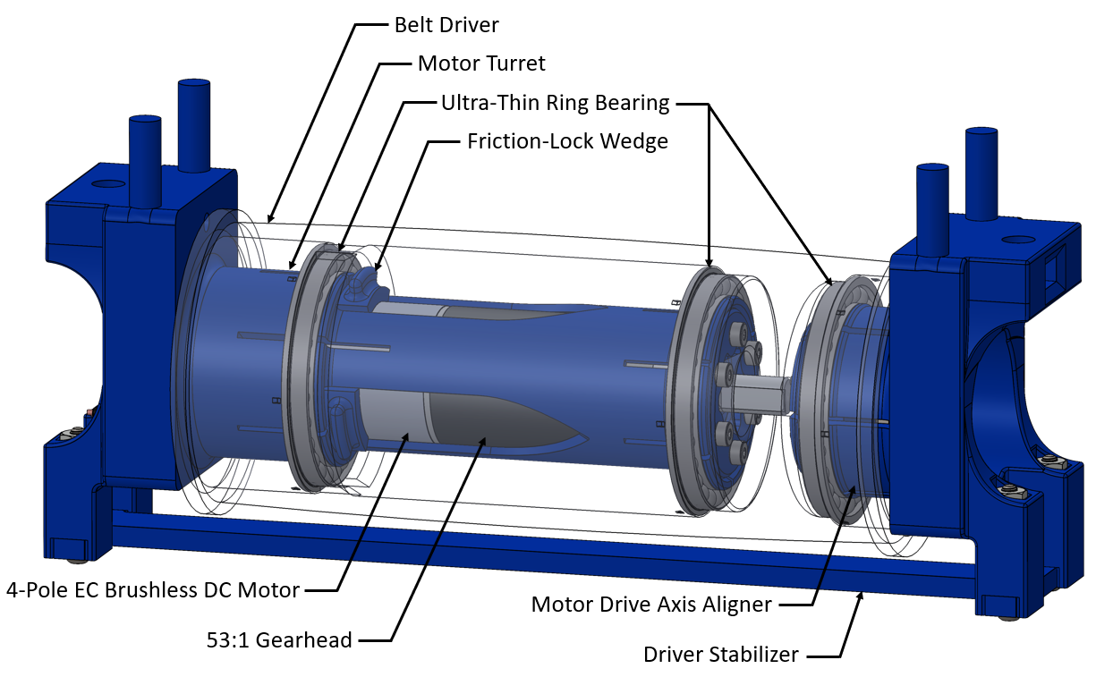

The belt is driven by a central drive pulley mounted to the belt tensioner mechanism. The drive pulley shell is a 3D printed hollow tube with internal mounting slots for the motor assembly and three ultra-thin ring bearings. The pulley was originally designed to be coated with a rubberizing spray to reduce slip between the rolling surface and the belt. However, testing revealed that the rubber coating created a tremendous amount of noise and vibration when driving the belt. Further tests with the drive pulley left as untreated plastic returned desirable results: no observable noise or vibration while still maintain smooth belt speed control. A cross-sectional view of the motor-driver assembly is shown in <Figure ?>.

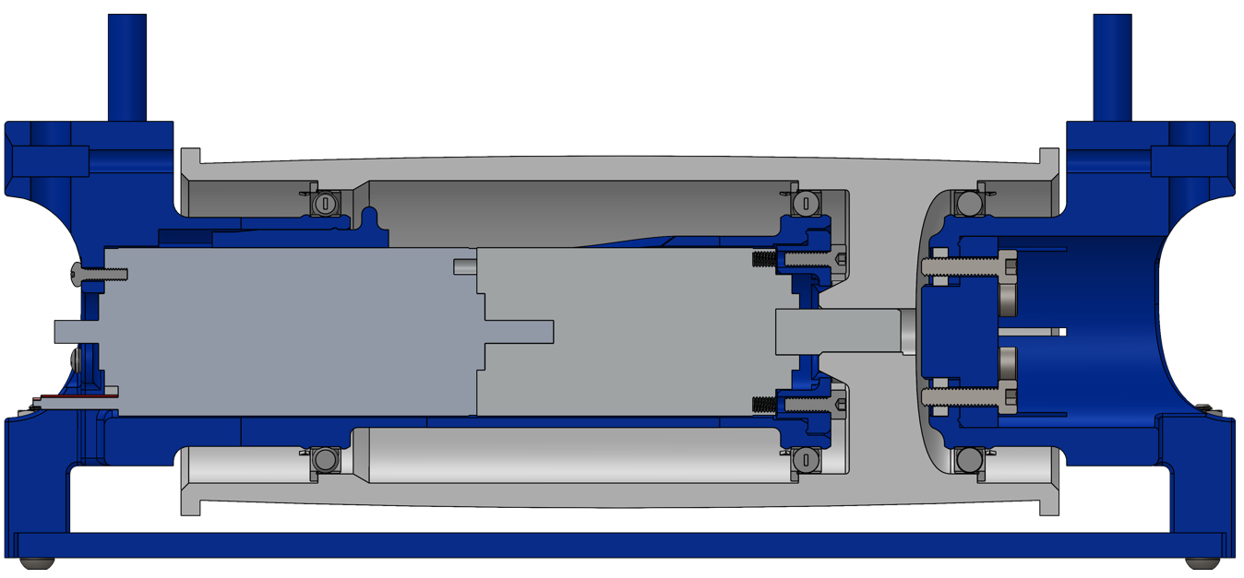

The motor is a custom-built EC 4-pole 3-phase brushless DC motor with Hall Sensor based commutation. The rated nominal speed and torque at the motor output shaft are 15000 rpm and 45.1 mNm. The motor is paired with a High-Power Planetary Gearhead with a 53:1 reduction ratio. The standard maximum running speed of *Blaberus discoidalis* is ~35 cm/s, so as a safety buffer, the max speed of the belt was designed to be at least 45 cm/s. The outer diameter of the shell is 44mm, so that establishes that the maximum speed output of the motor must be at least 195 rpm. The transformed rated nominal speed and torque at the gearhead’s output shaft become 283 rpm and 2390 mNm, satisfying the minimum speed requirement substantially. Both the motor and gearhead are manufactured by the Maxon Group. A critical qualifying characteristic that contributed to selecting a motor-gearhead combination was minimal weight. This combination, compared to a large variety of alternative options with similar speed-torque profiles offered by Maxon and dozens of other motor manufacturers, was by far the lightest option available. The listed mass for the motor is 125 g and 78 g for the gearhead, but the actual measured mass of the combined pair was found to be 198 g, 5 g lighter than anticipated. This is still significantly lighter than the next lightest option found that met all needs, which was 347 g and only delivered 1278 mNm.

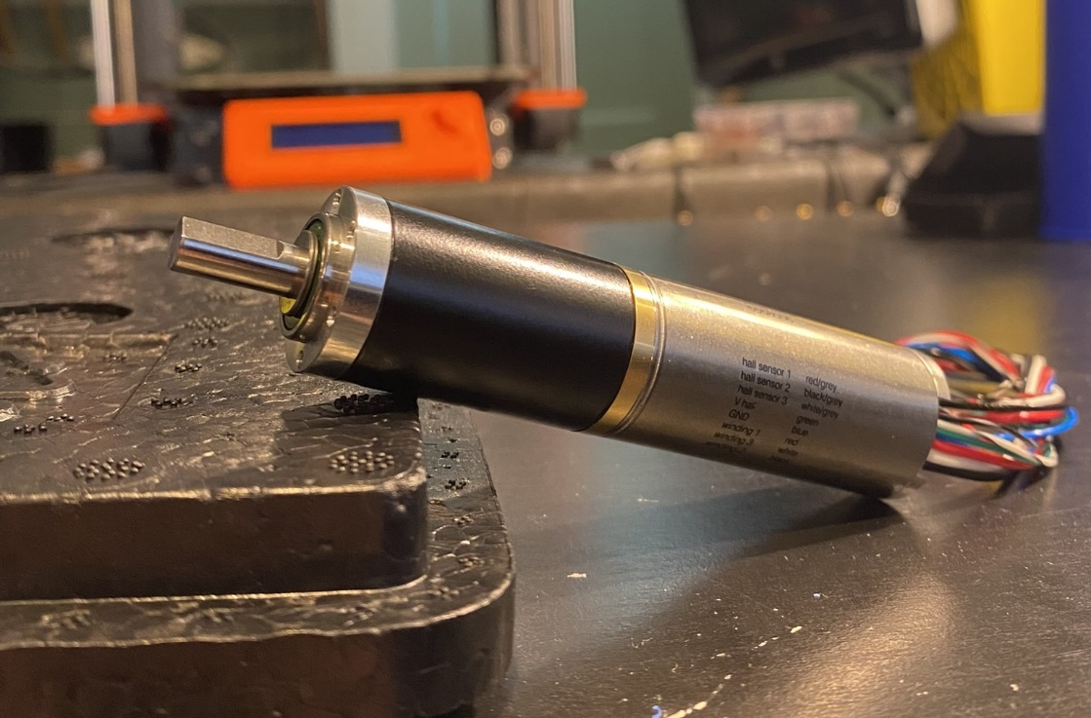

In order to engage the drive pulley with the belt such that slip is minimized, belt speed is smoothly maintained, and the running surface is effectively rigid (deformations from GRFs are negligible), the drive pulley must be driven down into the belt with substantial force to create high belt tension. The Gearhead is equipped with a D-Shaped driveshaft that press-fits into a corresponding D-shaped slot inside the drive pulley. To maintain stable performance of the motor, the axial and radial forces generated by tensioning the belt must be diverted from the driveshaft to reduce the motor’s output to be purely torque. This is done by addition of 3 ultra-thin ring bearings. The two bearings at either end of the pulley absorb the majority of the radial load, while also stabilizing the two belt tensioners’ central axes to the pulley’s axis of rotation. Since the shorter belt tensioner (located on the right of <Figure ?>) only has one bearing for alignment, a linkage is used to connect both tensioners such that small angle deviations between the short tensioner and the drive axis are removed. The central bearing absorbs radial forces near the driveshaft that otherwise would’ve been exerted on the driveshaft, reducing performance. This bearing also works with the bearing at the base of the motor turret to align the motor’s axis of rotation with the pulley’s. <Figure ?> is a simplified visualization of how the bearings act to align axes. Without all axes aligned, the pulley would chatter up and down on the belt and would generate tremendous vibration with poor belt speed output.

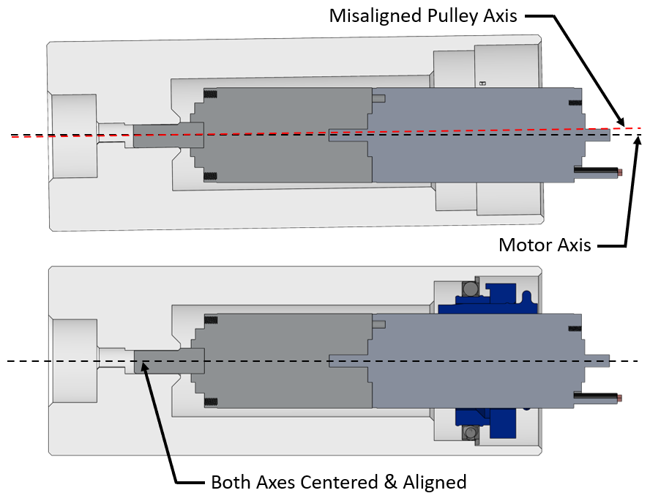

To maintain the modular aspect of design as well as to avoid permanently modifying the motor by mechanically bonding a bearing to the body of the motor, a bearing with an inner diameter of the inner ring larger than the outer diameter of the body of motor was selected such that the bearing could be mounted to the motor via a removable coupler. The belt tensioner identified as the “motor turret” is a hollow tube that the motor slides into like a sleeve and acts as a dual-bearing coupler. At two points are two sets of retention rings that lock the bearings into place to prevent them from sliding along the central axis. The retainer ring walls have 6 slices spaced 60° apart that allow the walls to deflect inwards so that the bearings can be snapped into place. However, once the bearings are placed, the sidewalls of the coupler must then be constrained to no longer deflect inwards such that the bearings are held firmly in place and do not chatter on the coupler. For the bearing located at the center of the motor’s body, once the motor is inserted, wedges are inserted between the motor and the coupler retention ring walls. These wedges have tabs that allow them to be easily removed via flathead screwdriver. These wedges also have retention rings that lock them into place once inserted. A simplified visualization of how this instance of the bearing retention ring mechanism works is shown in <Figure ?>. Although the deflection gap mechanism can be used for the coupler walls for the other two bearings, the friction-lock wedges can not be used since there is no central volume they can be coupled to. Instead, the other two coupler walls are constrained from deflecting by kinematic chucks that screw into place. These chucks have circular ridges that fit into grooves on the couplers that, when screwed together tightly, force the coupler walls into fixed, desired diameter. This second mechanism is shown in <Figure ?> and <Figure ?>. Finally, each bearing slides over a set of one-direction snap ridges on the inner wall of the belt pulley that lock the bearing in place to the pulley to keep the pulley from drifting towards either end of the rotational axis.

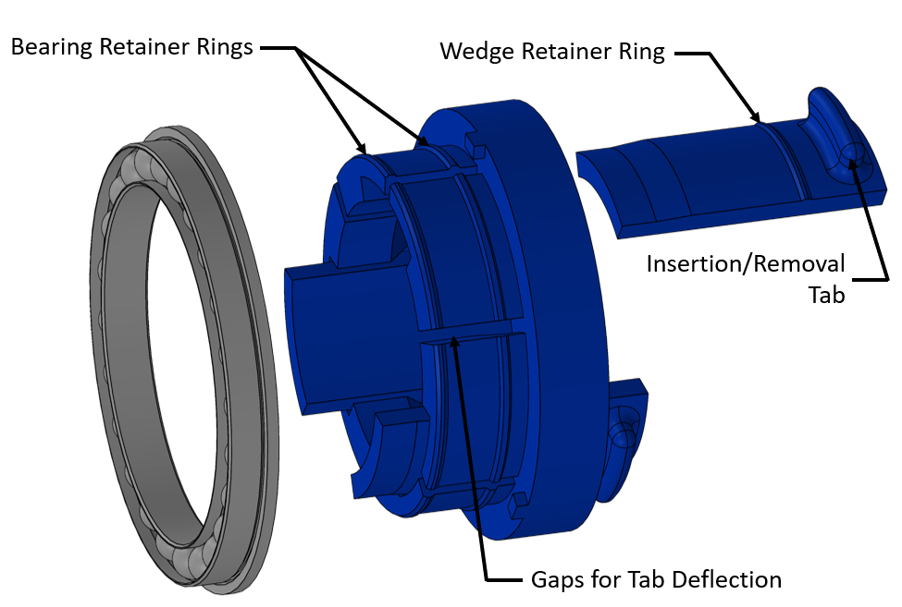

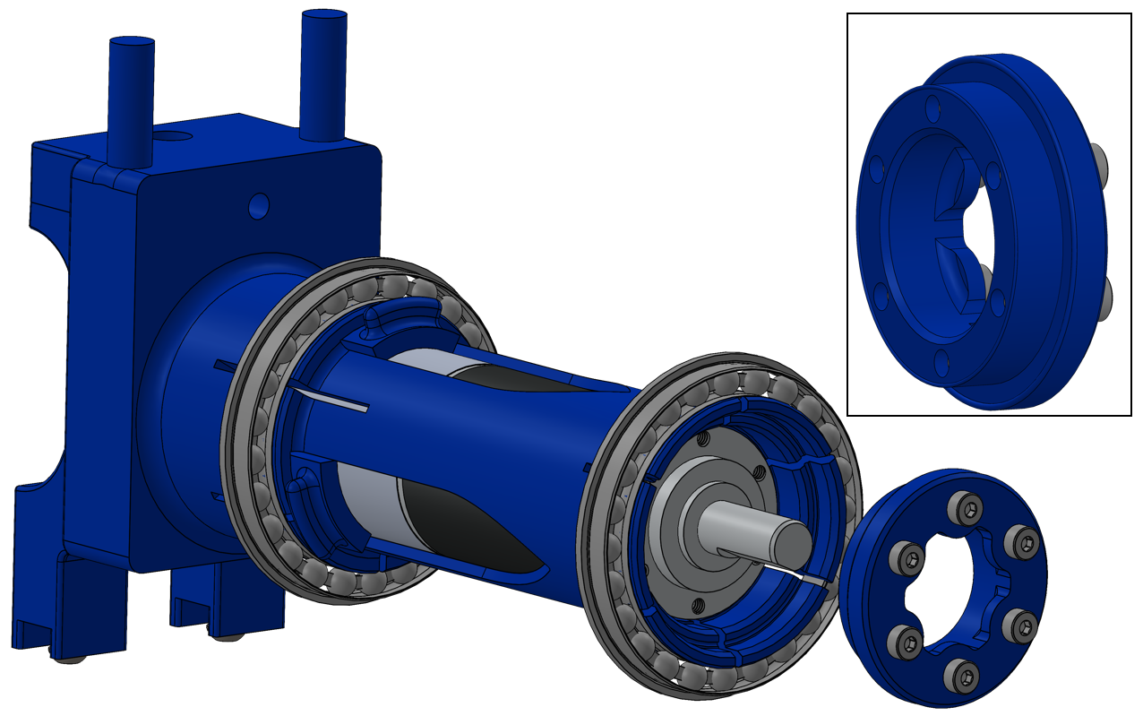

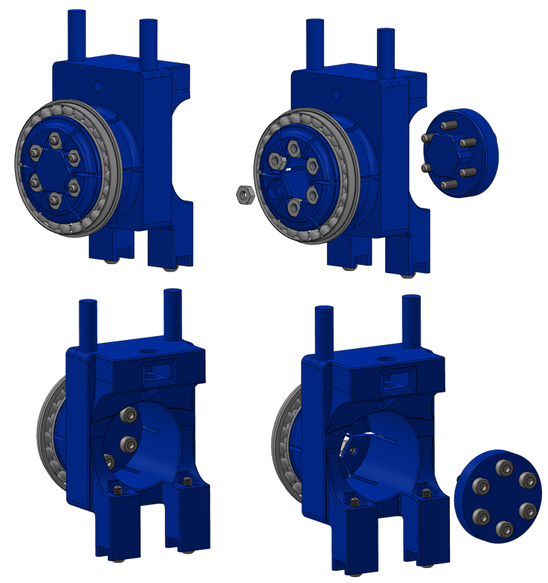

**Rollers**

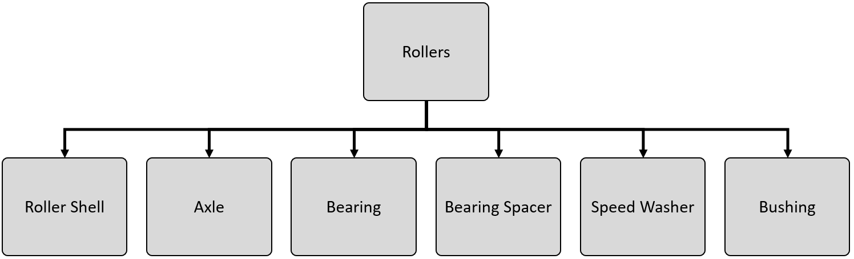

The rollers are passively rotating components that complete the loop for the path traveled by the belt. Their role is to maintain a constant profile for the runway for the cockroach, meaning they need to be able to hold the belt in tension with little variation in its position while rotating upwards of 200 rpm. A major challenge encountered when designing these was belt tracking. “Belt tracking” means to keep the belt centered on the rollers when rotating so that the belt does not drift off the roller. If the belt does crawl across the roller, it can be catastrophic. As experienced countless times during development, without belt tracking, a belt can quickly drift into the chassis, fold over itself several times, shred itself, get stuck inside bearings, and seize up the whole treadmill so aggressively and suddenly that structural parts crumple. Many different strategies were implemented to prevent this from occurring, as this could result in a very expensive failure that would take a long time to fix and could potentially cause injury or death to an insect specimen.

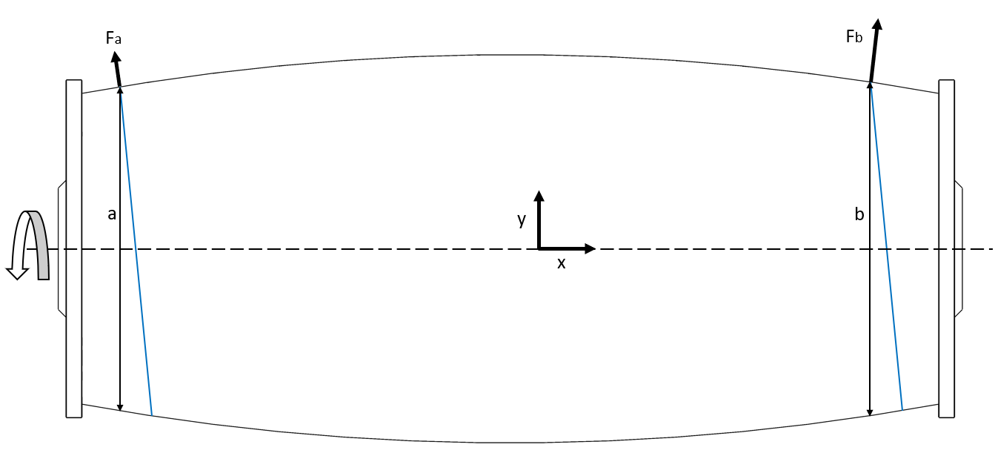

The most impactful design choice for mitigating belt-drift was the profile of the roller. Both rollers, as well as the belt drive pulley, were designed as crowned rollers with end-flanges. The fundamental principle of how the crown design keeps the belt centered is depicted by the exaggerated roller profile shown in <Figure ?>. For instance, as shown in <Figure ?>, when the belt starts drifting towards the left side, the effective roller diameter gets shorter at the left edge and longer at the right. Tension is directly proportional to the radius the belt is being stretched to, so as the radius increases, so does the tension at that point. Effectively, what happens is the tension gets looser on the side the belt is moving towards, and tighter on the side the belt is moving away from. This causes the higher tension end to pull the belt back over until the tension is pulling evenly on both sides. Additionally, as the belt crawls left or right, it points in the direction it is crawling. This means that at the slack end of the belt that is being fed into the roller, the edges are being pointed towards the center of the roller. This causes the roller to grab ahold of the belt closer towards the center than the crawling edge as the roller rotates, again, until the belt stabilizes evenly balanced across the crown. However, incorporating too much crown causes the belt to ripple and crease, so just a modest crown was added to keep the belt flat while still passively keeping it centered.

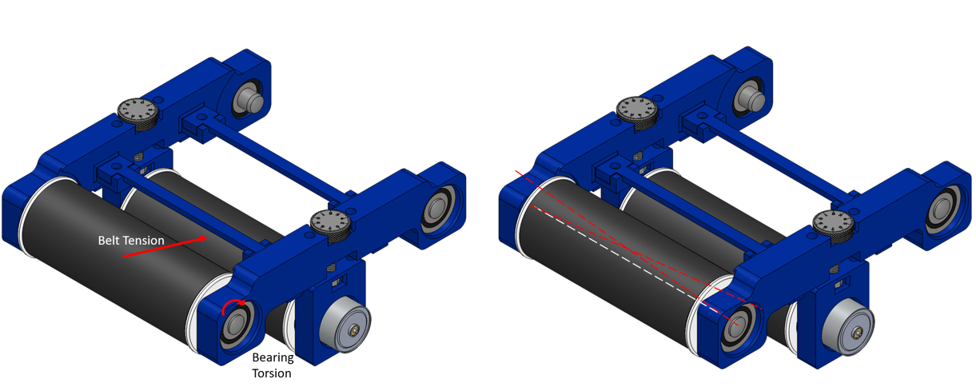

Another design concern was rubbing between the rollers and the supports. The original design for the roller-bearing interface was a steel shaft press-fit through the ball-bearing into a pair of holes on either side of the roller. A pair of these shafts and bearings sandwiched the roller on either side of the roller strut. This design had one major flaw: it was not dimensionally constrained. As the belt was loaded in tension, it would pull the rollers inwards towards the center of tension. This would put torque on the bearings and shafts about the Z-axis. Torque applied this way would cause the shafts to be pulled out of the rollers, much like the claw of a hammer pulling out a nail. As the shafts would get pulled out, they would curl the struts inwards, pinching the rollers and causing rubbing. This also caused the bearings to rotate off axis, which added a significant amount of drag and rotational “pulsing”. Finally, the procedure for sandwiching the roller between the bearings tended to bias the roller closer to one of the struts, which increased rubbing between rollers and the strut sidewalls.

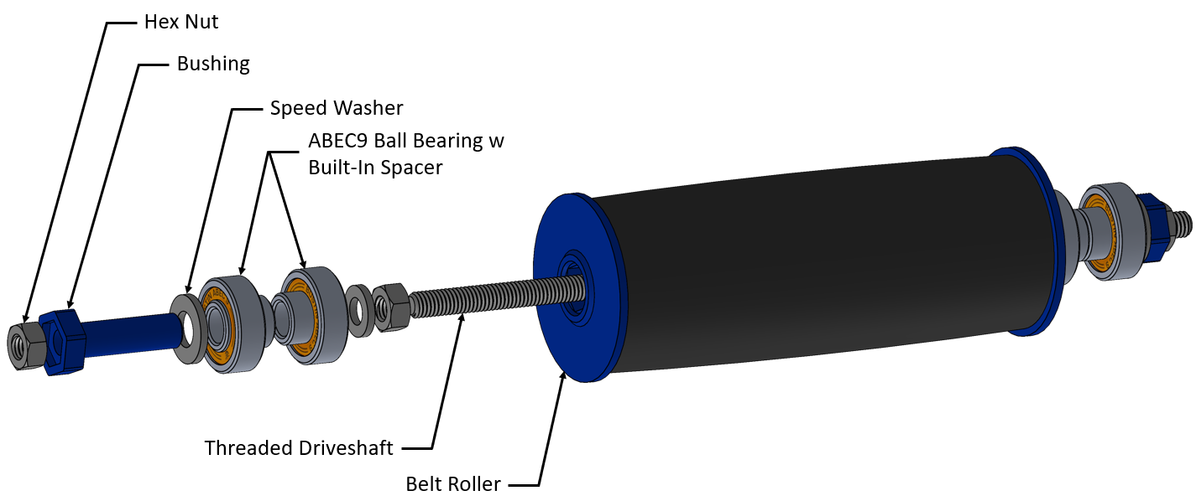

The solution for this was to dimensionally constrain the rollers, bearings, and struts to the same rotational axis. The new design concept is derived from the industry standard method for mounting longboard wheels to reverse kingpin trucks. For those not familiar with longboarding, longboards are much like skateboards, but are designed for long-distance riding. As such, the wheel-bearing assemblies for longboards are designed to minimize friction as much as possible to maintain a smooth ride and to maintain constant speed as long as possible. These attributes are desirable for this application for reducing vibrational noise that could corrupt measurements, as well as maintaining stable belt speed for long periods of time. The longboard wheel-bearing assembly can be reduced to a collection of elements: a central threaded shaft, or “axle”, that acts as the axis of rotation; a pair of ball-bearings that press-fit into circular cutouts in the wheels, rotationally locking the outer race of the bearing to the wheel; hex nuts to compress all elements together along the rotational axis; speed washers to distribute the compressive force evenly across the inner race of the bearings; bearing spacers that, when compressed by the inner races of the bearing, align the bearings and remove compressive forces from the shields of the bearings that could cause rubbing. For better performance, in terms of maintaining speed by reducing chatter and drag, bearings with built-in spacers are used. The advantage of built-in spacers is that the diameter of the inner-wall of the spacer is the same as the diameter of the unthreaded portion of the axle, so the spacer is perfectly centered about the axis of rotation. When the spacer is built-in to the bearing’s inner race, the bearing also becomes perfectly centered about the axis of rotation, which prevents the wheel from vibrating as it spins.

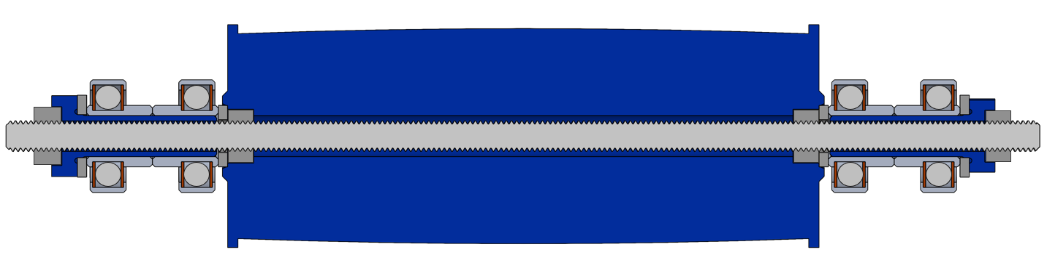

This same design principle acts as the foundation for the belt-roller strut-bearing assembly. However, there is a key difference that prevented using the previously discussed architecture as-is and required significant modification such that it fit the context of this application. That key difference is the fact that instead of two rotating elements being mounted to the ends of a central static element, this application features two static supporting elements mounted to the ends of a central rotating element. This creates the issue of a “floating” central axis that is resolved by modification of certain component configurations as well as addition of a few more components that correct deviations in centricity. In this application, many of the same components play the same role: ball-bearings press-fit into circular cutouts in the roller struts; hex nuts at either end compress all elements together to dimensionally constrain the assembly to fixed distances along the rotational axis; speed washers distribute the compressive force of the hex nuts evenly across the sidewall of the inner race of the bearings; built-in spacers align the bearings and conduct compressive force through the axle towards the roller. The additional components include: a threaded driveshaft that spans the full length of the bearing-roller-strut train; a pair of hex nuts that fit into hexagon shaped cavities at either end of the roller to center the threaded driveshaft to the centerline of the roller; a bushing that centers the bearings’ axes of rotation to the centerline of the driveshaft. The bushing performs this centering action because it’s outer diameter is the same as the inner diameter of the inner race of the bearings, which centers the bushing to the bearings when press-fit together. The bushing is centered to the threaded driveshaft via the compressing hex nut, which fits into a matching hexagon shaped cavity at the end of the bushing. Finally, the bearings selected are lubed with nanoceramic grease, which packs asperities in the racetrack with ceramic particles that heat up and cure to form an extremely smooth surface that massively reduces the magnitude of vibrations generated from rotation.

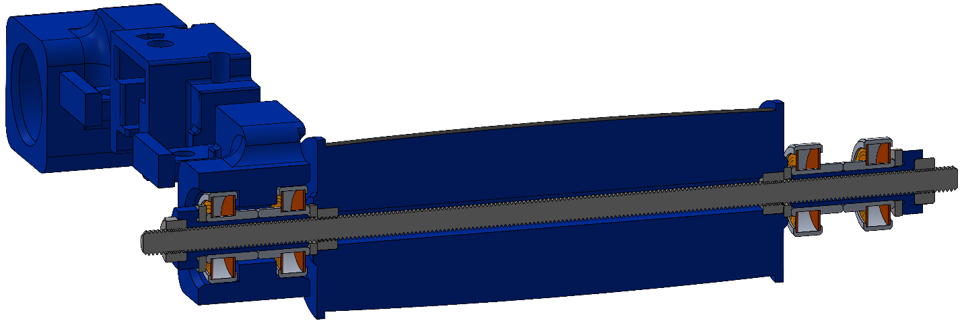

**Belt Tensioner**

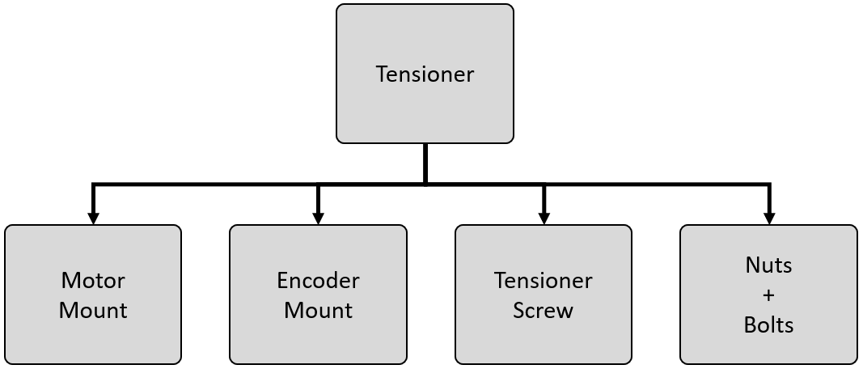

The belt tensioner is the mechanism that translates the belt driver assembly up and down to engage the belt pulley with the belt. Adequate tension in the belt is necessary for two primary reasons: 1) to reduce slip between the belt and the rollers and pulley such that stable speeds are maintained and to reduce vibrations generated from belt slip; 2) to generate a simulated “platform” for the specimen to run across that experiences minimal deflections in response to ground reaction forces exerted by limbs of the specimen during motion.

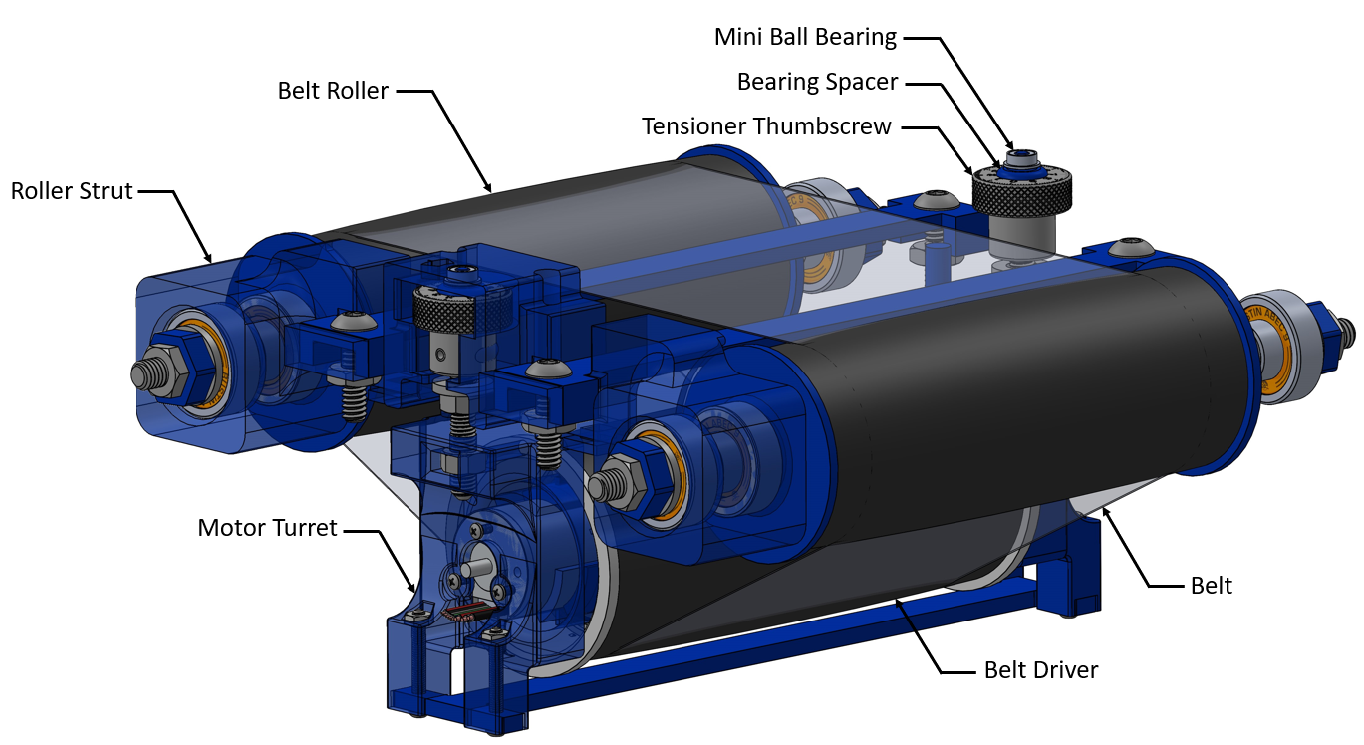

The elevator mechanism of the belt tensioner is a relatively simple screw lift. On both struts, a thumbscrew fits into a cavity. The two motor mounts in the belt driver assembly contain hex nuts that are dimensionally constrained in each direction within a slot. A hole in the mount passes through the center of the hex nut so the thumbscrew can engage with the nut. As the thumbscrew is rotated, the mated motor mount moves up or down by the pitch of the thread. Once the mount is at the desired elevation, a second hex nut between the strut and the thumbscrew head is tightened, compressing a washer to the surface of the strut, locking the rotation of the thumbscrew. The head of the thumbscrew is laser engraved with a rotation gage that aligns with a datum view port located in the ceiling of the strut cavity. This gage is used to ensure that tension is balanced on either side of the driver. Belt stability is fine-tuned by moving either thumbscrew by a known count.

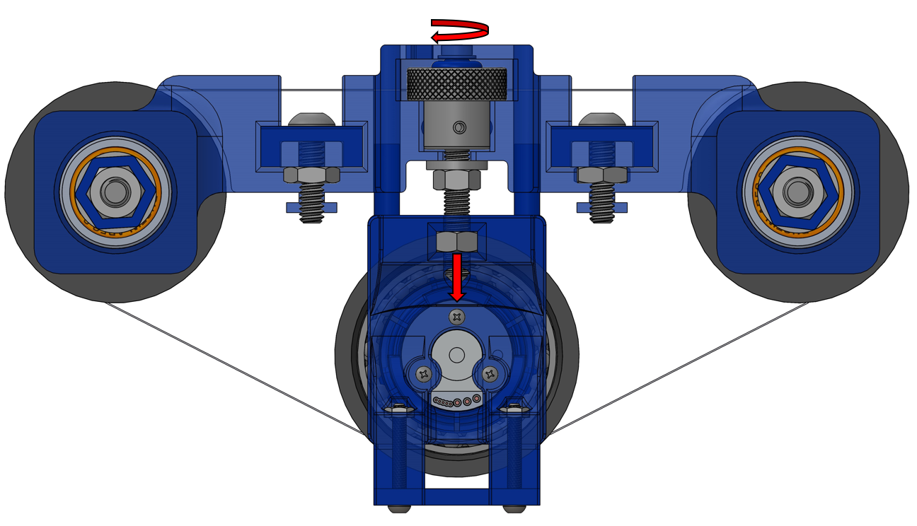

As the thumbscrew rotates to push the driver down, reaction force pushes back on the thumbscrew, pushing it up. In earlier designs, this would drive the head of the thumbscrew into the ceiling of the cavity. This prevented the belt from being sufficiently loaded in tension because a point would be reached where the tension of the belt created such high friction force between the head of the thumbscrew and the ceiling of the cavity that the thumbscrew could not be rotated further. This blocked the ability to reach the necessary nominal tension, as well as the ability to fine tune the tension on each side to balance the load across the driver. The solution for this was to place a miniature ball-bearing in the ceiling of the strut cavity that mated with a spacer that locked the thumbscrew vertically against the inner race of the miniature bearing. This both vertically constrained the thumbscrew, as well as removed the impeding friction force between the head of the thumbscrew and the strut. This allowed the thumbscrew to be easily rotated, regardless of the magnitude of tension present in the belt. Note that this does not imply that high tension in the belt could cause the thumbscrew to rotate, as the locking hex nut is engaged after reaching the desired tension point.

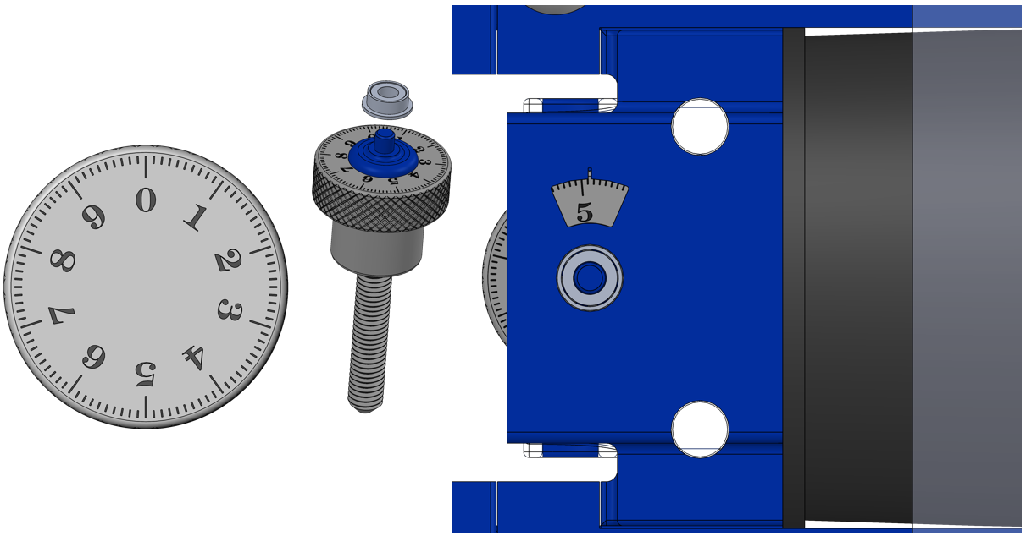

**Cockroach Enclosure**

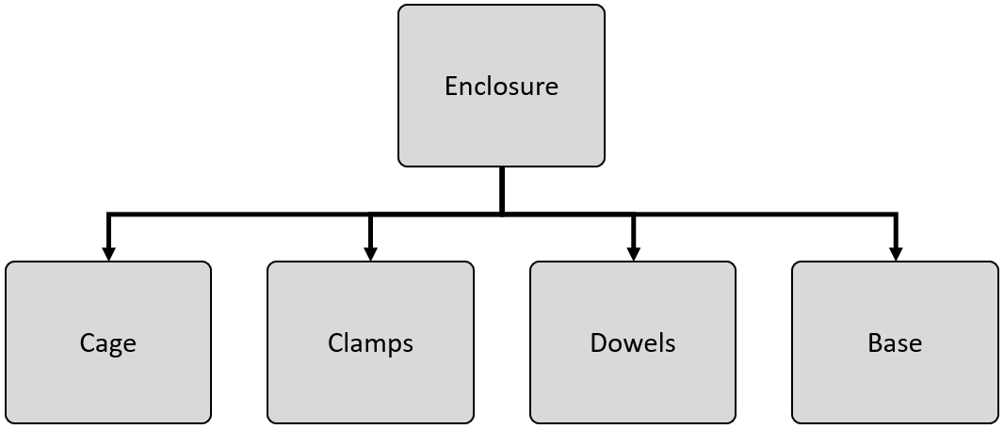

The cockroach enclosure, which mechanically isolated from the treadmill, is considered a constituent of the treadmill because it is dimensionally controlled by the geometry of the treadmill. The enclosure is mechanically isolated from the treadmill because it does not contact the treadmill; instead all of its weight is supported by the transducer hub. This is done for two reasons: 1) to remove weight from the treadmill, and 2) to allow the specimen to be transported from storage to the treadmill already inside the enclosure to reduce risk of the specimen escaping. The enclosure is a simple construction of four acrylic panes glued to a set of eight clasps that slide over wooden dowels. The clasps have slots in front of the dowel sleeves that hold hex nuts. Wing screws thread with the hex nuts and screw against the dowels to lock the enclosure in place. This allows the enclosure to be mounted as close to the belt as possible to prevent the cockroach from escaping, yet still avoiding making contact with the drivetrain.

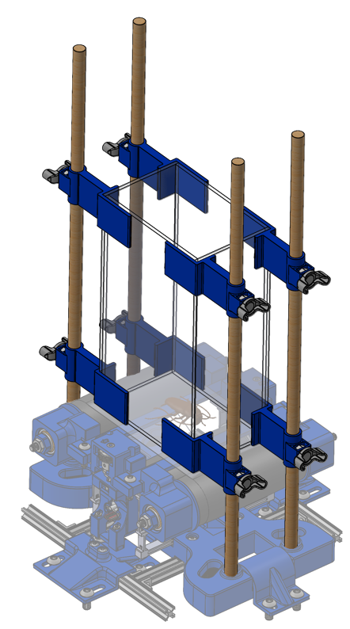

### 3.1.2 Transducer

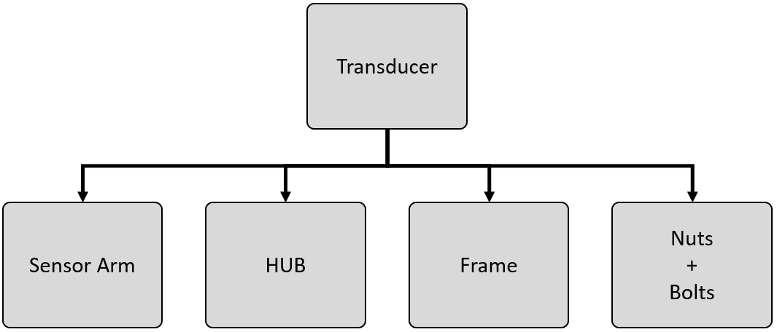

While the transducer could be seen as a subsystem of the treadmill assembly, it is broken out as a separate structural system to emphasize its importance to the overall design and to elevate its priority rank for driving design decisions. The transducer is the transformation stage from the mechanical domain to the electrical. Here, carefully designed cantilevered beams equipped with semi-conductor strain gauges discretize 3D forces into their 1D components. The strain gauges, mounted at nodes of maximum bending strain, then convert each of the one-dimensional force components into an electrical signal that is then sensed and recorded by the Strain Gauge Signal Conditioner network. An overview of the composition of the transducer system can be seen below in <insert field>.

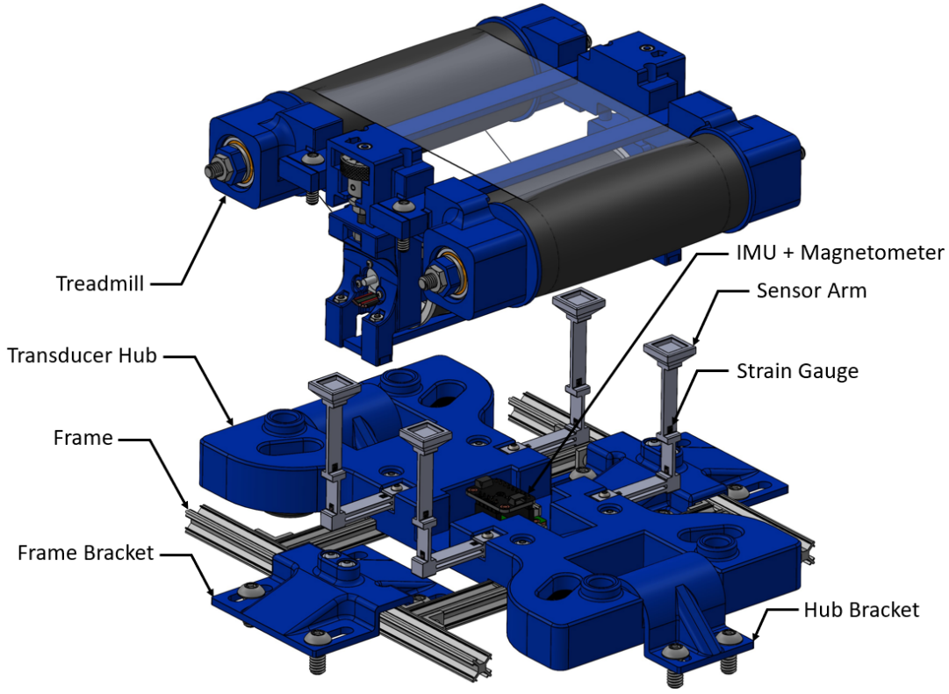

**Sensor Arm**

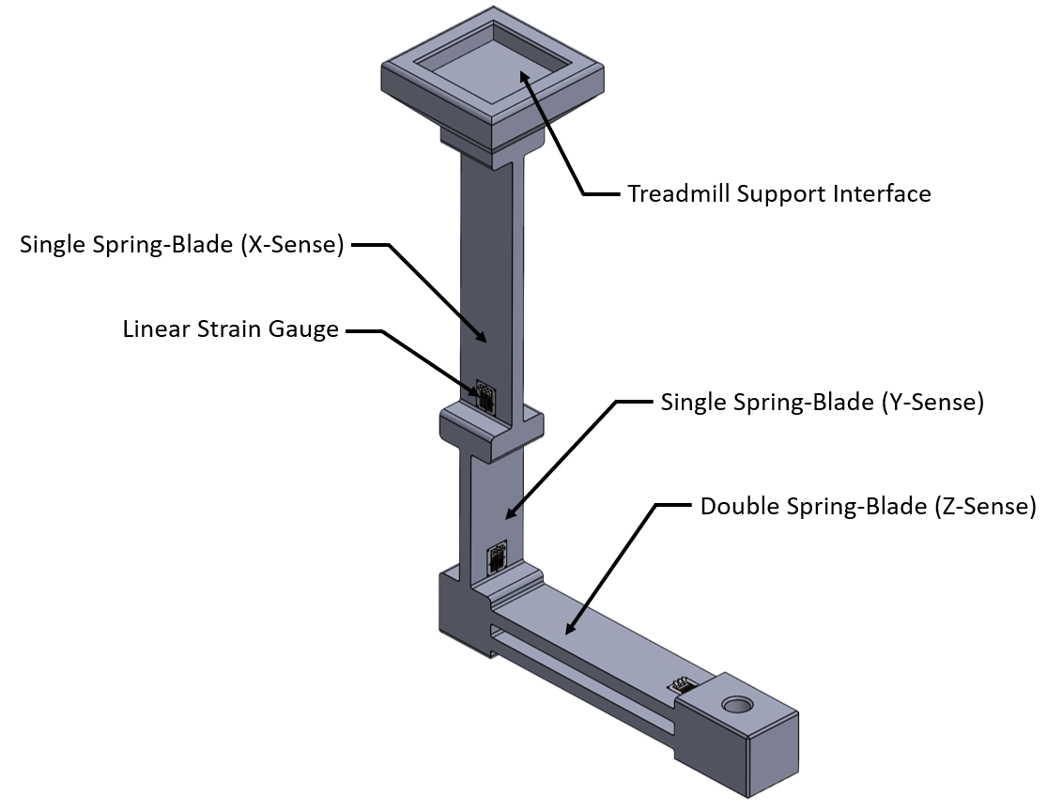

At a fundamental level, the main design principle of the transducer is force amplification via generation of nodes of concentrated surface strain at the base of cantilevered beams loaded in bending. Through this mechanism, a small force, acting at a distance, can produce a large bending moment on a thin beam, resulting in a local surface strain with a magnitude great enough to be detectable by a strain gauge. A visualization of this type of loading and the stereotypical resultant strain profile is depicted in <Figure ?>. Note that all discussions of force response behaviors of the sensor arm will start with the same base generalization that the applied force can be considered a 3-dimensional force vector applied to the center of the square footpad of the treadmill support interface.

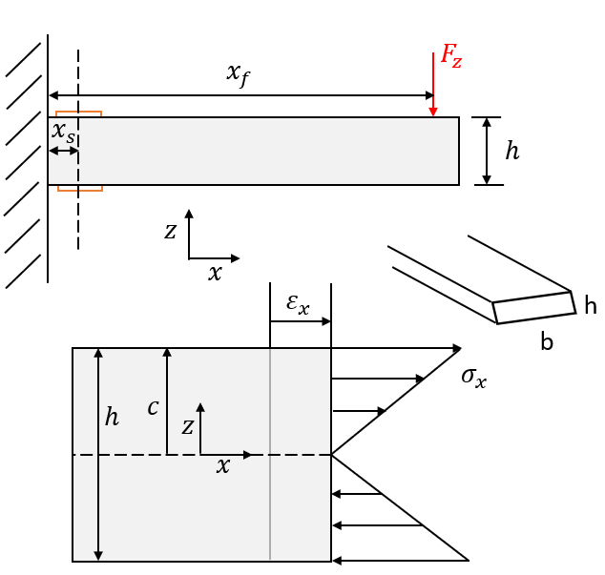

From this model, the equation for maximum strain at the site of the strain gauge can be determined as:

$$ε_{max}=\frac{6F_{z}\left(x_{f}-x_{s}\right)}{Ebh^{2}}$$

A sample application of this type of loading and its corresponding strain response generated from Finite Element Analysis simulation are provided below. The images below represent a sample beam tested for empirically testing the strain response of a simple cantilevered beam as a constructor to the more complex triaxial cantilevered beam design. Also note that the dimensions of the sample beam have been scaled in the first image to simplify the visual for demonstrative purposes. This sample beam test will be discussed in greater depth in Chapter 5.

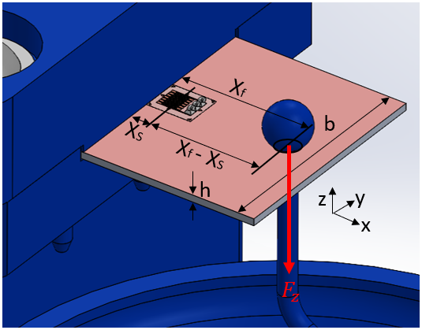

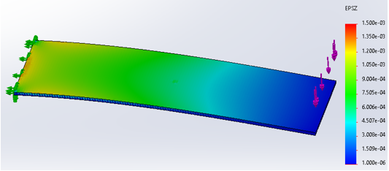

In Heglund’s earliest force platform design [15], he outlined a cantilevered beam sensor arm design framework he referred to as a *spring-blade*. A spring-bladeis a force-amplifying sensor arm constructed of cantilevered beams in series connected by approximately rigid junctions. While a simple spring-blade is certainly the easiest design to work with for force amplification, the concept does not hold up well in the application of accurate triaxial force discretization. Here a problem arises referred to in this thesis as *transaxial crosstalk*. In the context of this design, transaxial crosstalk is when a force applied in one direction disguises itself as a force applied in another direction through a strain transformation. In other words, a force of interest generates a sensed stimulus on a sensor other than its own intended sensor. This is essentially a mechanical glitch that is produced by compound loading. Take, for instance, a force acting on a sensor arm in the Z-direction. This produces a moment in the Z-sense beam, generating a large node of surface strain at the base of the Z-sense beam.

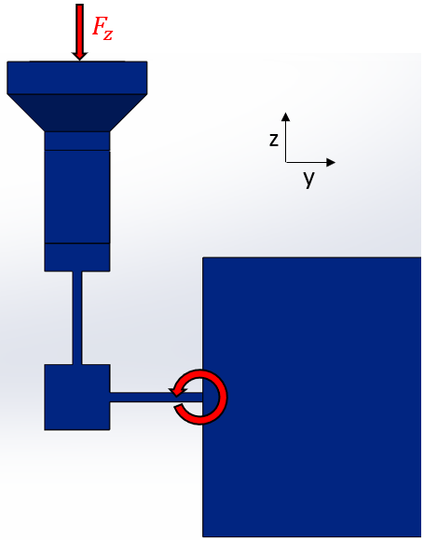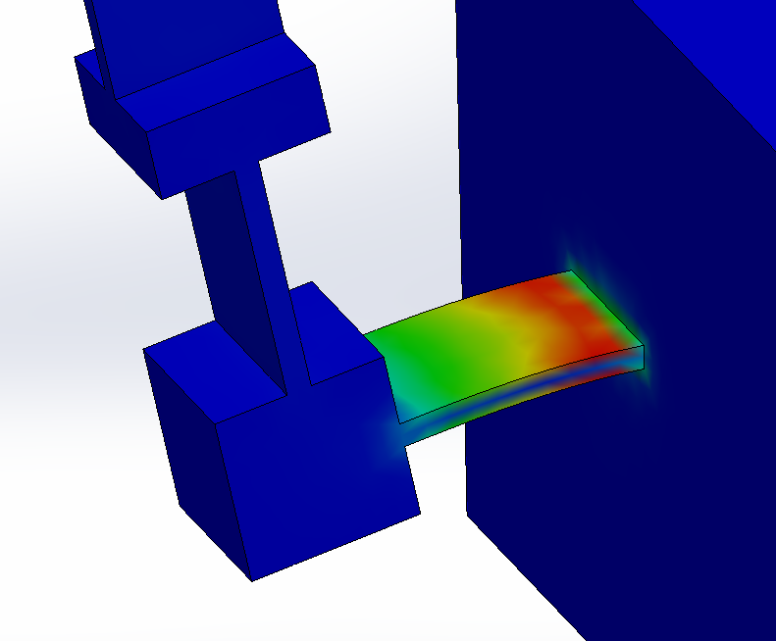

Similarly, consider a force acting on the same arm but instead acting in the Y-direction. This generates a moment at the junction block between the Z-sense beam and the Y-sense beam. However, in this case, the moment arm for the reaction force Z-sense beam to resist the moment at that junction is very small (one half the Z-sense beam thickness). As a result, observable tension and compression forces are produced by the beam to counteract the torque at the junction, producing a very similar strain response on the surface of the Z-beam. Despite the fact that no forces were applied in the Z-direction, a substantial stimulus from the Y-acting force is observed by the Z-sense strain gauges.

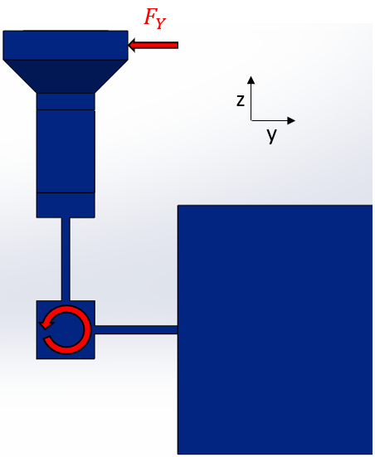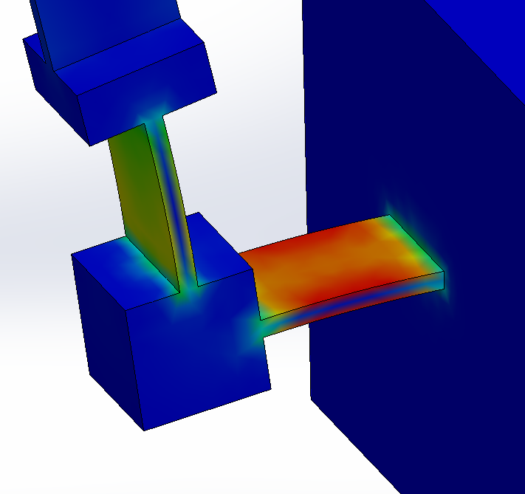

This phenomenon of transaxial crosstalk, which is a result of insufficient bracing of the Z-sense beam against torque on the YZ junction, reveals a simple design compensation: a *double spring-blade*. A double spring-blade is a pair of parallel cantilevered beams spaced equal distances above and below the neutral axis of bending to effectively act as a single cantilevered beam in response to applied forces normal to the surface being sensed by strain gauges. Consider here the Z-sense beam substituted with a double spring-blade, where the thickness of each beam is half of the original beam thickness. With this configuration, the bending stiffness of the Z-sense beam is still approximately the same, preserving the beam’s sensitivity to forces applied in the Z-direction. However, the reactive moment of the compound beam to torsion of the YZ junction generated by Y-forces is greatly increased due to compression and tension forces of the pair of beams acting at a greater distance from the neutral axis. This forces the Y-forces to be absorbed almost entirely by deflections generated in the Y-beam, thus greatly reducing the magnitude of transaxial crosstalk.

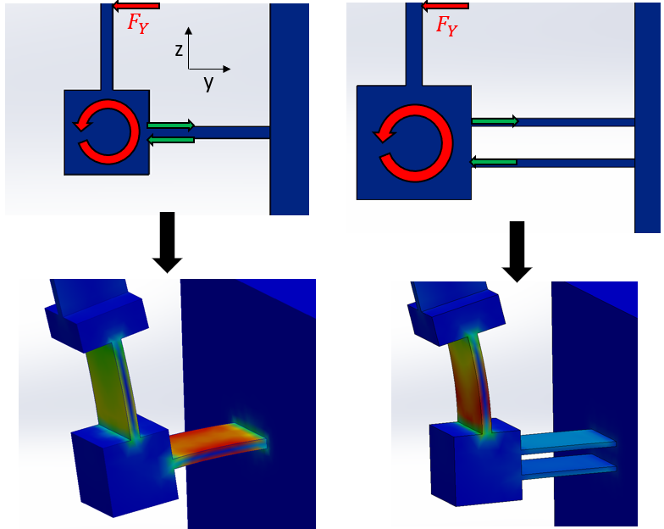

**Transducer Hub**

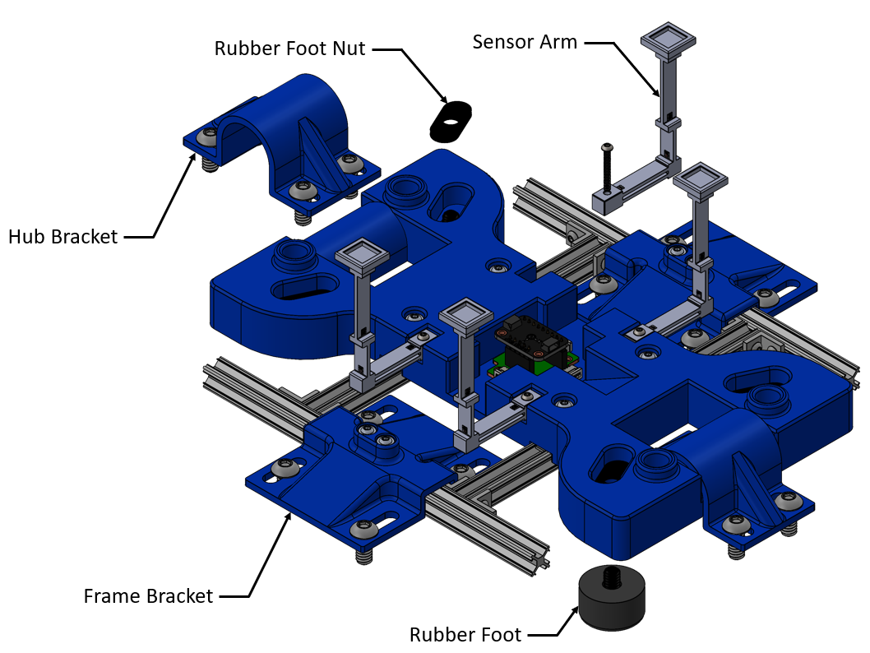

The sensor arms are made out of polycarbonate. This material was chosen because it is a linearly-elastic glass-polymer. In standard strain gauge applications, metal is preferred because of its linear strain response to imposed stress. However, since this application aims to detect very small forces, the high Modulus of Elasticity of most usable metals greatly reduces the beam sensitivity, making it very difficult to detect forces. While plastic would be much more sensitive due to their significantly lower Modulus of Elasticity, not any plastic could be used because most are visco-elastic and have a non-linear stress-strain response in the elastic region. Glass-like polymers, however, are a type of plastic that is linearly elastic, as well as adequately sensitive to force. Polycarbonate was chosen because it can be 3D printed on SLA printers with high dimensional accuracy and layer resolution. However, due to their glass-like behavior, they are also brittle, like glass, and can shatter easily when over-strained. As an effect, the sensor arms are very fragile instruments that are prone to breaking. Since mounting strain gauges to them also makes them expensive and time-consuming parts to make, it is highly beneficial to design them to be modular and replaceable. That way, if one arm breaks, the entire transducer assembly doesn’t need to be replaced. That is the driving decision for the Transducer Hub, which acts as the mounting point between the rigid frame and the individually assembled sensor arms.

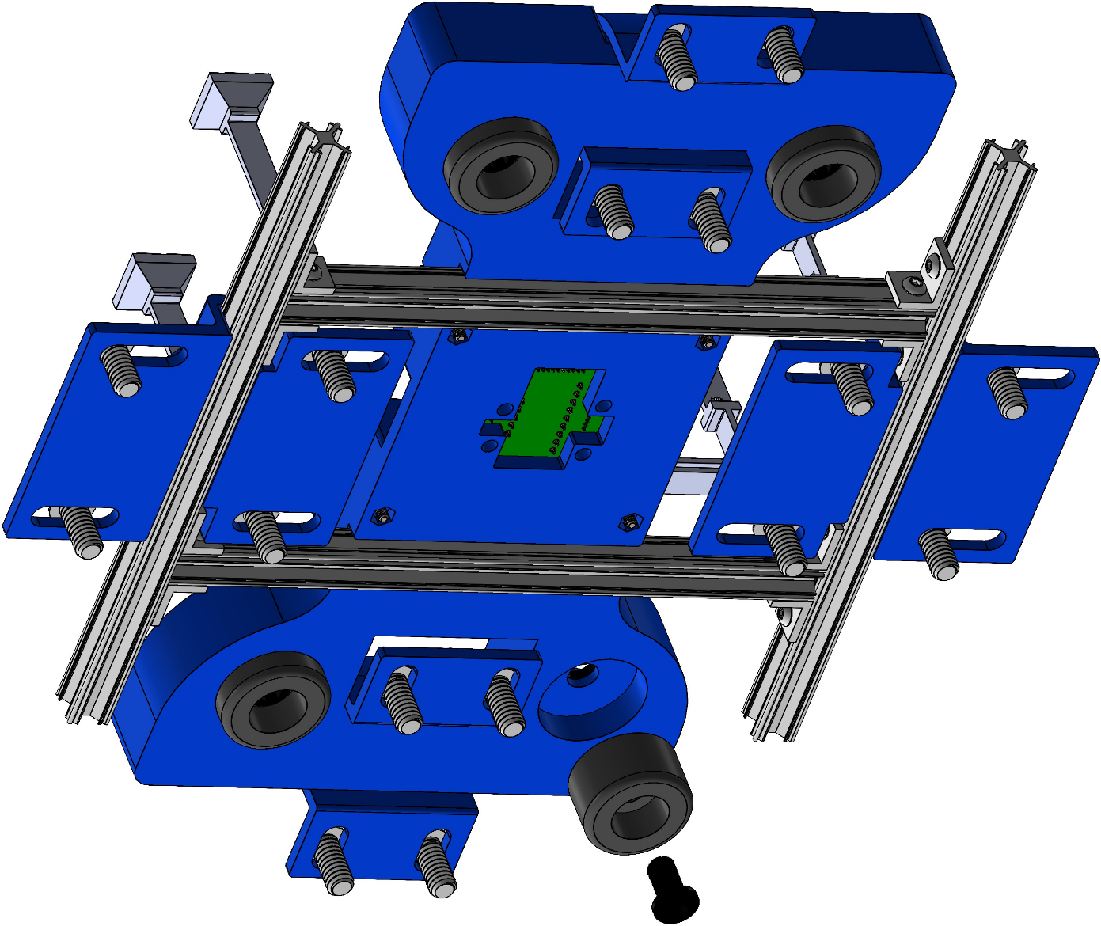

The transducer hub is the base frame of the treadmill that secures the whole assembly to the test stand. Not only does it host the sensor arms, but it also supports the cockroach enclosure via slots that the wooden dowels fit into. The hub is reinforced with stainless steel t-slot framing, which is bracketed to the test stand at two points. A second pair of brackets stabilize the hub to the test stand at opposite ends of the hub. Rubber feet screw into the underside of the hub. These are compressed into the steel plate surface of the test stand when the brackets are screwed down. This acts to absorb vibrations between the treadmill and the surface of the test stand.

### 3.1.3 PCB Mounts

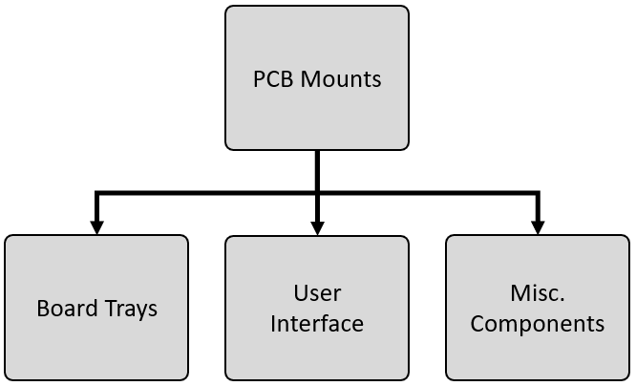

The custom electronics designed for this project, despite having structural and mechanical elements, will not be discussed in this section. Instead, the mechanical aspects of each board type will be discussed at the same time each board’s circuitry is analyzed. However, the mounts and housings made for the full collection of boards can be discussed in this section because these components are purely structural. There are three main groups the PCB mounts fall under: 1) Board Trays; 2) User Interface; 3) Miscellaneous Components. This section will start its focus with Board Trays.

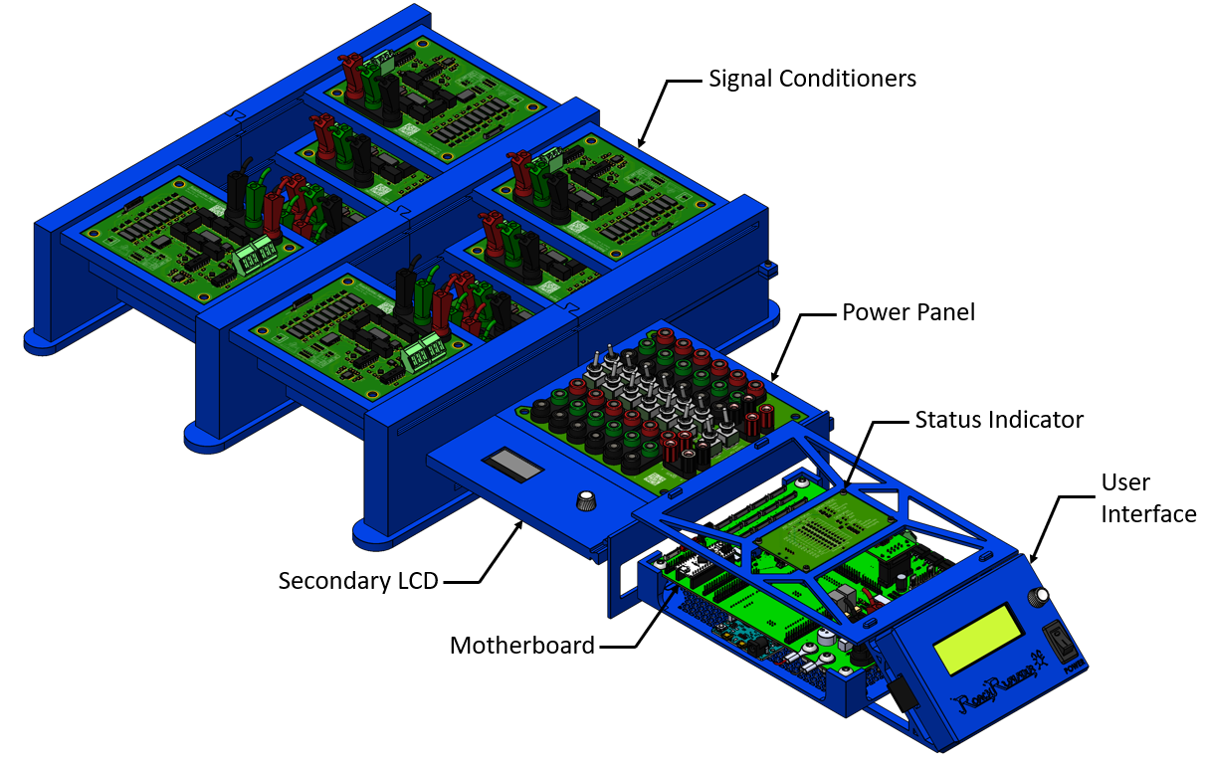

**Board Trays**

Board trays the plastic housings used to organize and protect the custom PCBs. A unique tray is designed for each board type. First is the Signal Conditioner board tray. This tray has a cavity that the board sits flush inside. The board screws in place with hex screws. Rails on either side of the tray allow it to be slid into storage racks.

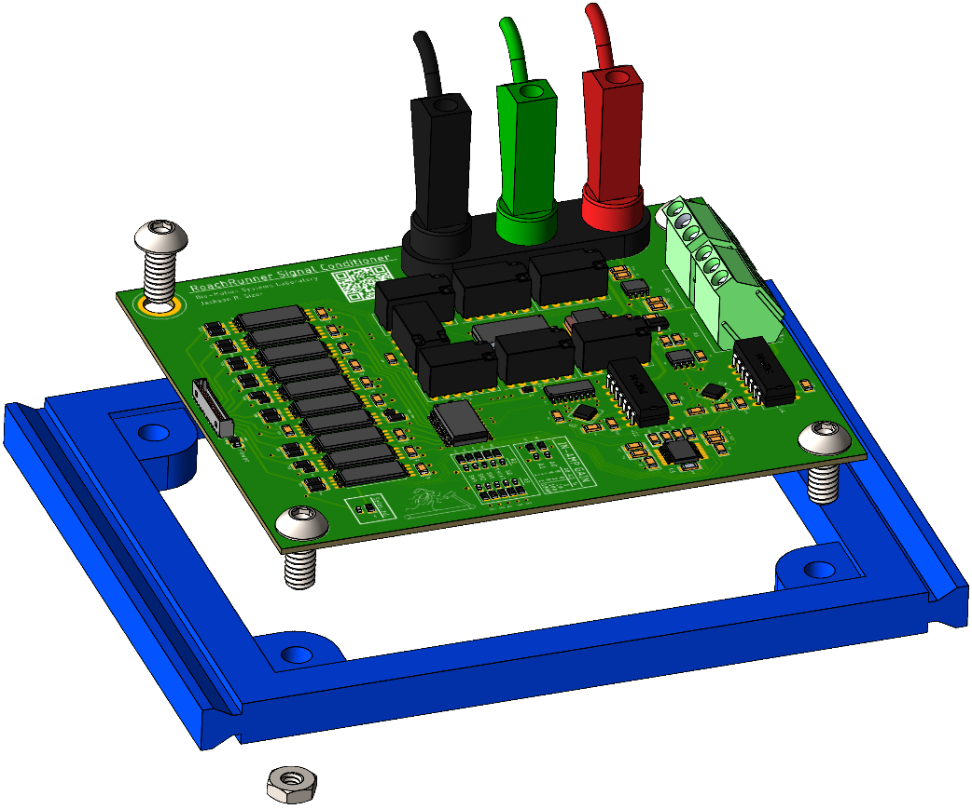

These Signal Conditioner board tray assemblies can be stored in two types of libraries: rack and row. The “rack” configuration is more compact and more stable. The “row” configuration is more accessible and easier to debug and modify on the fly. If the user is still in a prototype phase and will be making frequent changes to their build configuration, the row configuration is the better option.

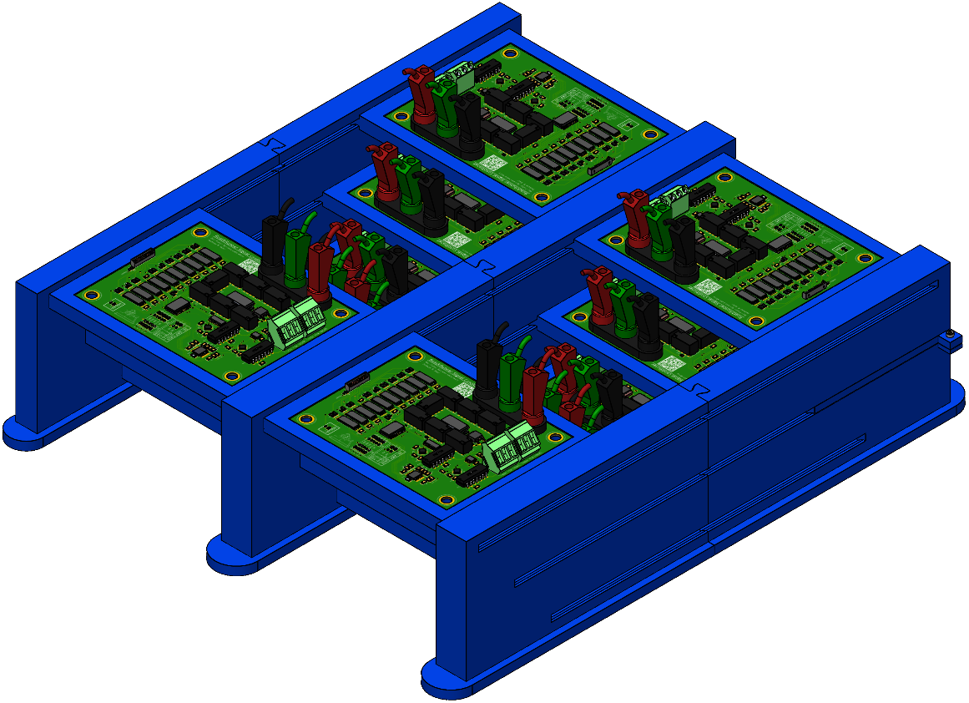

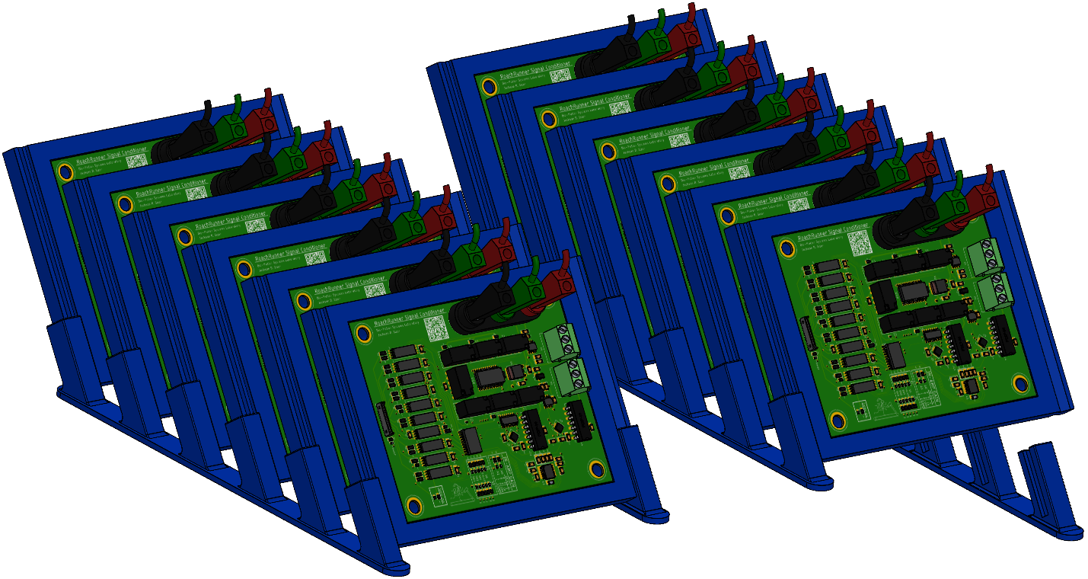

The power panel is seated in a similar style board tray. The board is notched at one end to ensure that it is screwed to the tray in the correct orientation. This ensures that signal conditioner identifier markings on the board match up with the organization of boards in the library.

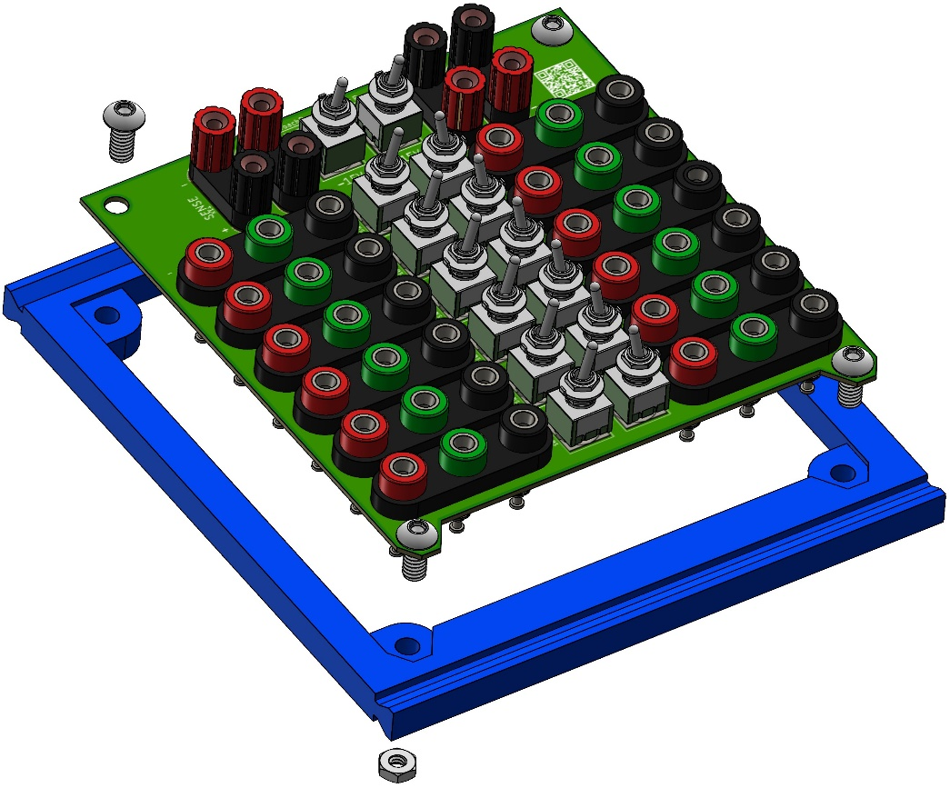

**User Interface**

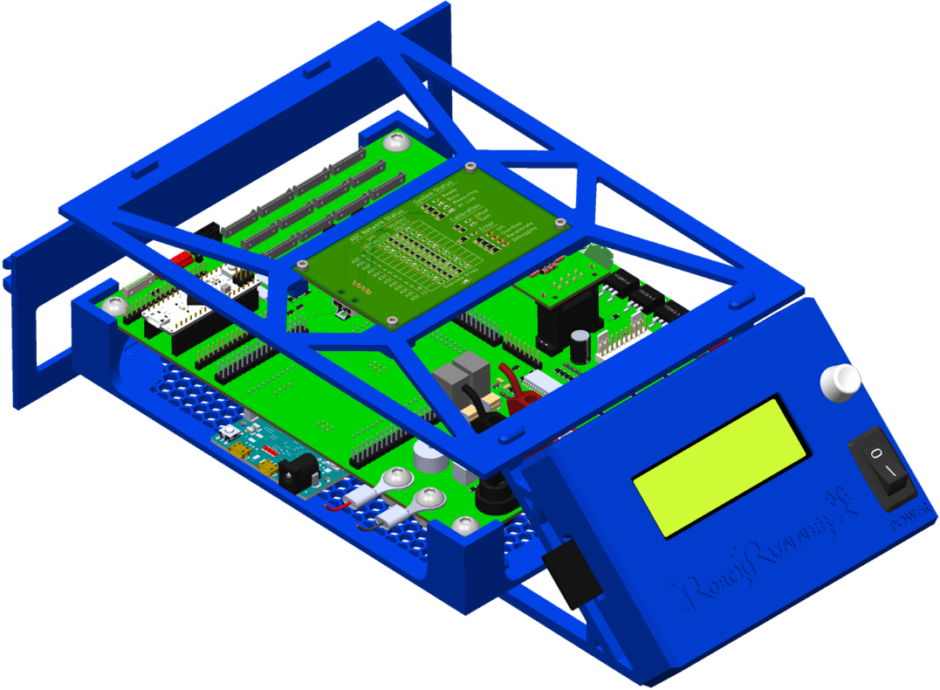

Together, the User Interface and the Motherboard housing form the full front end of the system. The motherboard acts as a shield for an Arduino Due, which mounts to the underside of the motherboard by plugging directly into male headers than align with the Due’s form factor. The Arduino Due is the controller for the whole system. The motherboard is equipped with cable headers for connecting to all peripherals. The motherboard performs all the logic operations and signal management for power distribution, system configuration, and digital communication. To maintain adequate ventilation for heat and to make cable management easy, the support items, like the back panel and both trays, are designed to maximize open space while maintaining structural stability. For instance, the motherboard tray is a hexagonal mesh rather than a solid sheet.

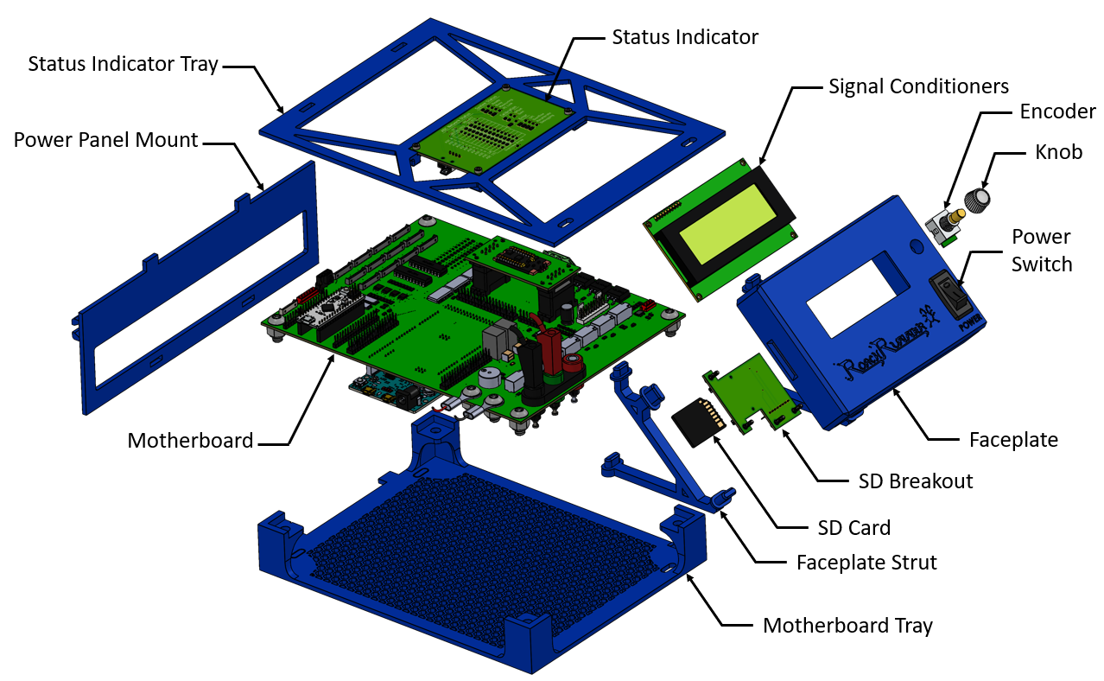

The User Interface is the central control point for the entire system. By turning and clicking a knob, a user can calibrate strain gauge signal conditioner boards, drive a brushless DC motor, activate a local Wi-Fi network to stream data, read and write data from and to flash storage, and change the amplitude of power supply busses. All of this is done by navigating through menus displayed on 20x4 character LCD display, which is mounted inside the User Interface faceplate. This faceplate also hosts a rotary optical encoder that is used to scroll and click. A rocker switch mounted to the front of the faceplate is used to toggle power to the digital circuitry on and off. A custom designed SD card reader breakout board mounts internally to the faceplate. This breakout board lines up with a slit in the side of the faceplate that an SD card slides into. The faceplate is supported by a pair of struts that plug into elliptical slots on the backside. These struts also plug into similar elliptical slots on the motherboard tray and the LED status indicator tray.

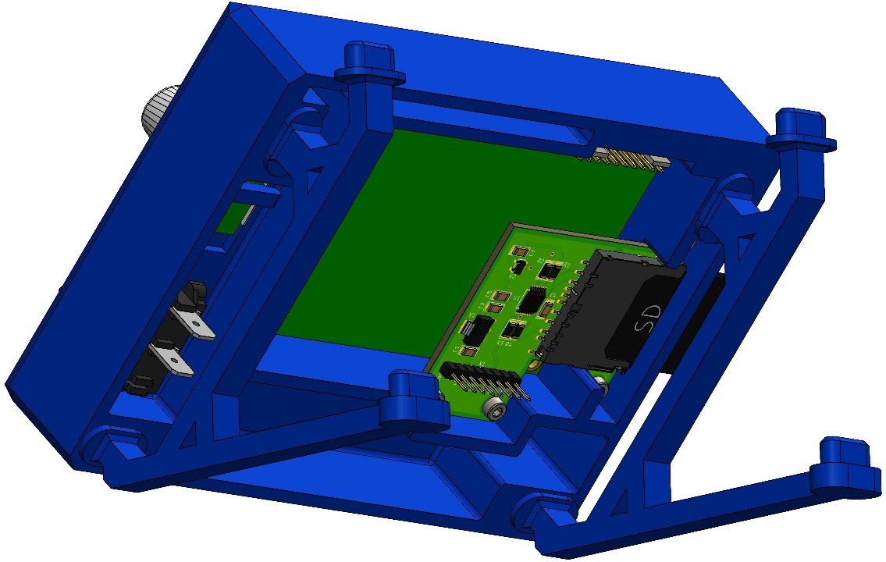

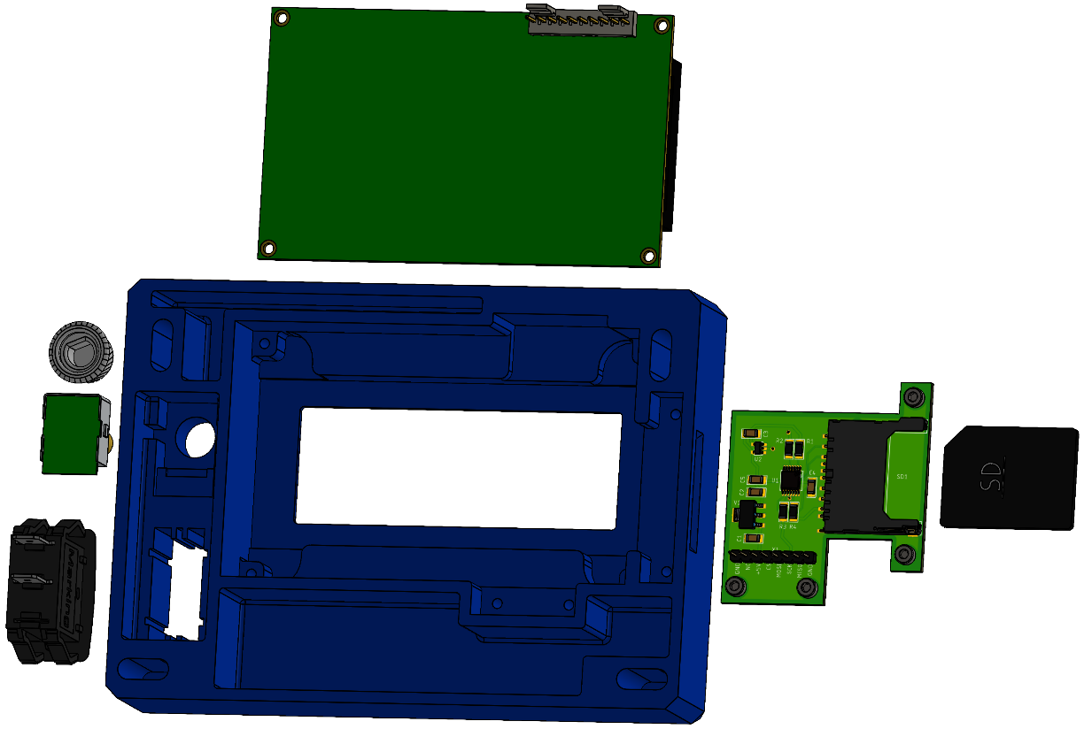

## 3.2 Electronics

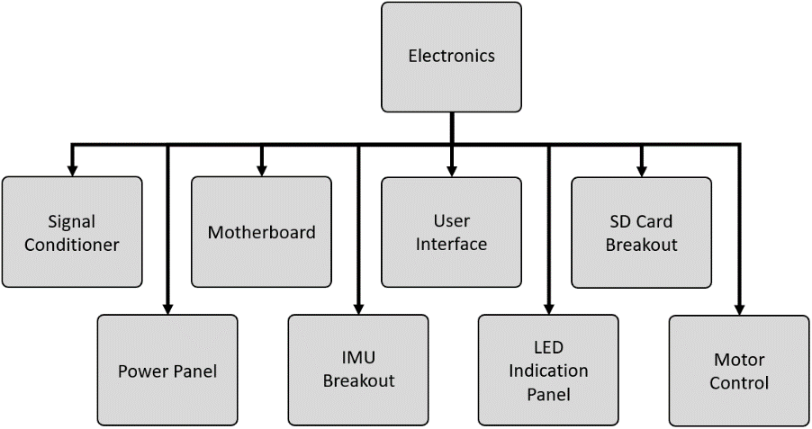

As described in the Structures and Mechanisms section, there is an abundance of signals that need to be sensed or driven. To improve modularity, reduce risk of catastrophic failures, and improve serviceability, electric functions are separated into groups and divided into individual circuit boards. This has the following benefits:

1. Failure of a board is isolated to that board alone. Rather than needing to replace or repair the entire electronic network, the damage or fault is confined to a single board that can be removed, repaired, or replaced.
2. Size and complexity of boards is reduced. Having too many electric functions present on a board can lead to messy, confusing circuits. Also, more functions requires more board space, which can lead to massive PCBs that can’t be conveniently mounted. This premise refers to reduction of both number of function *types* as well as number of function *instances*. An example of reduction of function types is performing all level shifting and signal prep for an SD Card Reader on an SD Card Reader breakout board rather than on the motherboard. An example of reduction of function instances is dedicating a unique Strain Gauge Signal Conditioner board for each force measurement rather than squeezing all 12 Strain Gauge Signal Conditioner circuits together onto a single shared board.
3. Peripheral tasks can be performed at the site of the task or at a location more convenient than the location of the motherboard. For instance, it is more convenient and intuitive to insert an SD card into the front panel of the User Interface than to insert an SD card into the motherboard directly.

Following this logic, all the electronic operations are grouped into the following collection of PCBs:

1. Strain Gauge Signal Conditioner
   1. This board type converts input from strain gauges into a digital signal that is sent back to the Motherboard. Several layers of signal conditioning, calibration, component configuration, and communication are performed by the circuit elements on-board these PCBs.
2. Motherboard
   1. This board manages an intricate network of digital signals that service every component and subcircuit involved in the system. This is the brain of all executed operations.
3. Power Panel
   1. This is the distribution point for the analog power supply that services all the Strain Gauge Signal Conditioner Boards. Each Signal Conditioner board can be toggled on and off with a paddle switch.
4. IMU Breakout
   1. This is a breakout for an accelerometer + gyroscope + magnetometer that mounts to the transducer hub. This senses ambient vibrations in the frame of the treadmill. This is also used to determine the orientation of running plane of the treadmill.
5. User Interface
   1. The User Interface isn’t a PCB, but a collection of discrete components mounted to a plastic housing. This is adjacent to a PCB, so it is categorized as one for this thesis for simplicity.
6. Motor Control
   1. This is the collection of components involved in powering and driving the brushless DC motor located in the belt driver of the treadmill.
7. SD Card Breakout
   1. This is a compact PCB that allows transfer of data between the controller and permanent flash storage.
8. LED Indication Panel
   1. This is a collection of LEDs that is used to quickly display information about the current state of the system. Useful for debugging issues encountered.

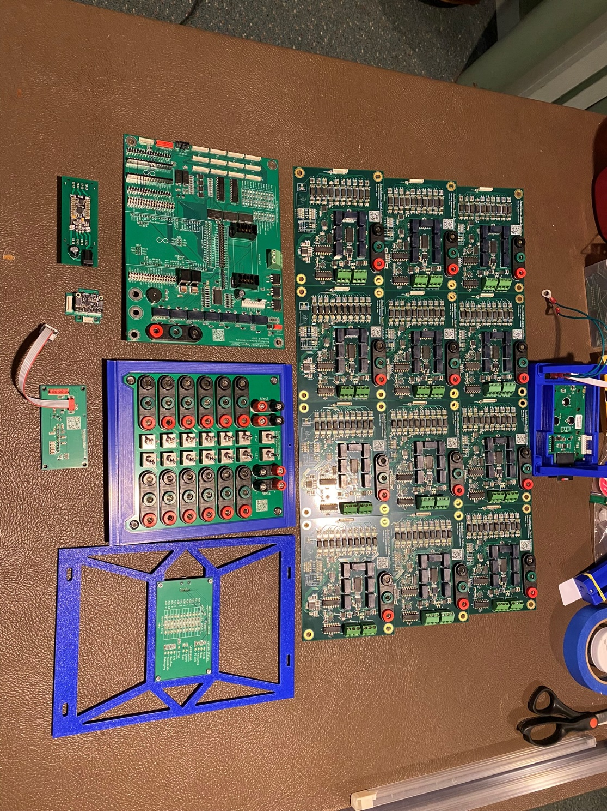

### 3.2.1 Strain Gage Signal Conditioner

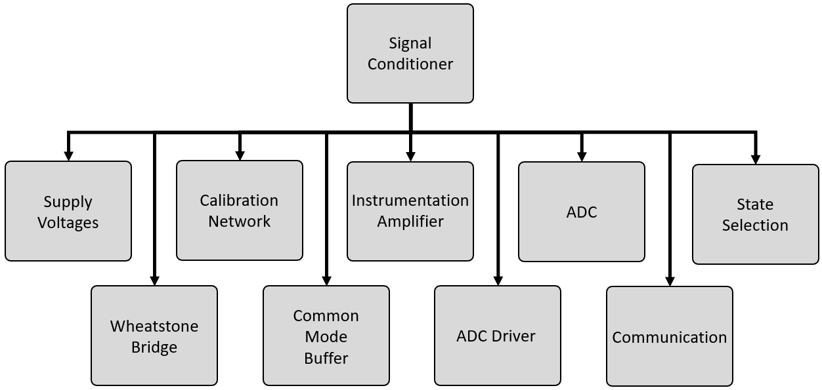

The Strain Gauge Signal Conditioner is the keystone of this thesis. As reported in Section 2.5.2, commercially available strain gauge sensing equipment that would’ve satisfied the requirements of this project would have cost a grand sum of approximately $120,000 USD. Unless I designed this specialized electronic hardware, this project would not have had the necessary funding to be completed. This very high investment is likely the barrier to entry that has prevented a tool like I have designed from being invented yet. At the end of the manufacturing process, the grand sum for all the custom PCBs, components, and tools needed to make all boards came out to just under $10,000 USD. This is just to emphasize how critical these electronics are to the feasibility of this project; a note to future researchers that may be interested in utilizing my work. A copy of the schematic is shown in <Figure ?>. All schematics and diagrams will be available in full resolution online, links are provided in <Appendix ?>.

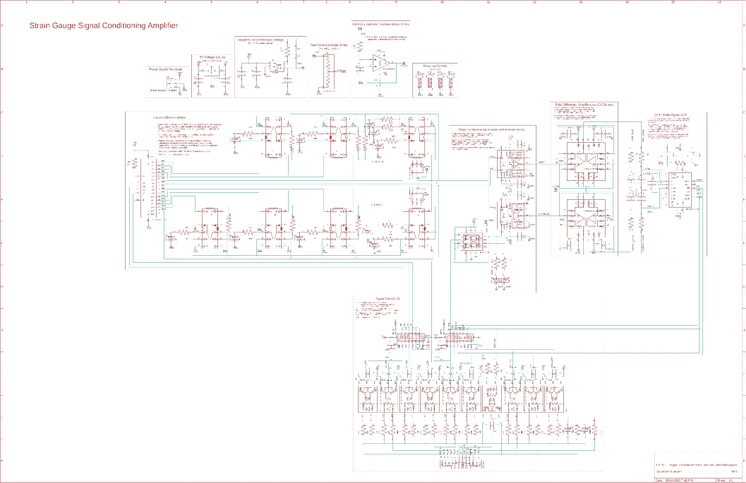

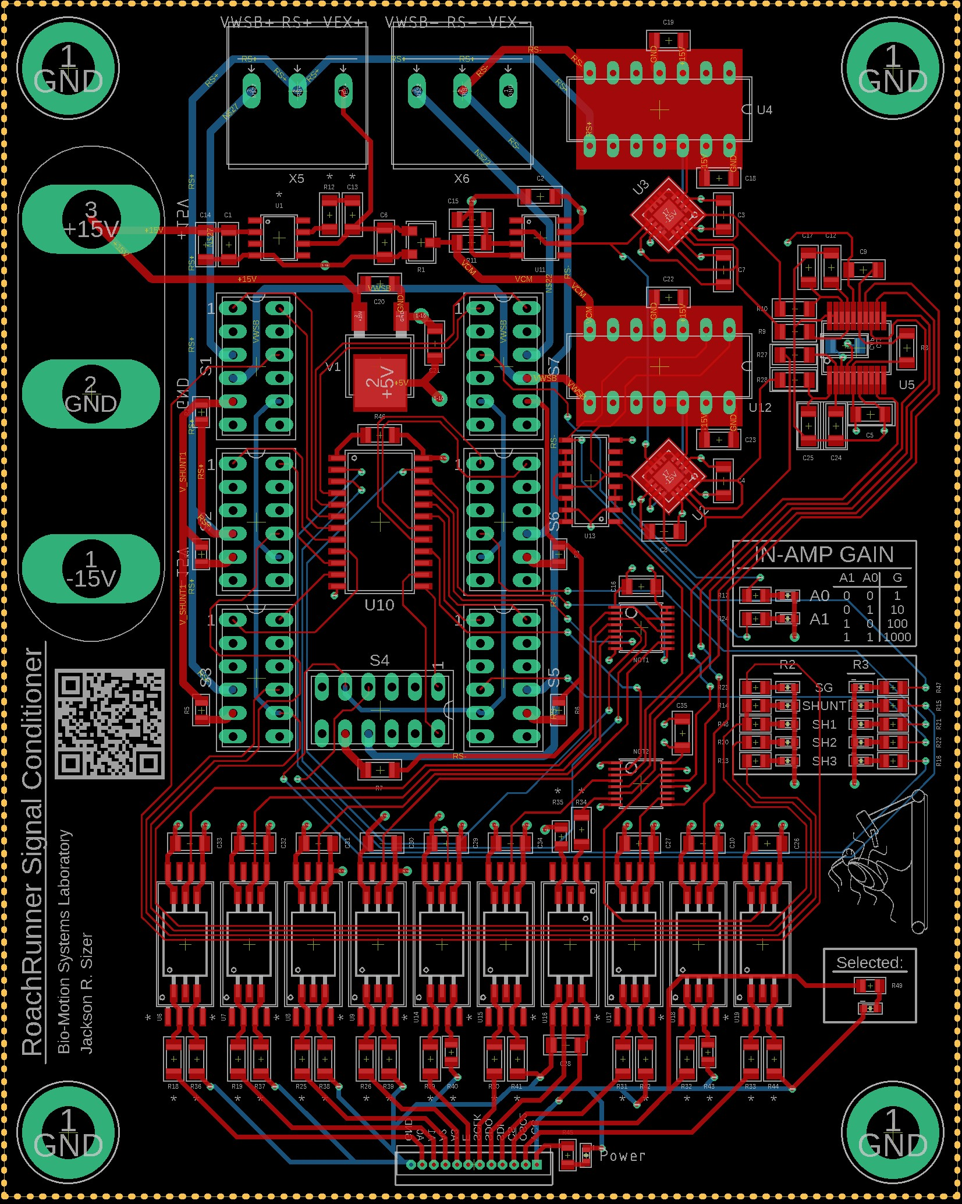

The Strain Gauge Signal Conditioner board’s main function is to extract a very small amplitude force signal from a very noisy source. To do this, several stages of signal conditioning are required to accurately and reliably isolate this signal. Aside from the actions performed directly on the input signal, several supporting circuits are needed to fully integrate and control the board. This includes generating reference signals for calibration, setting gains, maintaining communication lines, and a handful of other functions. To accomplish all tasks, this board is built from nine different subcircuits: 1) Supply Voltages; 2) Wheatstone Bridge; 3) Common Mode Buffer; 4) Calibration Network; 5) Instrumentation Amplifier; 6) ADC Driver; 7) ADC; 8) Communication; 9) State Selection. While not a subcircuit, the designed layer stack was another design element key to the proper functionality of this board.

**Supply Voltages**

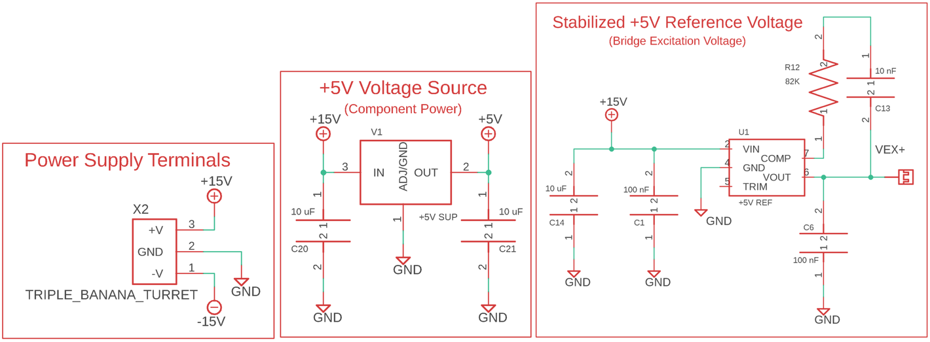

This board is supplied by a bipolar voltage source. +15V, GND, and -15V are input through banana cables to banana turrets. The +15V supplies a high current output +5V LDO source used to power logic chips and the ADC. This source doesn’t need to be very accurately regulated as it is just a supply for digital components. The +15V also supplies an ultra-stabilized +3V reference voltage that is used as the excitation voltage for the Wheatstone Bridge. All three supply voltages (+15V, GND, and -15V) are used to supply the Instrumentation Amplifiers and the Fully Differential Amplifiers.

**Wheatstone Bridge**

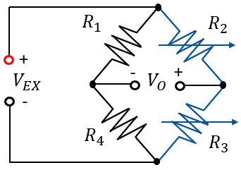

The strain gauges in this application are arranged in a half-bridge configuration where R2 and R3 are the strain gauges. During beam bending, one strain gauge is loaded in tension, the other in compression. This is done both to cancel out thermal strain while also doubling the strain sensitivity. The location of R2 and R3 on a beam for the sensed axis varies across each beam. Each pair of strain gauges for each axis of each beam is wired such that when a force is applied in the positive direction of the sensed axis of the reference coordinate frame, a positive voltage will be produced by this relation:

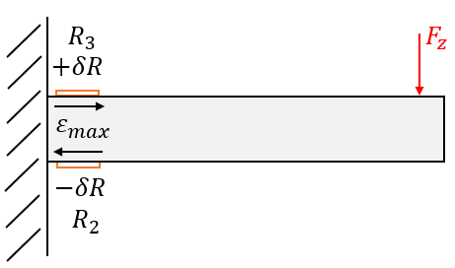

$$\frac{V_{O}}{V_{EX}}=\frac{1}{2}Sε_{max}=\frac{3SF_{z}(x_{f}-x_{s})}{Ebh^{2}}$$

Note that the strain gauges are both located on the same side of the bridge. Usually, one strain gauge is placed on one leg and the other strain gauge is placed on the other leg such that the compressed strain gauge pulls it’s junction voltage up or down by the exact opposite amount as the strain gauge in tension. This is usually done so that sensitivity is doubled, but both sides of the bridge are still balanced about the common mode voltage $V_{CM}$ of the bridge. This intentionally avoided in this application, however. The reason most cases keep the legs balanced is so that $V_{O}$ acts as a differential pair reflected about a constant common mode and can be accurately read directly by a differential ADC. Our application avoids doing this because the magnitude of the signal generated by the force exerted by the limbs of the specimen is so small that it must be amplified prior to sampling. So rather than keeping $V_{O}$ reflected about $V_{CM}$, $V_{CM}$ is generated as a reference voltage by splitting $V_{EX}$ perfectly in half with a balanced resistor pair. This balanced resistor pair acts as R1 and R4 of the Wheatstone Bridge.

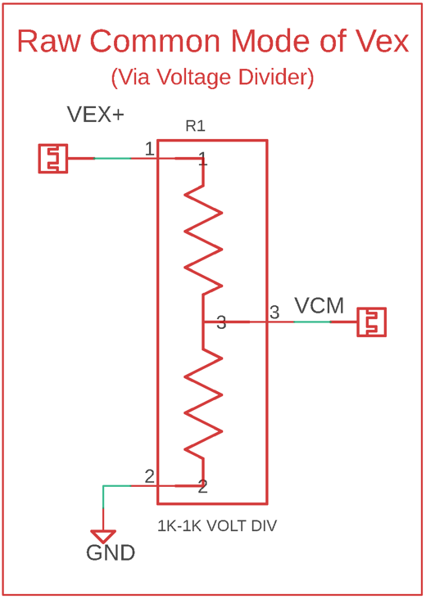

In this context, $V_{CM}$ acts as $V_{O}^{-}$, or:

$$V_{O}^{-}=V_{CM}$$

How $V_{CM}$ is utilized will be discussed in later sections. The strain gauges are wired to screw terminal blocks that tie into a calibration network. The calibration network is a network of relays and resistors that can be configured to generate either real force data or simulated calibration data. This will also be discussed in greater depth in a later section.

**Common Mode Buffer**

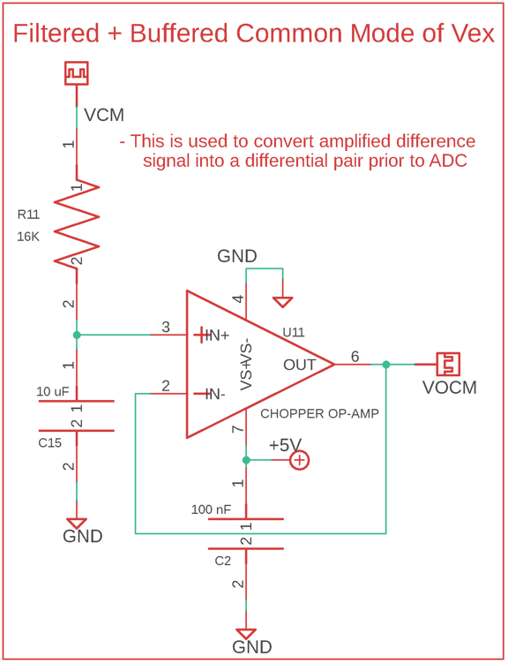

Since $V_{CM}$, the common mode voltage of the bridge excitation voltage, is generated via a voltage divider, it has low output impedance, meaning that devices connected downstream can bias this voltage up or down, which would defeat the purpose of using it as a reference voltage. In order to preserve the integrity of this reference voltage, it is buffered by a chopper stabilized operational amplifier configured in unity gain. The feedback networks used by chopper stabilized op-amps actively “chop off” the error from the output signal. This type of op-amp is the best choice for outputting an exact clone of the input signal that is not affected by load attached to the output signal. This stabilized copy of $V_{CM}$, named as $V_{OCM}$, is fed into one of the Fully Differential Amplifiers.

**Calibration Network**

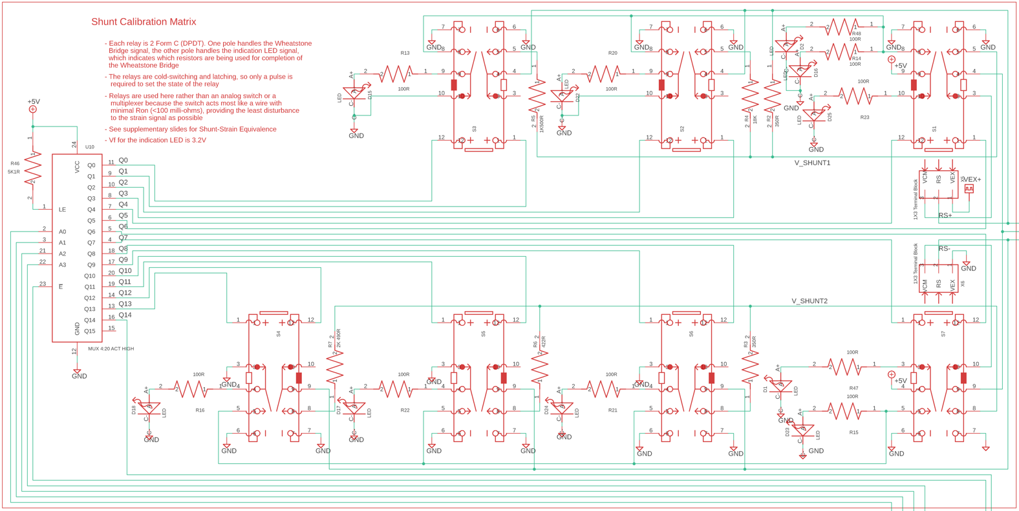

As mentioned in the Wheatstone Bridge section, R2 and R3 are selected by a calibration network. The calibration network is a network of relays and resistors that can be used to measure either real strain signals or simulated strain signals. At the center of the right side of the above diagram, a pair of terminal blocks represents both strain gauges in a pair. Directly above and below those terminal blocks are a pair of relays. Switching the upper relay toggles R3 between Real and Simulation. Switching the lower relay toggles R2 between Real and Simulation. The two relays to the left of the R3 Simulation relay toggle on or off precision resistors that correspond to resistances that correspond to specific strain values. The relays to the left of the R2 Simulation relay are also used to create resistances that correspond to known strain values.

Note that R2 and R3 require a different number of relays. This is because when simulating strain, R2 must decrease and R3 must increase. When the Simulation relays are set to Simulation, a precision 350Ω resistor is switched in for that resistor. When both R2 and R3 are set to Simulation with no strain resistors active, they are both set to that nominal 350Ω resistance, which results in $V_{O}=0V$. R3 can easily be increased by adding additional precision resistors in series to the base resistor. R2, however can’t have resistance removed as easily. Switching between precision resistors is an inaccurate method of lowering R2 because of additional sources of resistance or error, like contact resistance or tolerance stacks. Instead, it is much more accurate to put the base resistor for R2 in parallel with another resistor that brings the equivalent resistance down to the desired value. This method works well to absorb error and can approximate a desired resistance very closely.

These relays are switched between states via a 4:16 multiplexer. The channel designator bits A0, A1, A2, and A3 and the Enable bit are transmitted from the Motherboard. When enabled, the multiplexer sends a pulse to the output channel specified by the designator bits. The relays are latching, cold-switching, small-signal relays with gold-plated contacts. When driven to a position by a mux signal, the pole remains in the driven position until driven to another position. This way, the relays don’t need to be held in an active state; they will remain engaged until commanded to disengage. Note that the right side of each relay switches resistor states, and the left side switches LED states. These LEDs indicate the status of the resistor they correspond to. The gold-plated contacts have contact resistance in the order of micro-ohms, so they do not affect the strain signals. This allows the whole calibration network to acts as close to a perfect wire as possible.

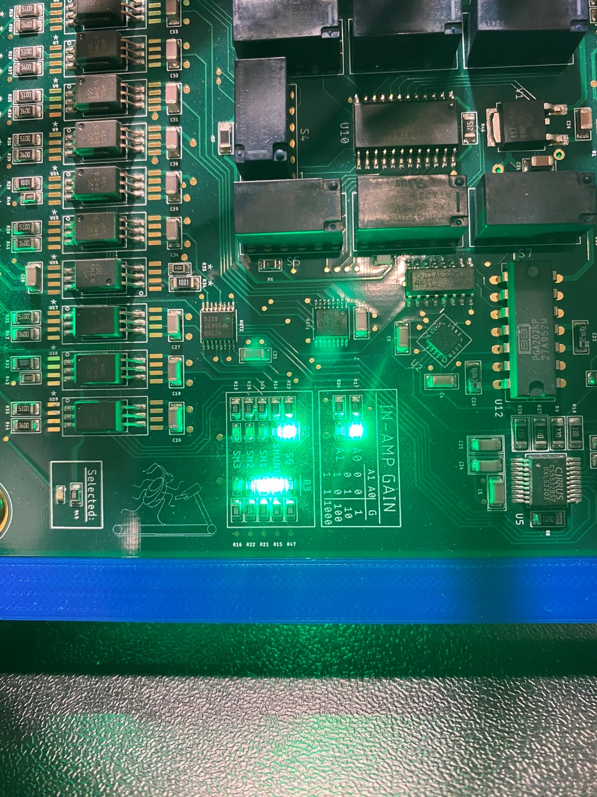

**Instrumentation Amplifier**

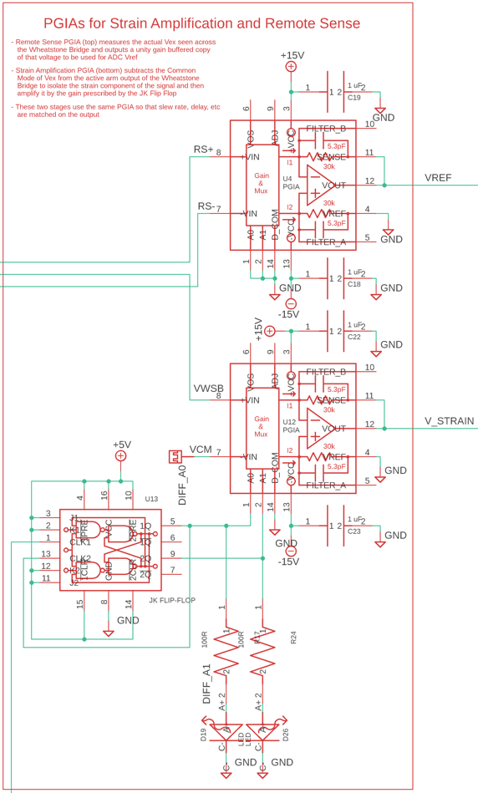

Downstream from the Wheatstone Bridge is a pair of Programmable Gain Instrumentation Amplifiers. These PGIAs act as difference amplifiers where the output is defined as:

$$V_{PGIA}=G_{PGIA}(V_{in}^{+}-V_{in}^{-})$$

where $G_{PGIA}$ is the selected gain. The gain for this PGIA is set by two bits A0 and A1. The possible gains that can be selected are 1, 10, 100, and 1000. The PGIA shown at the top of the above diagram measures the bridge excitation voltage as seen at the strain gauges. The strain gauges are 3-lead where two leads connect to the same side of the strain gauge. One lead connects to the excitation voltage, and the other is used for remote sense to measure the actual bridge voltage at the end of the strain gauge leads. This remote sense voltage is fed into one of the high input impedance PGIAs to generate a buffered copy as a reference voltage. Both gain setting bits of this PGIA are tied to ground so that the gain is held at 1 to keep $V_{RS}$ sensed at unity gain. This copy of $V_{RS}$ will later be used by the ADC as a reference voltage to perform ratiometric voltage readings.

The second PGIA isolates and amplifies the strain component of the bridge output voltage. Prior to this stage, the voltage at the junction of R2 and R3 strain gauges is the strain voltage riding on top of the common mode of the bridge excitation voltage. In other words, this junction voltage can be represented by:

$$V_{O}^{+}=V_{CM}+V_{ε}$$

So, this implies that the strain voltage can be isolated by subtracting the raw common mode voltage from the junction voltage between R2 and R3:

$$V_{ε}=V_{O}^{+}-V_{CM}$$

Note that the raw common mode is subtracted here, not the filtered and buffered copy. This is to ensure that all noise is equal in phase and magnitude when performing the subtraction. The PGIAs have extremely high input impedance, so this action does not distort $V_{CM}$. This isolated $V_{ε}$ is simultaneously amplified by the gain specified by this PGIAs gain bits. These gain bits are set by a JK Flip-Flop, which is configured as a 2-bit ripple counter. Every time a pulse is sent to this JK Flip-Flop, the bit combination ticks up a bit. The sequence of outputs is 00, 01, 10, 11, 00, etc. These correspond to PGIA gains of 1, 10, 100, and 1000. The pulse to increment upwards a bit is sent from the 15th channel of the multiplexer that is also used to drive the calibration network relays.

Looking back at the generic form for voltage output for a Wheatstone Bridge:

$$V_{O}=V_{O}^{+}-V_{O}^{-}=\left(V_{CM}+V_{ε}\right)-V_{CM}$$

Which reduces down to:



$$V_{O}=V_{ε}$$

Isolating $V_{ε}$ this way makes a tremendous contribution to the overall signal integrity. Any noise riding on the bridge excitation voltage, such as common mode line noise, gaussian noise, thermal noise from the voltage regulator heating up, swings in the 15V supply lines from other devices, and more, will be present in sync and at the same scale at both $V_{O}$ junctions of the Wheatstone Bridge. Subtracting the common mode out from $V_{O}^{+}$ removes all of these types of noise and bias, leaving only the strain component behind. This behavior is depicted by a simulated version of this circuit that drove this design decision. To generate the following figure, a simulated voltage source with a collection of noise types superimposed is used as the excitation voltage for an identical configuration Wheatstone bridge that feeds into a similar style PGIA. A strain signal is fed to a pair of simulated strain gauges that make up R2 and R3. In this figure, the orange curve corresponds to $V_{O}^{-}$, which is the raw common mode reference voltage $V_{CM}$. The blue curve corresponds to $V_{O}^{+}$, which is the sum of $V_{ε}$ and $V_{CM}$. The plot on the left shows a black curve for $V_{ε}$ behind the blue curve; this is just to show how the strain signal is concealed by noise and to emphasize the point that measuring $V_{O}^{+}$ directly would obfuscate much of the actual data. Realistically, $V_{ε}$ would be reflected about 0V. When $V_{CM}$ is subtracted from $V_{O}^{+}$, a perfect copy of $V_{ε}$ reflected about 0V is left behind. The black curve on the right shows the result of the difference amplification performed by the PGIA. Returning to the generic equation of the PGIA, the equation for the strain gauge PGIA is first defined by its inputs as:

$$V_{GIAε}=G_{PGIA}(V_{O}^{+}-V_{O}^{-})$$

Substituting for $V_{O}^{+}$ and $V_{O}^{-}$:

$$V_{GIAε}=G_{PGIA}V_{O}$$

Replacing $V_{O}$:

$$V_{GIAε}=G_{PGIA}V_{ε}$$

Returning to generic form for a half-bridge Wheatstone Bridge:

$$\frac{V_{ε}}{V_{EX}}=\frac{1}{2}Sε_{max}=\frac{3SF_{i}(x_{f}-x_{s})}{Ebh^{2}}$$

**ADC Driver**

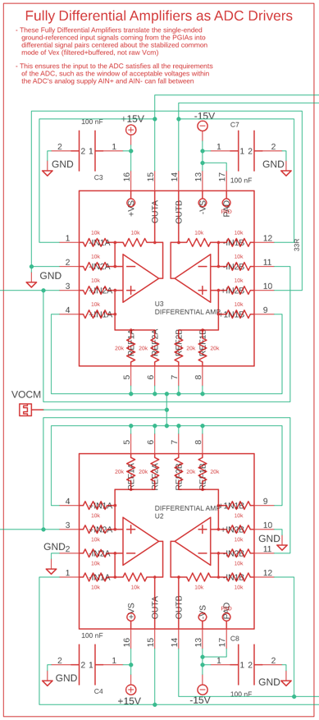

The ADC used in this circuit, which will be discussed in full detail in the next section, is capable of measuring bipolar signals that make up a differential pair where both ends of the pair are bounded within the ADC’s supply voltage and are reflected about a relatively constant common mode voltage. The ADC is supplied by +5V and GND, so both analog inputs $AIN^{+}$ and $AIN^{-}$, as well as both ends of the reference voltage $VREF^{+}$ and $VREF^{-}$, must be within the tolerated window within the supply range. After the PGIA stage, both the reference voltage and the amplified strain voltage are single-ended ground-referenced signals. Negative forces would push $V_{GIAε}$ negative, which would be out of the input range of the ADC. Even a positive force would be ground referenced, which would push $AIN^{-}$ below the allowable threshold.

To address this issue, both the amplified strain signal and the reference voltage are turned into differential pairs reflected about a shared common mode voltage via a pair of Fully Differential Amplifiers. The common mode voltage used as the centerline for this stage is the chopper-stabilized buffer copy of the low-pass filtered $V_{CM}$, $V_{OCM}$. These Fully Differential Amplifiers have very low input impedance, so they need to originate from a source with extremely high output impedance. The PGIAs used have massive output impedance, so their output can be connected to the Fully Differential Amplifiers without concern. $V_{CM}$, however, comes from a very low output impedance source (a simple voltage divider), which is why the chopper-stabilized buffer stage was needed. Since $V_{OCM}$ is only needed as a centerline for this stage, $V_{CM}$ was low-pass filtered prior to buffering to create a clean copy since a copy of the noise is not needed for this stage.

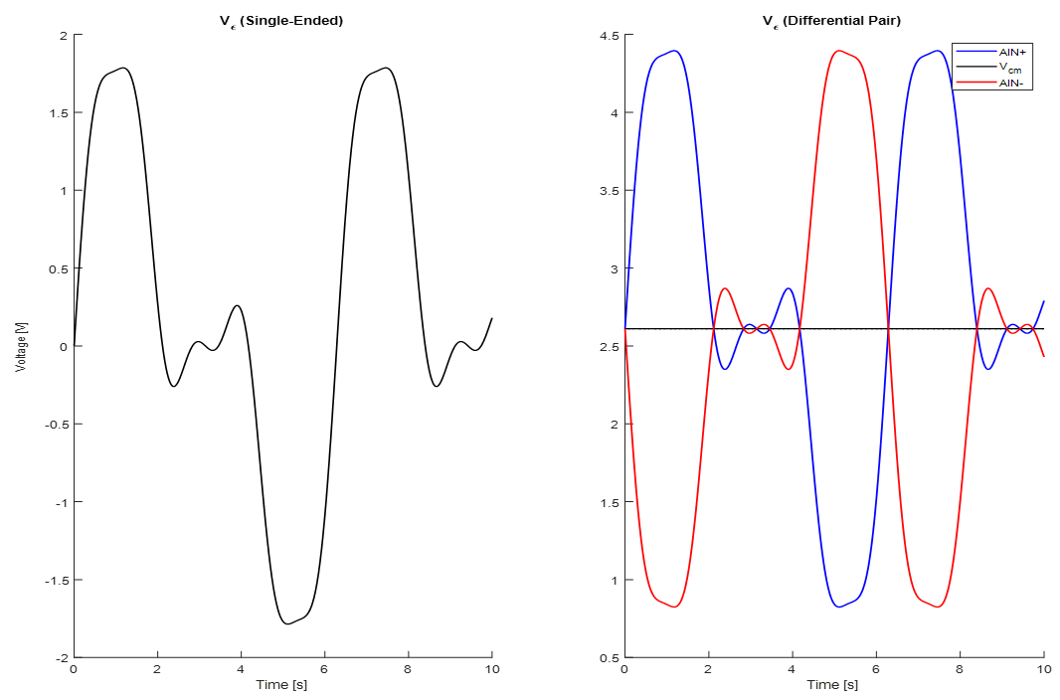

The principle of operation for the configuration of this Fully Differential Amplifier used in this circuit can be represented by the following equations:

$$V_{O}^{+}=\frac{1}{2}\left(V_{A}^{+}-V_{A}^{-}\right)+V_{C}$$

$$V_{O}^{-}=\frac{1}{2}\left(V_{A}^{-}-V_{A}^{+}\right)+V_{C}$$

Where:

$$V_{O}^{+}=AIN^{+}$$

$$V_{O}^{-}=AIN^{-}$$

$$V_{A}^{+}=V_{GIAε}$$

$$V_{A}^{-}=GND$$

$$V_{C}=V_{OCM}$$

Substituting:

$$AIN^{+}=\left(V_{GIAε}-GND\right)+V_{OCM}$$

$$AIN^{-}=\left(GND-V_{GIAε}\right)+V_{OCM}$$

Condensing:

$$AIN=AIN^{+}-AIN^{-}$$

$$AIN=V_{GIAε}$$

Summarizing, this operates by adding the single-ended ground-referenced version of the amplified strain signal to a common-mode offset voltage. Next, the single-ended ground-referenced amplified strain signal is copied with reversed polarity, then added to the same common-mode offset voltage. This creates a pair of identical copies of the amplified strain signal that are mirrored about a common centerline that ensures that both ends of the signal remain within the bounds of the ADC’s input range. The same process is applied to the remote sense copy of the bridge excitation voltage.

**ADC**

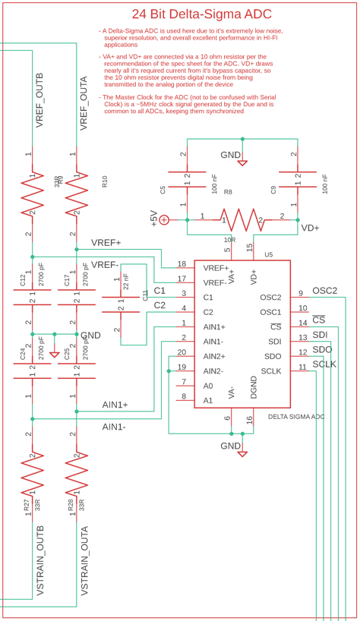

The ADC used for this board is a 24-Bit Delta-Sigma ADC. Delta-Sigma ADC’s are the superior ADC option when it comes to extremely low-noise, high-resolution, high-fidelity applications. Additionally, the ability to perform ratiometric measurements is massively valuable in this application. As shown in <Equation ?> the strain voltage is inherently proportional to the bridge excitation voltage. As such, when $V_{EX}$ fluctuates, $V_{ε}$ will fluctuate proportionately. This includes random noise as well as constant regulator error, such as bias or drift. Regardless of the amplitude of $V_{EX}$, the ratio of $\frac{V_{ε}}{V_{EX}}$ will always determined purely by load applied to the sensed beam. This is advantageous over comparing the strain signal to a constant voltage (for instance, a perfect 5V source) because variations in $V_{EX}$ will be mistakenly observed as an artificial load due to a lack of this scaling factor.

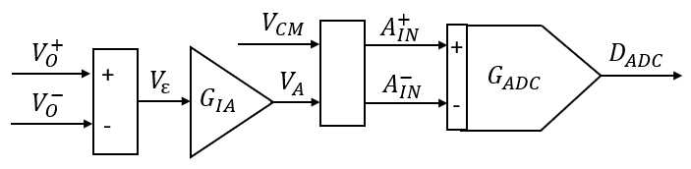

The full transfer function from Wheatstone Bridge to the converted digital output is depicted by <Figure ?>. The ADC has two additional amplification stages that occur between the Fully Differential Amplifier and the actual conversion from an analog signal to a digital signal. The first stage is a true amplification stage performed directly on the input via an internal PGIA that can be set to a gain of 1, 2, 4, 8, 16, 32, or 64. The second stage is a digital gain, which functions by inputting a known maximum ratiometric voltage to the ADC as the upper bound voltage that corresponds to a fully utilized 24-bit reading consisting entirely of ones. Another ratiometric voltage is supplied as the zero-point for calibrating out offset by designating that voltage as a 24-bit reading consisting entirely of zeros. The voltage range spanned by these two points is then divided by the 24-bits to generate the voltage bin-width of the LSB. To this effect, that gain-offset calibration virtually yields a digital amplification that scales the established input voltage span to occupy the full available resolution of the ADC. Note that effectively, the ratios of voltages are being stored as calibration points, not the intermediate voltages themselves. This allows the ratiometric aspect to be maintained as the size of the LSB also scales proportionally with $V_{EX}$. The equation relating the ratiometric strain voltage to the digital output of the ADC becomes:

$$\frac{V_{ε}}{V_{EX}}=\frac{K_{Bi}}{2^{N}G_{PGIA}G_{ADC}AR_{G}}D_{ADC}$$

Relating this back to the mechanical derivation of this ratiometric voltage:

$$\frac{3SF_{i}(x_{f}-x_{s})}{Ebh^{2}}=\frac{K_{Bi}}{2^{N}G_{PGIA}G_{ADC}AR_{G}}D_{ADC}$$

So fully rearranging to relate force directly to the digital output of the ADC, the conversion equation from a 24-bit digital reading to a force value becomes:

$$F_{i}=\frac{K_{Bi}Ebh^{2}}{2^{N}3AG_{PGIA}G_{ADC}R_{G}S\left(x_{f}-x_{s}\right)}D_{ADC}$$

The ADC also has onboard registers for configuring general system settings, populating gain and offset registers, as well as creating sampling “Setups” that contain sampling attributes like sampling rate, PGIA gain, polarity, calibration register pointers, and more. The possible sampling rates are 7.5, 15, 30, 60, 120, 240, 480, 960, 1920, and 3840 Sps. All of these registers are read from or written to via an SPI based serial port. The SPI lines are transmitted to and from the motherboard. This ADC requires 2 clock signals to operate: a SCLK for SPI communication, and a Master Clock (MCLK) for driving conversions. The MCLK must be 4.9152 MHz, supplied externally. This clock is generated by converting a 16-bit PWM channel of the Arduino (84 MHz base clock for Due, 400 MHz base clock for Giga) into a timer by using port-forwarding to overwrite the prescaler, auto reset counter, frequency divider, output compare, and alternate function registers of a GPIOH channel onboard the Arduino’s CPU to create a 50% duty clock of exactly 4.9152 MHz from the selected PWM pin. Once the ADC has finished generating an output measurement word, it will store it in a readable conversion register and raise a flag on SDO. Circuitry on the motherboard will detect this flag has been risen and then read the stored conversion word from the conversion register. All data exchanged passes through the communication portal located immediately adjacent to the cable header for the cable coming from the motherboard.

**Communication**

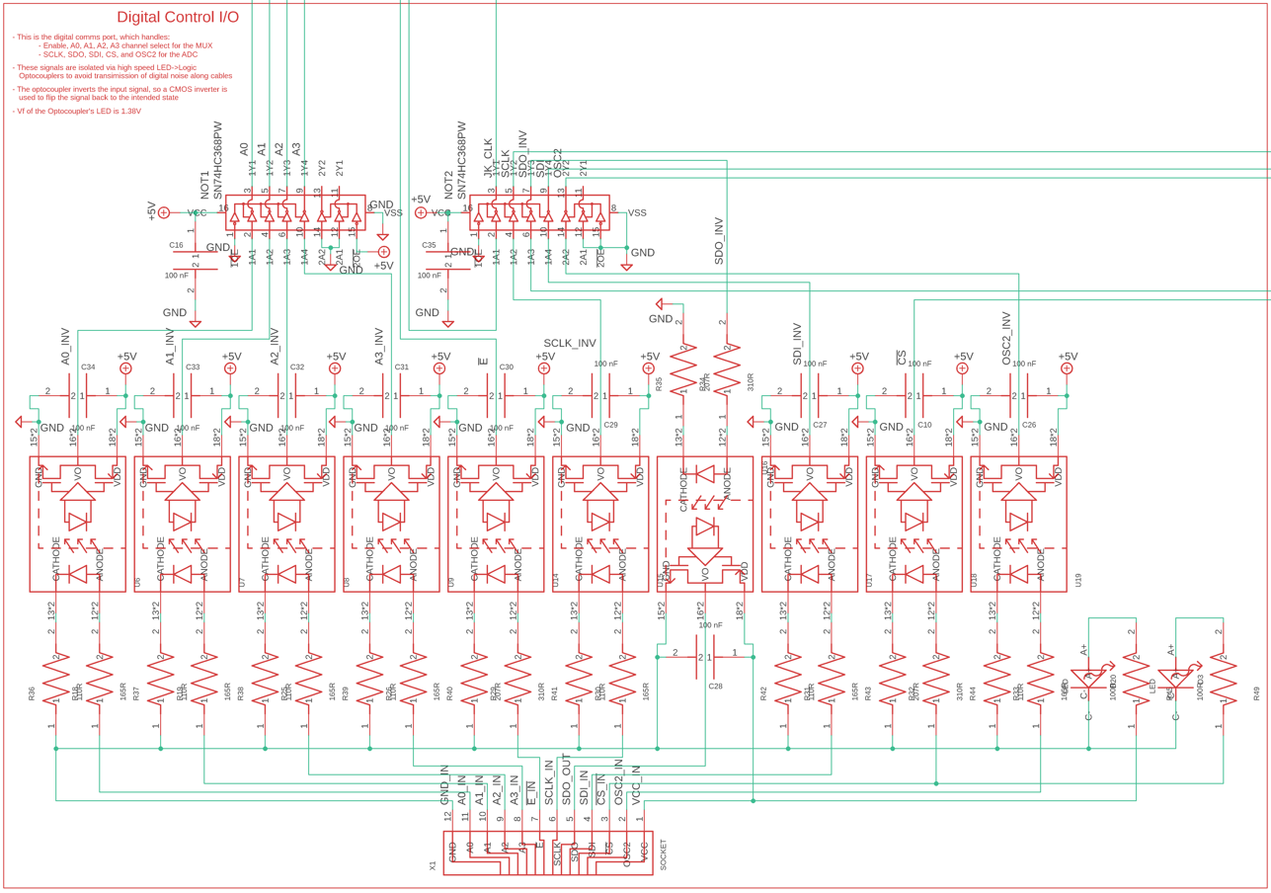

Since this board is a very high-fidelity application where unwanted noise could completely corrupt the observed signals, noise has been cut at the source wherever possible. One large source of noise is chatter from digital lines at the ends of cables. Capacitive shielding, paired with this digital chatter, tends to add a fair amount of noise to the ground plane of the receiving peripheral board. Another source of noise and failures is ground-fault loops, which occurs when there is more than one path back to earth-ground from a local ground. This can cause there to be small potential deltas along the ground loop that cause current to flow from other components through the peripheral component to earth-ground. This current flow creates small potential deltas between components on the same board and can completely destroy the integrity of small, sensitive signals. In some cases, the current flow generated by ground-fault loops can cause ESD to onboard components and kill the board. Both of these concerns are avoided by isolating the Signal Conditioner’s voltage planes from the Motherboards via Optocouplers. These are non-contact signal transmitters that act as bridges between circuits by turning transmitted signals into light, then turning the light back into a received signal on the other side via a phototransistor.

CMOS open-source open drain optocouplers were used for this application. The phototransistors are paired to pull-up resistors, so they output active LOW, inactive HIGH. This means the optocouplers invert the signals sent through them. To compensate for this, the inverted signals are then fed through push-pull NOT logic gates. These perform a second inversion, which inverts the inverted signal back to the original polarity. These are push-pull, so they do not require pull-up resistors.

**Layer Stack**

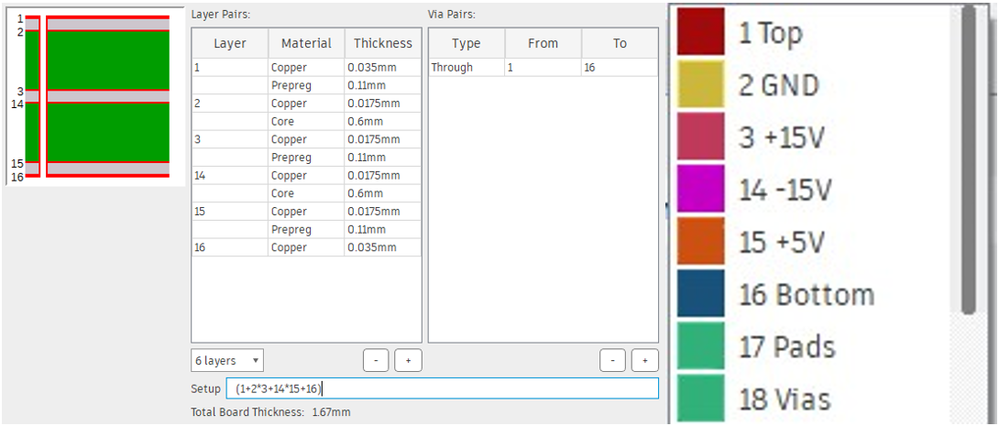

The Strain Gauge Signal Conditioner board was designed as a 6-layer board. The Top and Bottom layers were reserved for traces, pins, and pads. Layer 2 was designated as a GND plane. All components that accessed the GND plane tied to it using through-hole vias that passed through the full width of the board, acting as a local current drain to a global current drain. Using a GND plane like this prevents return currents from components further away from the GND source from flowing through GND pins of devices closer to the GND source. Instead, all components dump into a GND service without compromising downstream components. Additionally, currents flowing through narrow traces can act as an antenna and generate EMF that disrupt measurements. This is also avoided by using a GND plane that spans a full layer of a board. Since the vias pass through the entire board, that also means they pass through all layers. This does not mean, however, that the vias are tied to each layer. Instead, only the layer the via goes to connects, all other layers avoid the via using a mask. For example, observe how the GND vias in <Figure ?> overlap the yellow GND plane and all other vias have a separating barrier between the via and the GND plane. The other three layers were designated as +15V supply plane, -15V supply plane, and +5V plane. All these planes operate functionally the same as the GND plane.

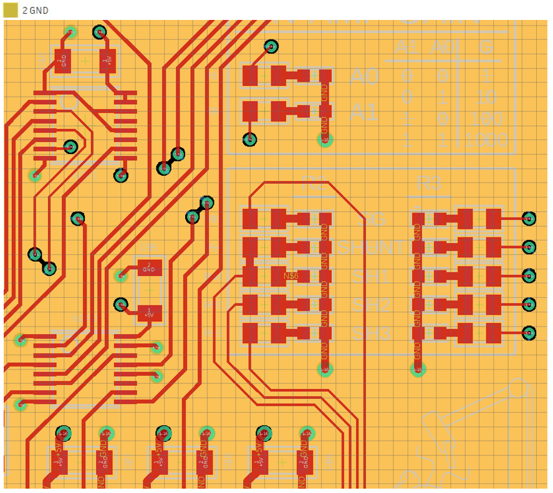

### 3.2.2 Power Panel

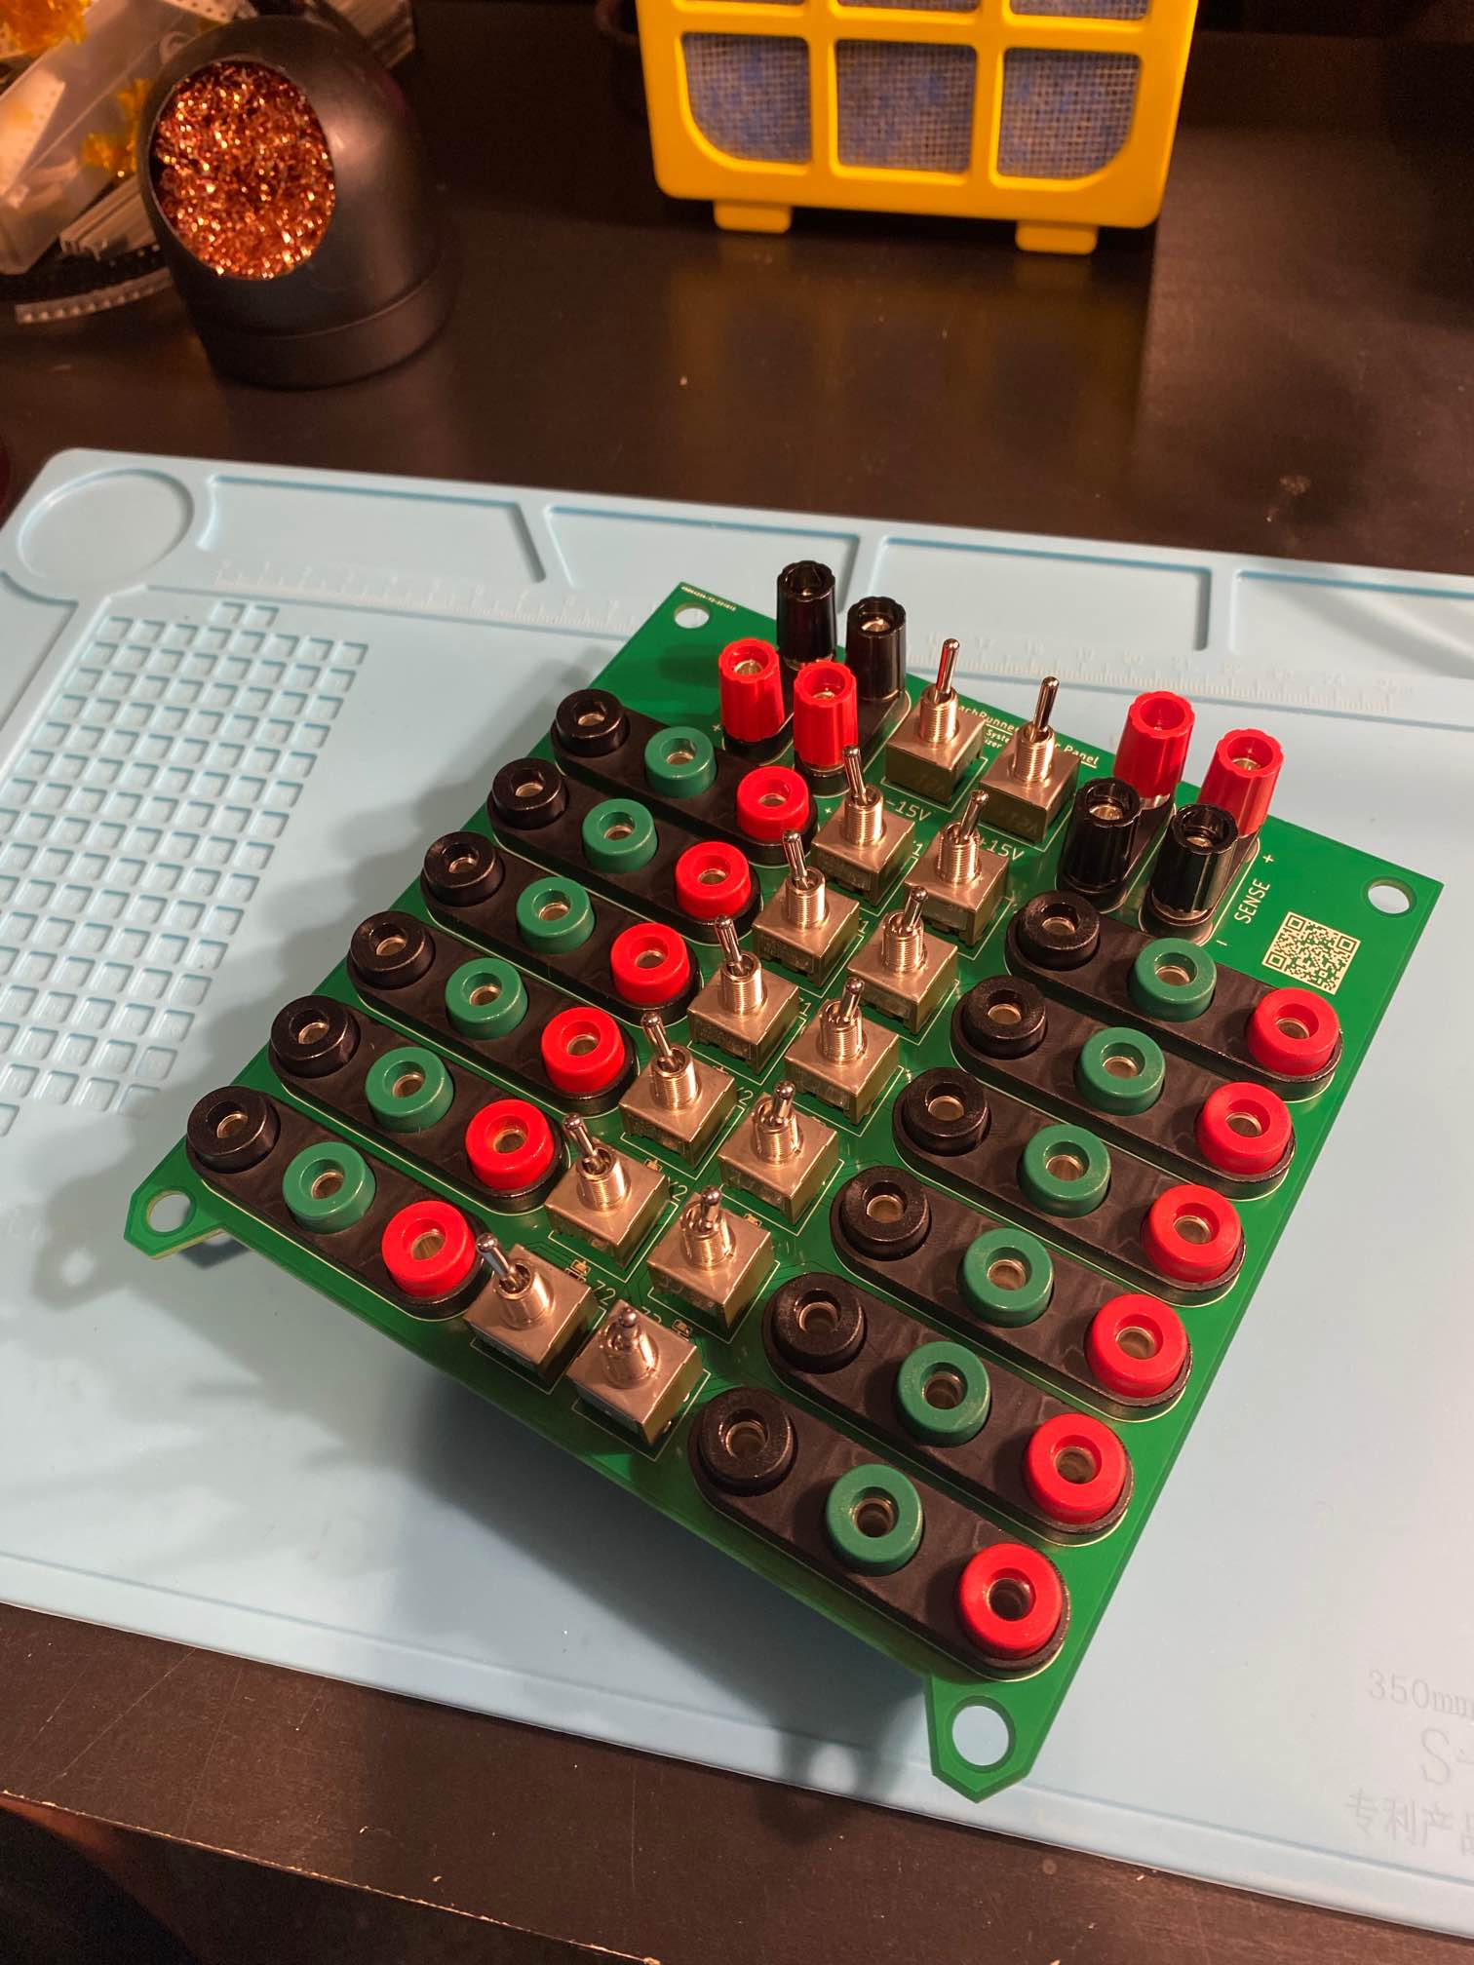

Each Strain Gauge Signal Conditioner board is supplied +15, GND, and -15V. Without any power supply management, the boards would need to be Daisy-Chained in order to deliver power lines to each board from the benchtop power supplies. This is a dangerous configuration because all current draw would need to flow through the first board to service the next eleven, then all the next eleven would need to flow through the second board to service the next ten, and so on. This creates a “voltage-tower” that has both the downside of unbalanced current load through each board, as well as a “Jenga Effect” of one board failing causing a cascading failure of all other boards downstream.



To avoid these concerns, the Power Distribution Panel acts as a single access point for all boards. This allows each board to independently be toggled on and off, whether to isolate a failure or to test boards individually.

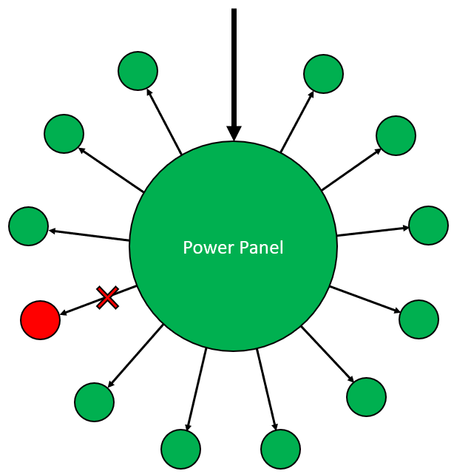

The Power Panel receives power input from a pair of SPD1168X Programmable Benchtop DC Regulators. These regulators act as high-precision sources and are equipped with Remote Sense capability to ensure that the voltage output remains constant regardless of load. This board also ensures that all three supply lines toggle on to service a board simultaneously rather than one by one. Since both regulators are turned on independently via buttons, human operation can’t ensure that both become active at the same time. Instead, with all Signal Conditioners disconnected from power (switched off), each supply can be turned on then switched on into the network. Once both supplies are powered on and switched in, each SPDT toggle switch can be switched to power each Signal Conditioner. Each switch is labeled for which board it supplies and has an on-board LED to indicate the power status of the board.

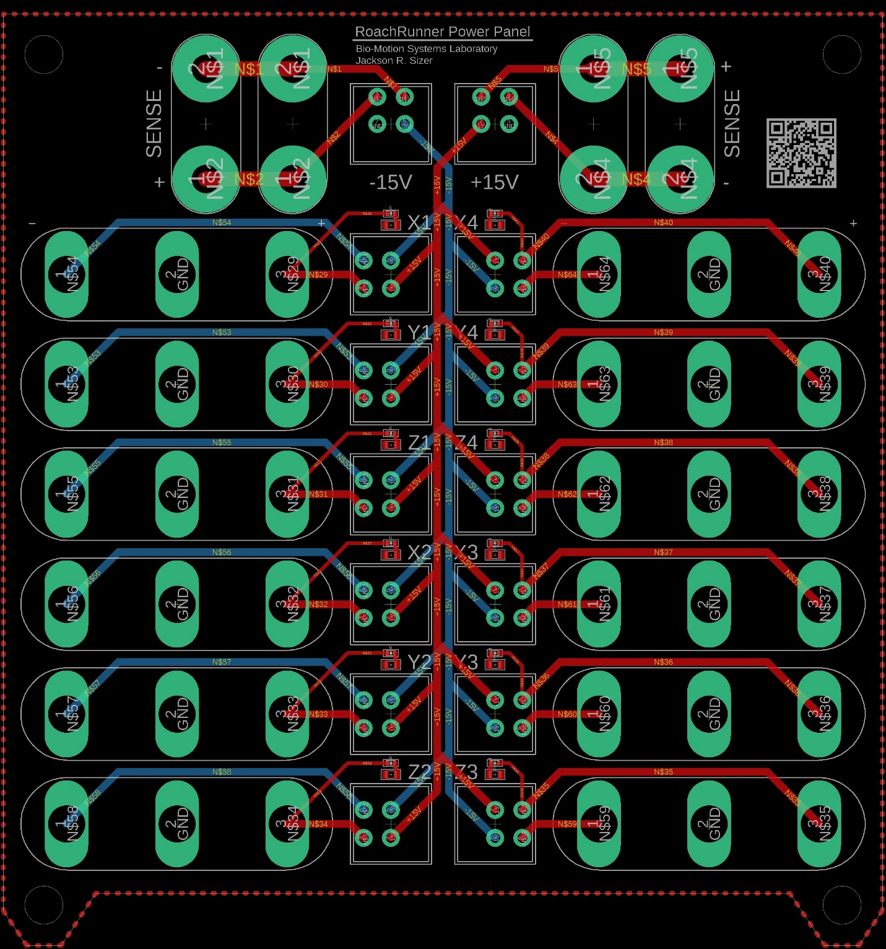

### 3.2.3 Motherboard

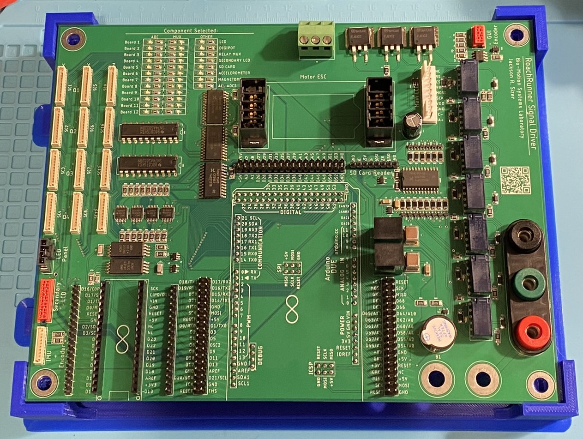

The Motherboard is the brain of the whole system. Every board, actuator, and sensor connects to and is driven by this board. At its core, a set of male header pins on the bottom side matching up with the form factor of an Arduino Due allow an Arduino Due to be plugged directly into the Motherboard like a shield. This Arduino Due (or Arduino Giga, which is selected controller for future release) acts as the central processor for all signal management and system maintenance. The peripheral components that are controlled by this board are the 12 Signal Conditioners, User Interface Encoder, User Interface LCD, BLDC Motor Driver, SD Card Breakout, IMU Breakout, Secondary LCD, and LED Indicator Panel.

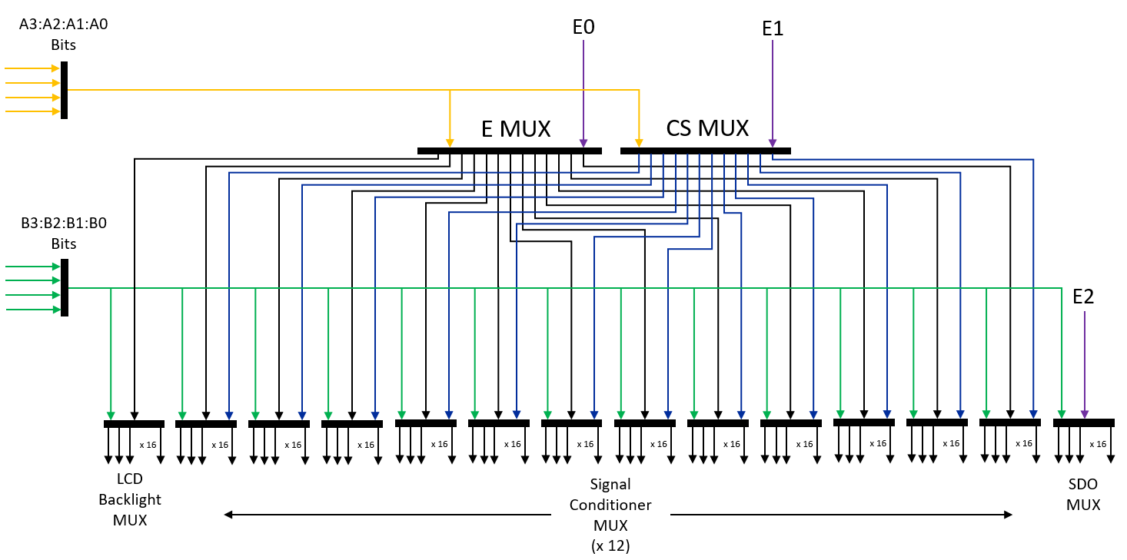

Despite the large number of digital pins offered by the Arduino Due (56), the number of signals demanded by all the components and peripherals greatly outnumbers the 56 connections the Due provides. Below is a breakdown of the core signals involved in the system:

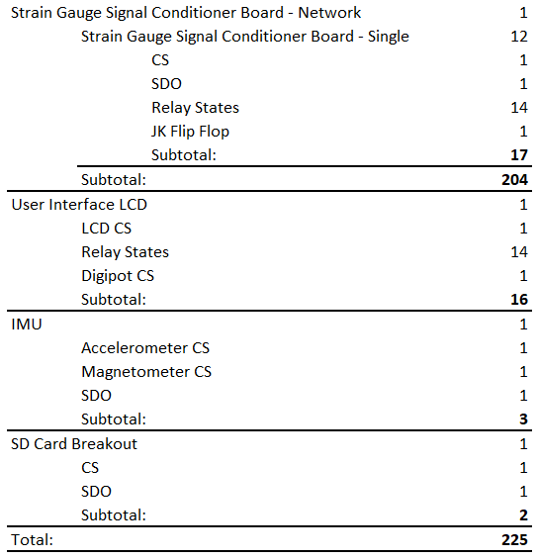

Note, this is not a list of all signals in the system, just all the ones used either for declaring a communication signal path or for toggling a component from one latched state to another. There are hundreds of other signals present in the remaining circuitry, but these two classes are isolated because they can be condensed to greatly reduce the number of driving signals. As shown in <Table ?>, there are 225 of these signals. This signal count is simplified using cascading multiplexers, as depicted in <Figure ?>. At the top level, a 4:16 multiplexer receives four signals [A0, A1, A2, A3] that encode 1 of the 16 output pins. Once the output pin of the multiplexer is declared, an enable signal is sent to that multiplexer, raising the selected output pin ACTIVE. A second set of encoded channel declaration signals [B0, B1, B2, B3] are sent to all 4:16 multiplexers on a second tier. The multiplexers on this second tier receive their enable signal from one of the outputs of the first-tier multiplexer. These second-tier multiplexers include the state-switching multiplexer on each signal conditioner board, a state-switching multiplexer for a relay network on the motherboard that sets the brightness of the LCD’s backlight, and a multiplexer that drives a group of tri-state level shifting buffers to switch which peripheral’s SDO line feeds into the Due’s MISO. A second first-tier multiplexer is used similarly to the other first-tier multiplexer, but rather than sending enable signals to cascaded multiplexers, it sends CS signals to devices connected to the SPI network. Using this method of cascading multiplexers, only 11 signals [A0, A1, A2, A3, B0, B1, B2, B3, E0, E1, E2] are needed to generate and control 320 signals. Each first-tier signal (E and CS signals) is tied to an LED on the motherboard to display the current ongoing action. This has been very useful for debugging.

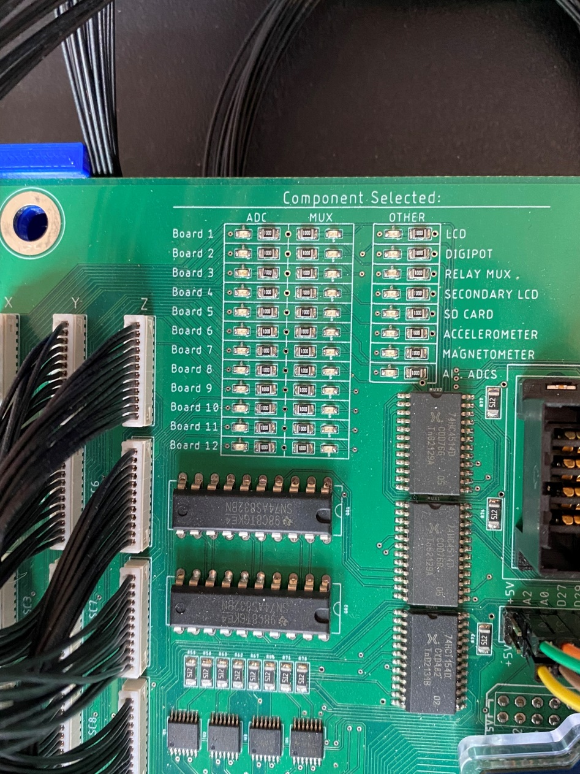

Like the Signal Conditioner board, the motherboard is a multi-layered board. This board, however, is only a 4-layer board, whereas the Signal Conditioner boards are 6-layer. Also, like the Signal Conditioner boards, the Top and Bottom layers are reserved for traces, pins, and pads. The two additional layers are a +5V plane and a GND plane. Including MISO, MOSI, and SCLK planes would have massively reduced the complexity of the trace design, but cost increases by orders of magnitude with added layers, so this was not done. The layer stack is shown below in <Figure ?>. Once again, “elevator-style” through-hole vias were used to connect layers.

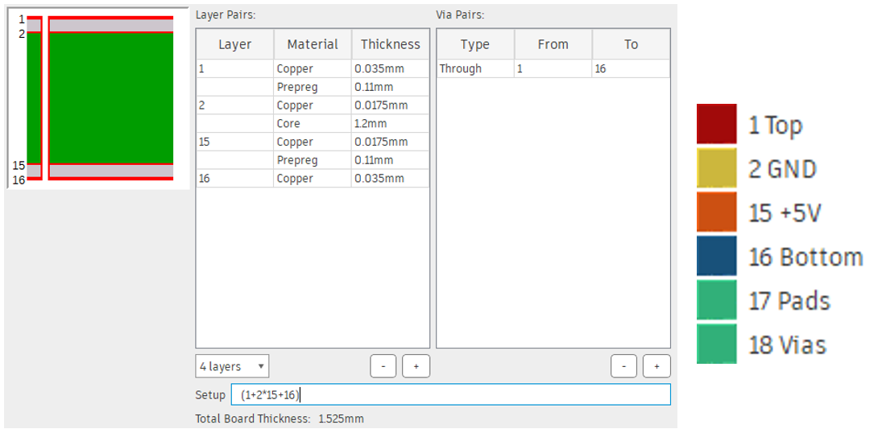

Board space was dedicated on the motherboard to host a breakout for an ESC used to drive a DC motor previously selected for the belt driver. However, the belt driver had been redesigned to the version discussed in Section 3.1.1. As a result, the sockets used to host the ESC breakout are no longer in use.

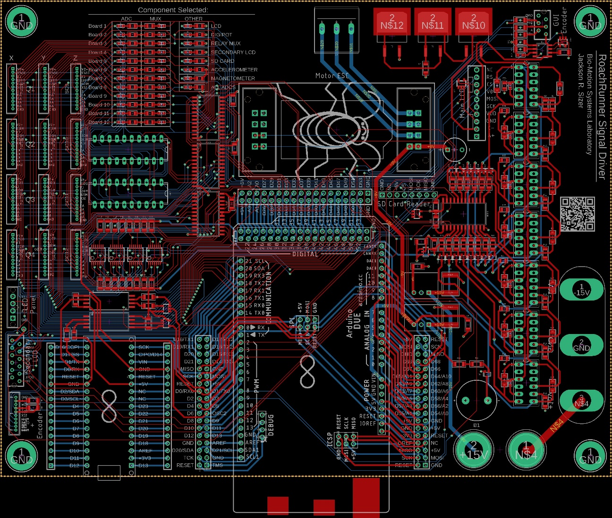

### 3.2.4 User Interface

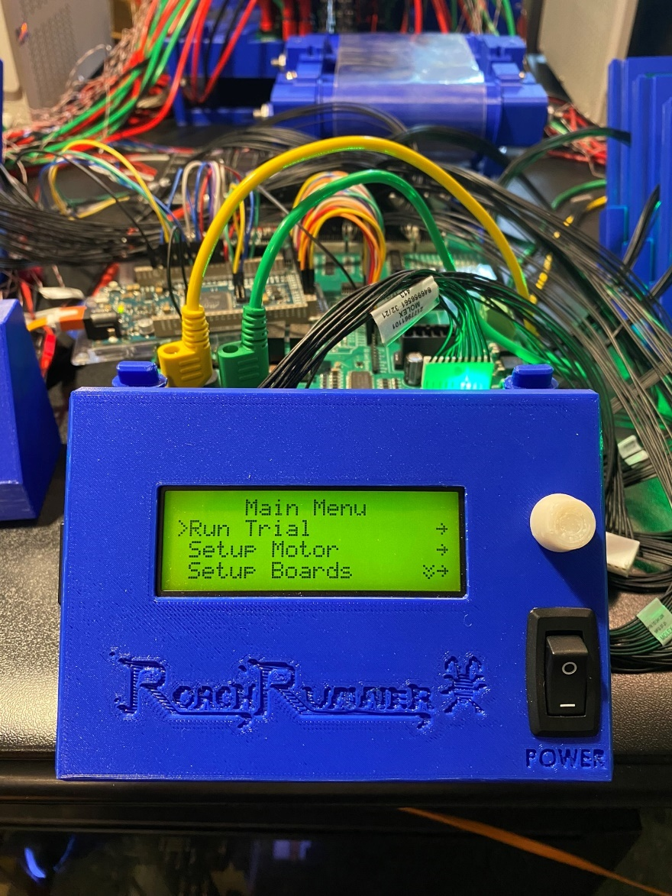

The User Interface, as described in earlier sections, is not its own standalone board, but a collection of electronic parts that together act as a cohesive unit. This interface includes a rotary optical encoder with a built-in button and quadrature. A knob fits over the shaft to turn and click the encoder. This allows the user to scroll through and click menu options to modify and operate each module. The power switch on the front panel switches on and off the power supply to the motherboard, which services all digital circuitry. The motherboard also hosts a piezo-buzzer, which beeps to provide auditory feedback to the user when they click the knob. However, this buzzer was disabled because it was annoying. The brightness of the LCD’s backlight is controlled by adding resistors in series by switching a network of relays. These resistors tie into a circuit of high current transistors to linearly scale the current output from the transistors without the current needing to pass through these gain setting resistors. The contrast of the characters is set using a digital potentiometer, which sets the voltage of the crystal polarizer in the LCD. The User Interface also hosts the SD Card Breakout, which is a small board with an SD Card slot and a level shifter that ties the SD Card to the SPI network.

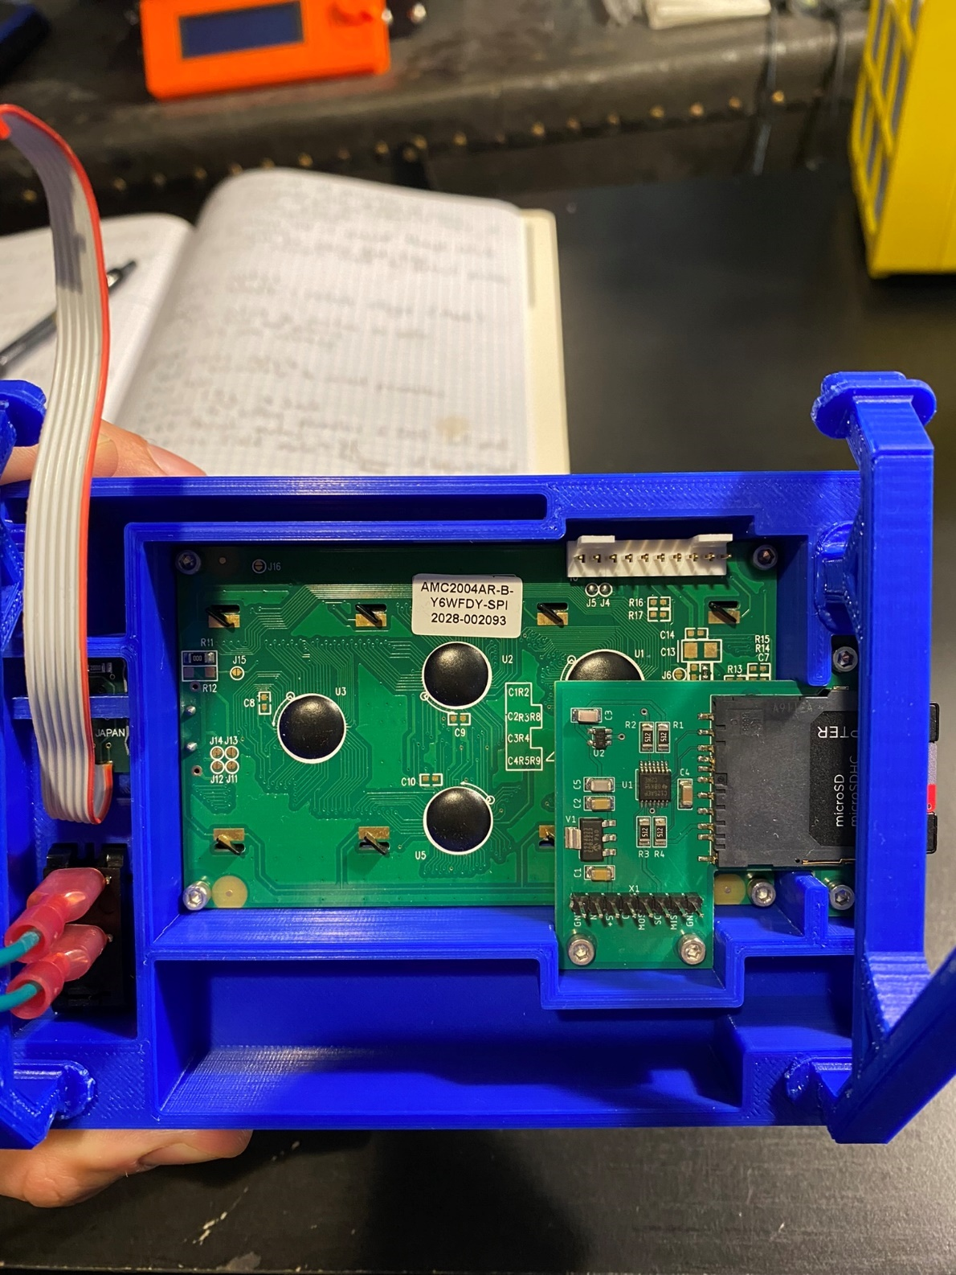

### 3.2.5 Motor Control

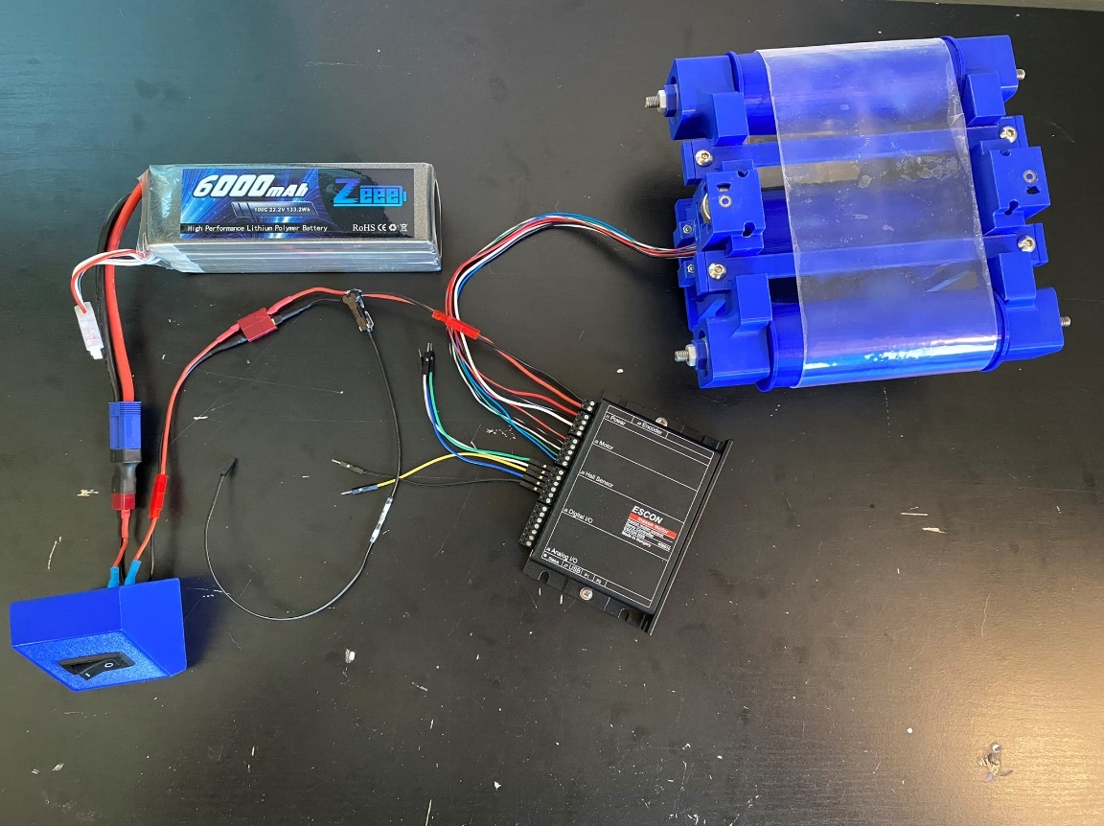

The motor used in the drivetrain of the treadmill is a 3-phase 4-pole brushless DC motor equipped with Hall sensors. It is controlled with a custom BLDC motor driver made specifically for the motor’s product family by Maxon, the same company that made the motor and gearhead. This motor requires 24V, which is supplied by a 6000 mAh 100C 22.2V Lithium-ion battery. Custom cable-header assemblies were made by hand to interface all the components together without making the assembly a permanent fixture. A housing for a power switch was made such that the battery could be disconnected from the motor instantly if needed, without requiring a full system-stop. This also prevents the battery from being passively drained when not in use.

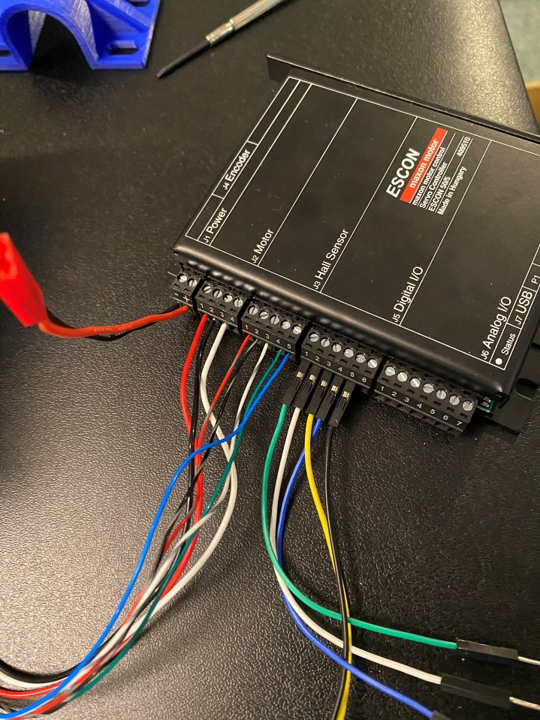

The wiring assignments to the motor driver are as follows, from left to right:

1. Black: Motor Supply GND
2. Red: Motor Supply +24V
3. Red: Motor Phase #1
4. Black: Motor Phase #2
5. White: Motor Phase #3
6. Red + Grey: Hall Sensor #1
7. Black + Grey: Hall Sensor #2
8. White + Grey: Hall Sensor #3
9. Green: Hall Sensor Supply
10. Blue: AGND
11. Green: PWM (Speed Setpoint)
12. White: Enable
13. Yellow: Direction
14. Blue: Speed Sense
15. Black: DGND

## 3.3 Software

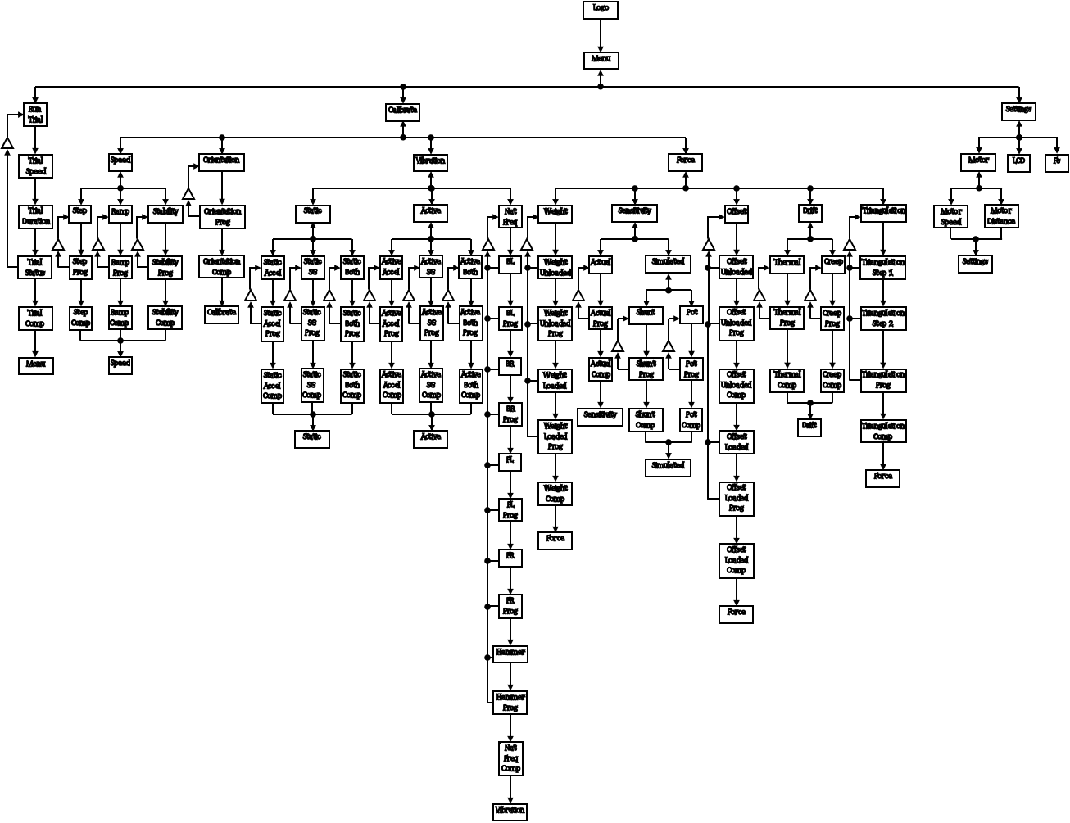

The software produced to control all the aforementioned electric and mechanical systems is a combination of embedded software and application software. The embedded software is the C++ based code written directly to the microprocessor integrated into all of the circuitry. This code supplies all the component drivers used to interact with all the circuit elements throughout the network of electronics. The embedded software also contains a central Finite State Machine that acts as an OS that navigates between procedure functions and makes calls to each of the electronic component libraries to sense or actuate selected elements. A loose model of this FSM is shown in <Figure ?>. The application software is the PC based collection of Python and Matlab based programs used to run Data Acquisition sessions.

### 3.3.1 Embedded Software

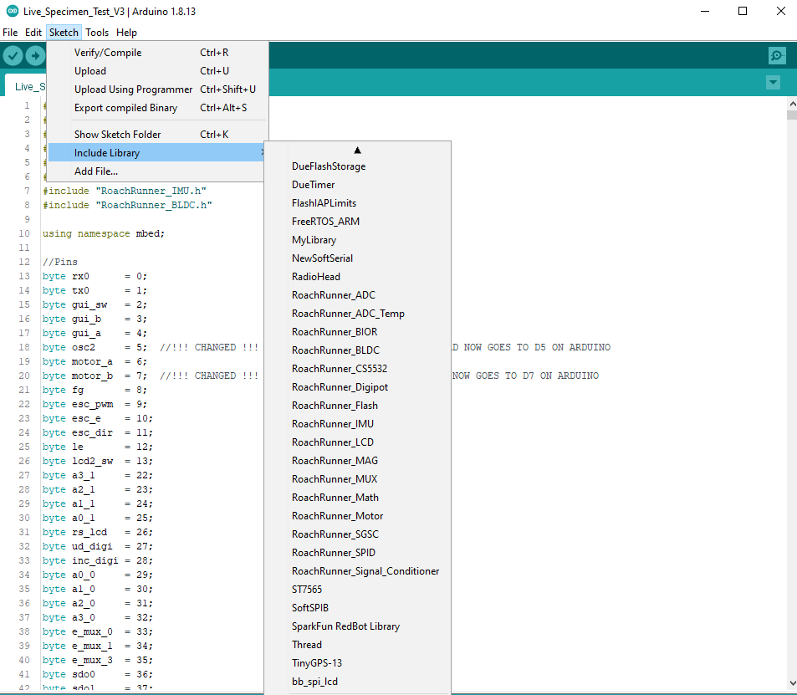

Since an Arduino is used as the central controller for all the electronics, all the C++ scripts were written in the Arduino flavor of C++, using the Arduino IDE for the compiler. This was the decided platform and compiler for two reasons: 1) Arduino’s IDE directly supports each board, guaranteeing the compiler will work for the board’s CPU; 2) Arduino is a user-friendly version of C++, which makes it easier for end-users to modify and run tailored versions of my code. The driver for each component is written as a separate library that can be installed to Arduino’s library directory, as shown in <Figure ?>. In the current release, over 19,000 lines of C++ were written to perform all the required operations quickly, correctly, and reliably. This point is made to reinforce the value of dividing all the required code into sub-libraries separated into a collection of files.

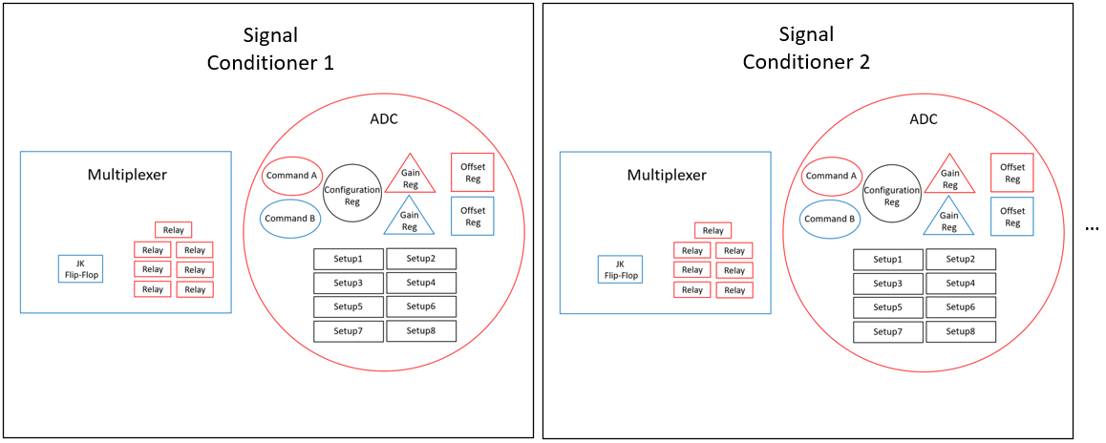

The embedded software is written following the Object-Oriented Programming paradigm, where boards, chips, registers, and more are represented as nested objects. For instance, consider a Signal Conditioner board, which contains two active chips that can be driven from the motherboard: a multiplexer and an ADC. The multiplexer can drive a JK Flip Flop to four different states and can drive seven relays to two different states. The ADC has an internal library of various numbers of instances of 6 types of 32-bit registers, where each bit in each register corresponds to a different system configuration property setting. There are 12 Signal Conditioner boards, each with this same collection of components that store local variations of each state or setting. Rather than manually defining every bit and state of every one of these attributes, then writing specific sections of codes to address each specific value, this process is made much more systematic by representing all of this data as instantiable classes. Each of the 6 register types in the ADC is defined as a class with attributes representing each bit. The ADC is defined as a class containing as many instances of each register class as is actually present within the physical ADC register library. A multiplexer is defined as a class consisting of seven relay instances and one JK Flip-Flop instance. A Signal Conditioner board is defined as a class consisting of one multiplexer instance and one ADC instance. This Signal Conditioner board class is then instantiated 12 times, once for each physical board. Values can then be easily read through commands like “int Gain = sgsc3.adc.setup4.G”. This methodology is used for all boards, pins, components, and even virtual elements, like the PID controller designed for motor speed control.

### 3.3.2 Application Software

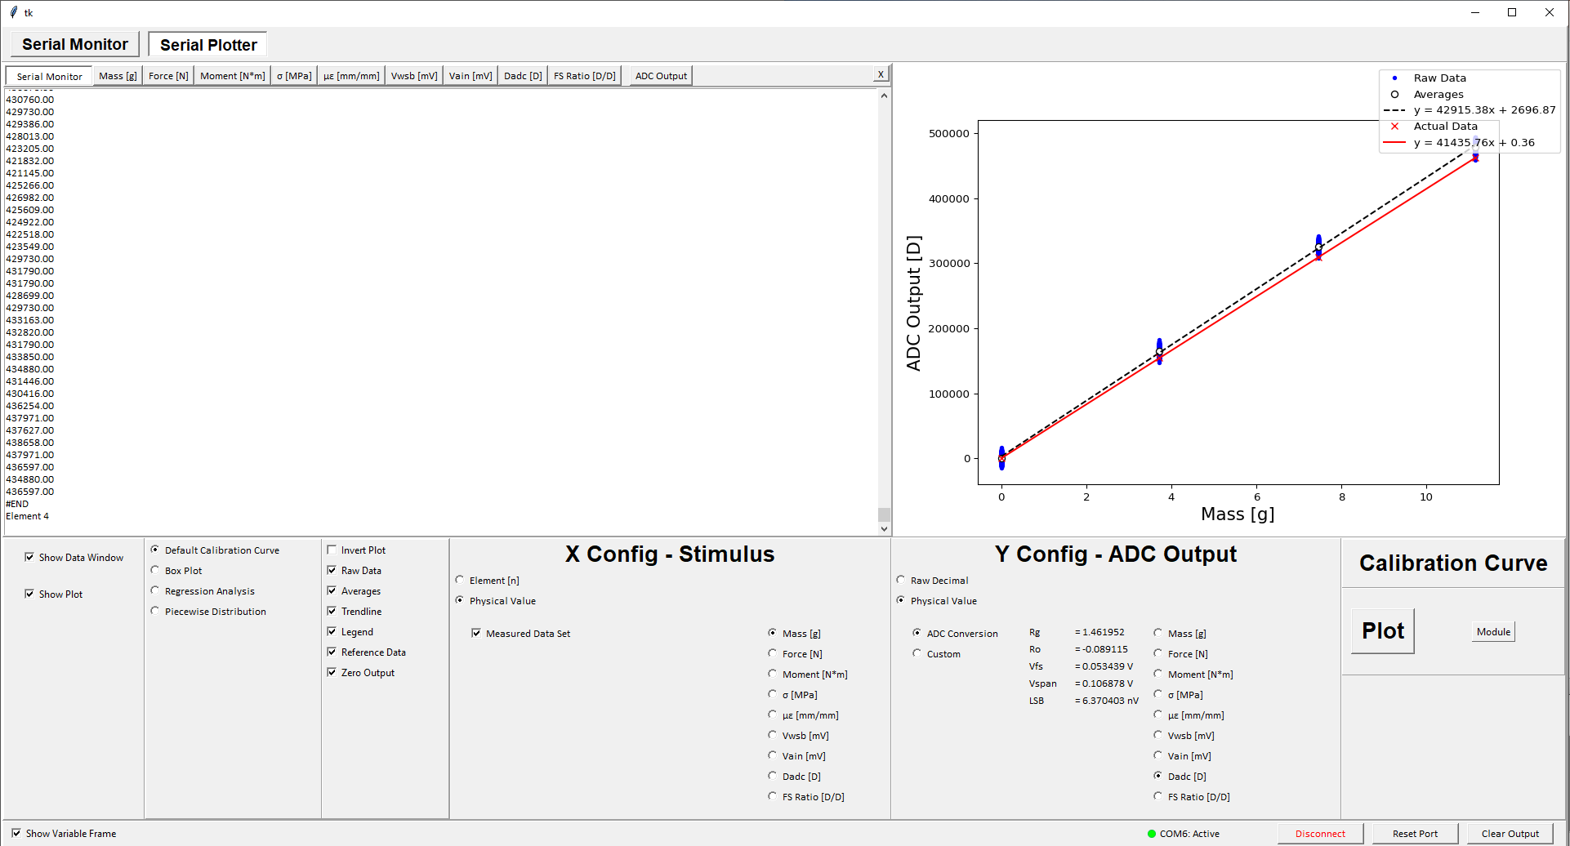

The application software is the front-end interface of all the software. If the embedded software is what makes the system operational such that data can be produced, the application software is what extracts and processes the data such that it can be used for analysis. Without the ability to store and analyze data, the whole RoachRunner machine is essentially a black-box closed-system. The interface shown in <Figure ?> is a sample look at the data acquisition GUI. In its most basic form, this interface is a Python based Serial Monitor for the input data stream sent from the Arduino board integrated into the circuitry. Additional features are built into this, such as the ability to run through calibration procedures, generate and view graphics reporting various types of performance metrics, view incoming measurements in a Live Plotter, and activate data logging sessions to log trial measurements to declared files for later analysis.

A driving factor for building this interface was to offload the Arduino’s CPU. The Arduino Due has 512 KB of available flash memory (which corresponds to 524288 bytes, not 512000 bytes). The desired sampling rate is the maximum provided by the ADC, which is 3840 Sps. During each poll, 12 ADCs (12 x 4 bytes), 3 Accelerometer axes (3 x 4 bytes), and 1 motor speed (4 bytes) are sampled. This adds up to a total of 64 bytes per sample. At 3840 Sps, this converts to 245760 bytes per second (240 kBps) of data generation. In 2.13 seconds, the entirety of the Arduino’s internal flash would be filled, ignoring the portion of flash already occupied by the embedded software flashed to the CPU. Obviously, 2.13 seconds of data would not be enough to provide an in-depth analysis of anything. Additionally, overflowing the flash would leave zero overhead for running background processes, which could trap the OS in a deadlock state. To solve all this, the measurement data stream is dumped to a PC, which is able to log the data to RAID storage and perform crude analyses in parallel to ongoing actions being run by the embedded system.

This point, however, is the bottleneck not yet overcome. Serial communication via USB is very slow. It is so slow, that when writing measurements to the Serial line directly at a rate of 240 kBps, there is major packet loss, and only roughly 35% of the data actually gets through. Of the data that does transmit, there’s commonly missed bits or string terminators that results in corrupted data. A major cause of this latency and packet loss is polling frequency. Between each transmission, both devices need to “handshake” and “plan out” the outbound transmission. When data is broken up into many small pieces, many polling handshakes need to be made and can cause chunks of data to be missed. Instead, it is faster and more reliable to cluster larger batches of data together into a buffer and send the whole buffer at once. To accomplish this, a multi-threaded approach was implemented.

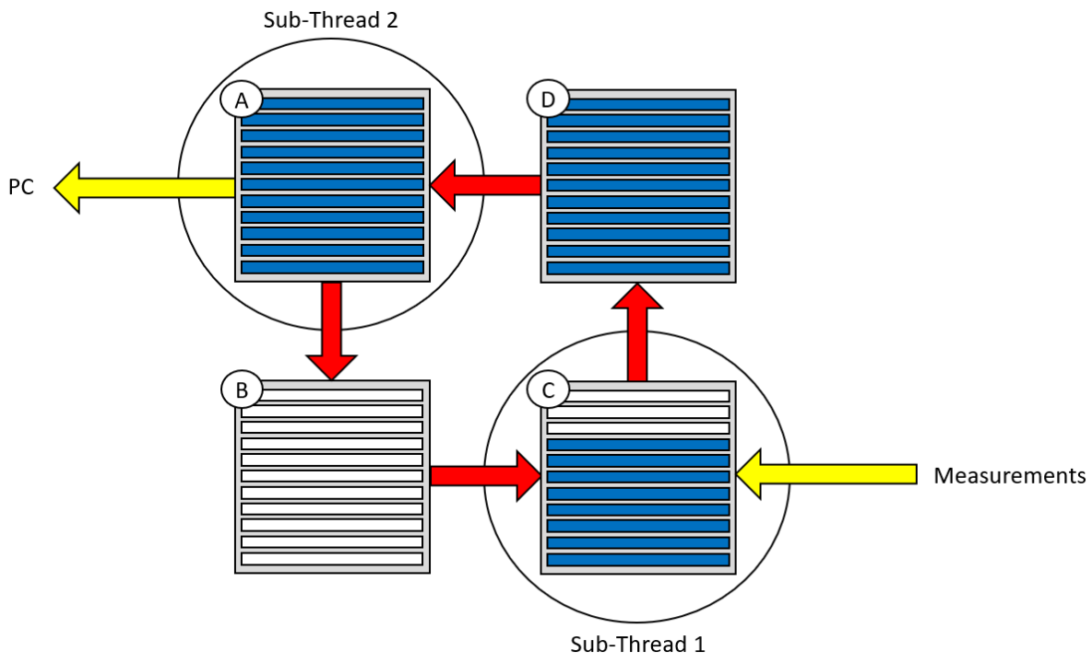

On the embedded side, a multi-threaded approach was used to run data collection and data streaming processes concurrently. In the designed OS, the core thread handled all the front-end processes, such as navigating between FSM nodes, actuating components, interacting with variables stored in volatile and non-volatile storage, and other primary routines. A secondary thread was designed to handle reading measurements from all devices selected to be sampled, storing each measurement into a sample buffer, then stacking a predetermined number of sample buffers into a transmission buffer. A third and final thread was designed to retrieve the fully populated transmission buffer from the outbound queue and send it to the receiving device. Four buffers are cycled between the two sub-threads to prevent latency caused by “resource hogging”, where one sub-thread can’t complete its task because the other sub-thread is using a resource it needs, like a transmission buffer. Having a fill queue and an outbound queue allows each sub-thread to work on its own buffer at its own pace, cycle it out as soon as it no longer needs the current active buffer, then retrieve a new buffer as soon as its ready to start working on the next one.

However, despite all the efforts made to optimize the networking to gain maximum bandwidth, the highest stable data rate achieved using the Arduino Due via Native USB was 940 Sps (58.75 kBps). This value was found by creating simulated components that generated artificial values of similar data types at specified frequencies, then using these simulated components to populate the sample buffers. The simulated sampling frequency was gradually incremented upwards until data transmission became unstable and major packet losses occurred. This point occurred at 940 Sps, 20 Sps lower than 960 Sps, the nearest sampling rate offered by the ADC. This meant that, using the current hardware, the maximum sampling rate that could be supported by Serial communication along the USB line was the next lowest offered sampling rate of 480 Sps, which is nearly an order of magnitude smaller than the desired sampling rate.

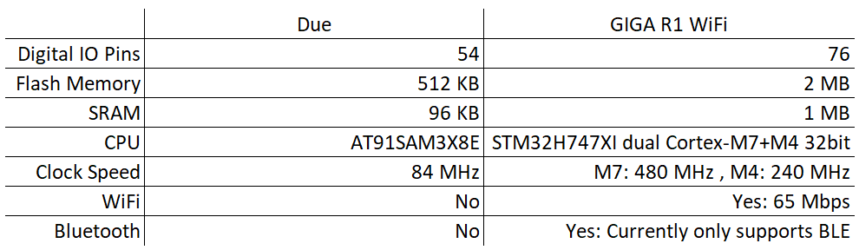

A solution path has been identified to circumvent this bottleneck scenario. Arduino just recently launched a new development board: the Arduino Giga R1 Wi-Fi. A comparison of base specs between the Arduino Due and the Arduino Giga RI Wi-Fi is provide in <Table ?>. The key draw for this board is the fact that it is nearly identical to the Arduino Due in form and function, but with the added feature of high-speed wireless capability. While traditional Bluetooth is not yet supported by the Arduino Giga, the Arduino Giga does come with full integrated Wi-Fi support and can transmit at rates up to ~8 MBps. This comfortably satisfies the 240 kBps requirement for desired data speeds. Wireless communication also significantly improves ease of operation, allowing remote operation of the test-rig, removing a prior requirement for the end user to be physically tethered to the test-rig. A unit-test of the Wi-Fi transmission of an identical, simulated data stream is shown in <Figure ?>. In this unit-test, the same number of signals, data types, and data frequency are sampled, packed, transmitted, received, unpacked, logged, and plotted all through a temporary, local Wi-Fi server created by the Arduino Giga, then subscribed to by a Python script running separately on a desktop PC. Similar to the multi-threaded approach used for transmission, another multi-threaded Python based algorithm was designed for receiving and unpacking the transmitted data.

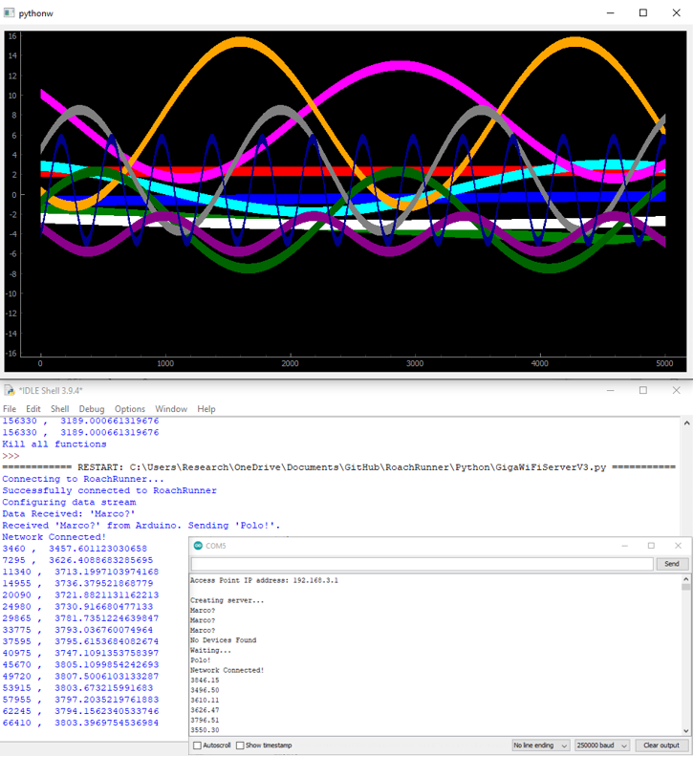

This successful unit-test of the Wi-Fi network implementation of high-speed data transmission stood as a Proof-of-Concept that justified a full upgrade of hardware and software to support the Arduino Giga in place of the Arduino Due. The Arduino Giga came with additional benefits other than the decision-driving high-speed wireless feature. This board also features a dual-cortex CPU. Each core can be targeted independently to upload programs, which can be run concurrently. This allows the board to act as an inherently parallel system via multicore processes, which has a major reduction on resource hogging present between concurrent processes. The main core has a clock frequency of 480 MHz and the secondary core has a clock frequency of 240 MHz. The Arduino Due had a clock frequency of 84 MHz, which is still high, but way outperformed by the Giga. This allows the Giga to complete tasks significantly faster, such as reacting to signal flags from peripherals closer to the moment the flag is raised, reducing latency. Additionally, the primary core has internal flash of 2 MB and the secondary core has internal flash of 1 MB, allowing larger programs and settings files to be written to the board.

However, these new features and improved functionality come with a cost. This new, high-performance CPU had vastly different architecture than the Due’s, so many of the embedded drivers had to be rebuilt to be compatible with the Giga’s CPU. All drivers were able to successfully be rewritten and were unit-tested to validate performance aside from one: the internal flash driver. Due to the complexity of the system and the enormous number of configurations and settings, it can take an hour or more to set all the software preconditions and states within the operating system to generate trials profiles that provide the desired output. Additionally, certain calibration procedures require removing the treadmill from the transducers and installing calibration tooling. This makes it very valuable to be able to store all of the settings, configurations, software preconditions, and calibration coefficients in volatile storage. For instance, when running a live specimen trial, if the system needs to be rebooted, it would not be feasible to remove the treadmill to perform calibrations while the specimen is on the treadmill. This module was working flawlessly on the Arduino Due. However, after the upgrade to the Arduino Giga, a successful rebuild has not been achieved. The module passes in baseline performance tests, but once incorporated into the main OS, the CPU encounters a flash fault that locks the CPU in a deadlock state recoverable only by re-flashing the firmware to the CPU. As of now, this is the last unsolved problem standing in the way of full integration, implementation, and full-scale validation. Significant efforts were made to solve this issue, but unfortunately, due to time constraints, this is where my role in this project comes to a conclusion.

# Chapter 4. FABRICATION AND DEPLOYMENT

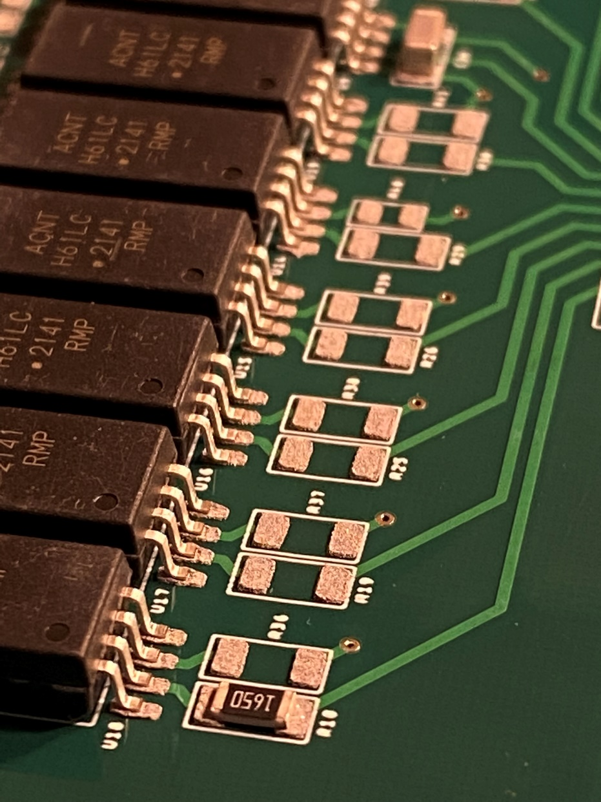

So far, all analysis of the system has been primarily theory driven design decisions. A major learning point of this project was that theory will only take you so far in design of physical systems. Beyond that, a major piece of the puzzle is designing (mostly redesigning) parts such that they can not only be independently constructed, but can also then be installed into larger assemblies consisting of many parts. This yields a sort of design feedback loop that emphasizes the value of modular, interchangeable parts. This chapter will provide a brief overview of tooling and methods used to construct different types of parts, as well as a quick look into how those types of parts were designed such that they could be made by the tooling and methods in place.

## 4.1 3D Printing

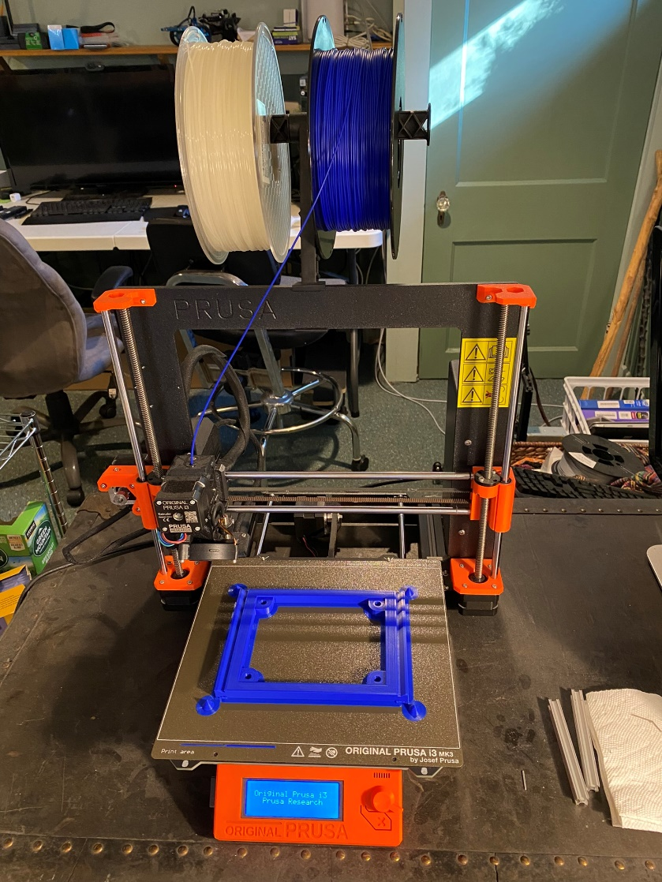

In total, there are 941 parts in this system, excluding individual circuit elements mounted to PCBs. Of these 941 parts, 96 were 3D printed. Aside from the transducer arms, all of these were printed in PLA using a Prusa i3 MK3S, which can print PLA with a layer height of 100 μm. Prints were prepared using PrusaSlicer. Print settings and .STEP files are provided in the GitHub repository linked in <Appendix ?>.

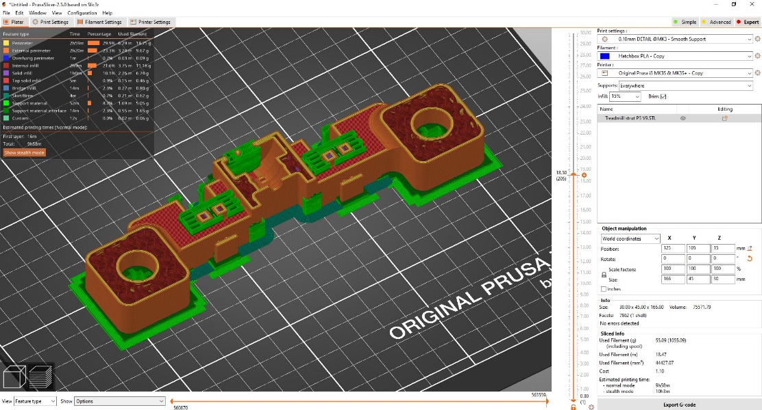

As previously mentioned, the transducer arms were the only 3D printed component not printed with the Prusa i3 MK3S. This is because it was decided that these transducer arms would be printed in Polycarbonate due to its linear-elastic stress-strain response. However, polycarbonate can not be printed with fused-deposition 3D printers, like the Prusa i3 MK3S. Polycarbonate is a UV-cured resin-type polymer and is commonly printed using stereolithography (SLA) 3D printers. The printer used to print these transducer arms was a Formlabs Form3, which can print Polycarbonate at a layer height of 25 μm.

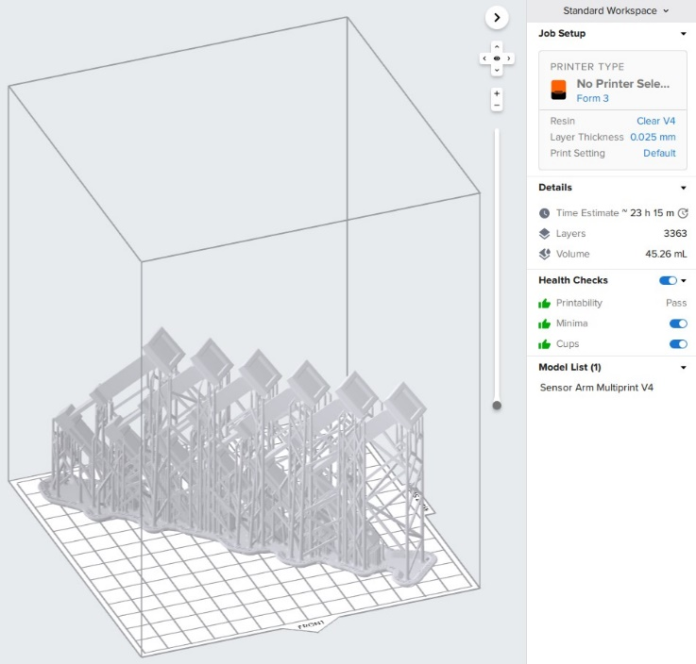

## 4.2 Transducers

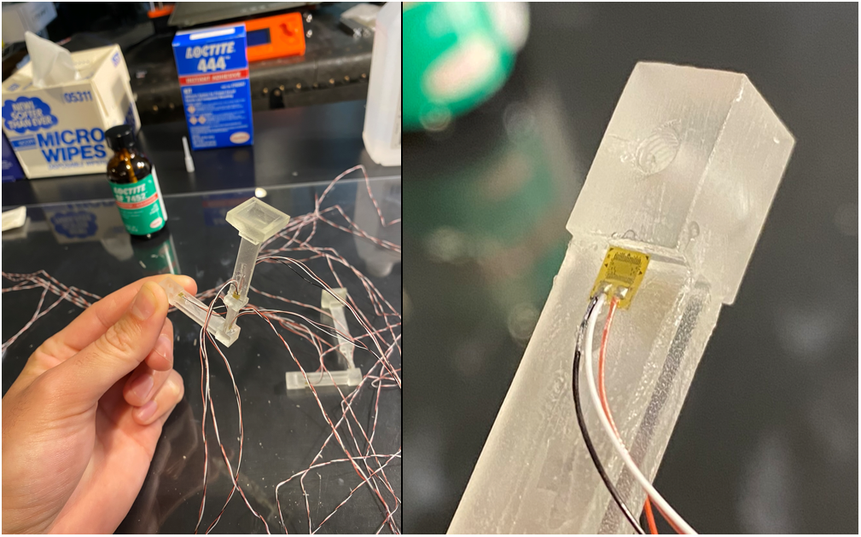

Once printed, the transducer arms are not transducers until the strain gauges are mounted to them. The strain gauges are mounted by hand using Loctite 444, which is a cyanoacrylate commonly used for mounting strain gauges. Although the photo on the left in <Figure ?> shows the fully constructed sensor arm being handled bare-handed, many precautions are taken prior to mounting the strain gauges to ensure no grease or particles are present that could weaken the bond between the strain gauge and the surface of the arm, like wearing latex or vinyl gloves.

To mount the strain gauge, the following procedure must be followed very closely. First, the location on the arms where the sensors will be mounted is lightly sanded to remove bumps, ridges, or particles stuck to the resin during curing. Once the mount surface is smooth, the arm is bathed in 100% isopropyl alcohol to dissolve all grease and to knock off dust created by sanding. The arm is then placed on a glass plate that has been washed with 100% isopropyl alcohol. A strain gauge is then removed from its package and placed with the face that will be glued face-down against the clean glass plate. Glueless tape is then pressed to the backside of the strain gauge to pick it up. The section of tape beyond the end of the strain gauge that does not have terminated leads is carefully cut away with tiny scissors, cutting as close to the edge of the strain gauge as possible without cutting the strain gauge. This allows the edge of the strain gauge to be pushed directly against the ridge near the junction where it is mounted, helping with alignment, so it is important to make sure a clean, flat edge is left after cutting. Once cut, the end of the tape that the strain gauge is not mounted to is secured to the clean glass plate in a way that the unsecured end of the tape bends backwards, pointing the exposed side of the strain gauge to the sky.

Next, the catalyst for the cyanoacrylate, Loctite 7452, is opened. The brush is very lightly wiped against the lip of the bottle seven times to remove excess catalyst. Then, the brush is passed twice very lightly “along the grain” of the strain gauge from the tip to the end where the wires terminate. The brush is then returned to the bottle and the catalyst is given two minutes to soak in and dry. The strain gauge is then carefully aligned to the exact position and orientation where it will be mounted on the arm and the tape is pressed down the full length of the arm, locking the wires in place. Then, the strain gauge end is carefully peeled back to point the mount face of the strain gauge to the sky, careful not to cause the strain gauge to fall off of the tape. One hand is used to hold the transducer arm and the peeled back strain gauge while the other hand places a drop of glue as big as a dewdrop roughly 1.5 strain gauge lengths away from the alignment ridge.

The glue hand then places the glue bottle down and holds the non-glued sides of the transducer arm between its forefinger and thumb directly at the point where the drop of glue was applied. Holding the transducer arm at that position is important because if not performed, the next step will snap the arm. Next, quickly but without rushing, the hand holding the peeled back tape uses its thumb to roll the tape back down, working its way from the wires to the strain gauge, careful to keep everything aligned with the strain plane of the mounting surface. The thumb then pushes the wires above the strain gauge into the glue, then rolls the strain gauge the rest of the way down. Immediately, a very thin layer of fresh, fully liquid glue squeezes from the glue drop down the full length of the strain gauge, making a perfectly homogenous, balanced bond layer between the strain gauge and the mount surface. This prevents the “skin” that forms over the awaiting glue drop from forming on the bond site, which would severely weaking the transmission of strain from the beam to the strain gauge. The thumb that rolled the tape down is then held over the strain gauge firmly, and then the forefinger of that hand pinches from the opposite side. The hand that was previously holding the transducer arm can now let go and set a two-minute timer. Constant pressure is held on the strain gauge, careful not to twist the strain gauge or snap the arm. Once the two minutes is up, the arm can be released. It is likely the glue with bond to the applicators glove and will tear a small portion off when pulling hand away. This can be carefully pulled away with tweezers or cut away with a thin blade. If tiny shreds are left behind, that is not a worry, it will not affect performance in any way. Looking through the beam from the other side can help verify the strain gauge is in fact fully glued down. Any areas missed with be obviously darker. Once verified to be a successful application, the process can then be repeated 23 more times until all 4 transducer arms are complete!

## 4.3 PCBs

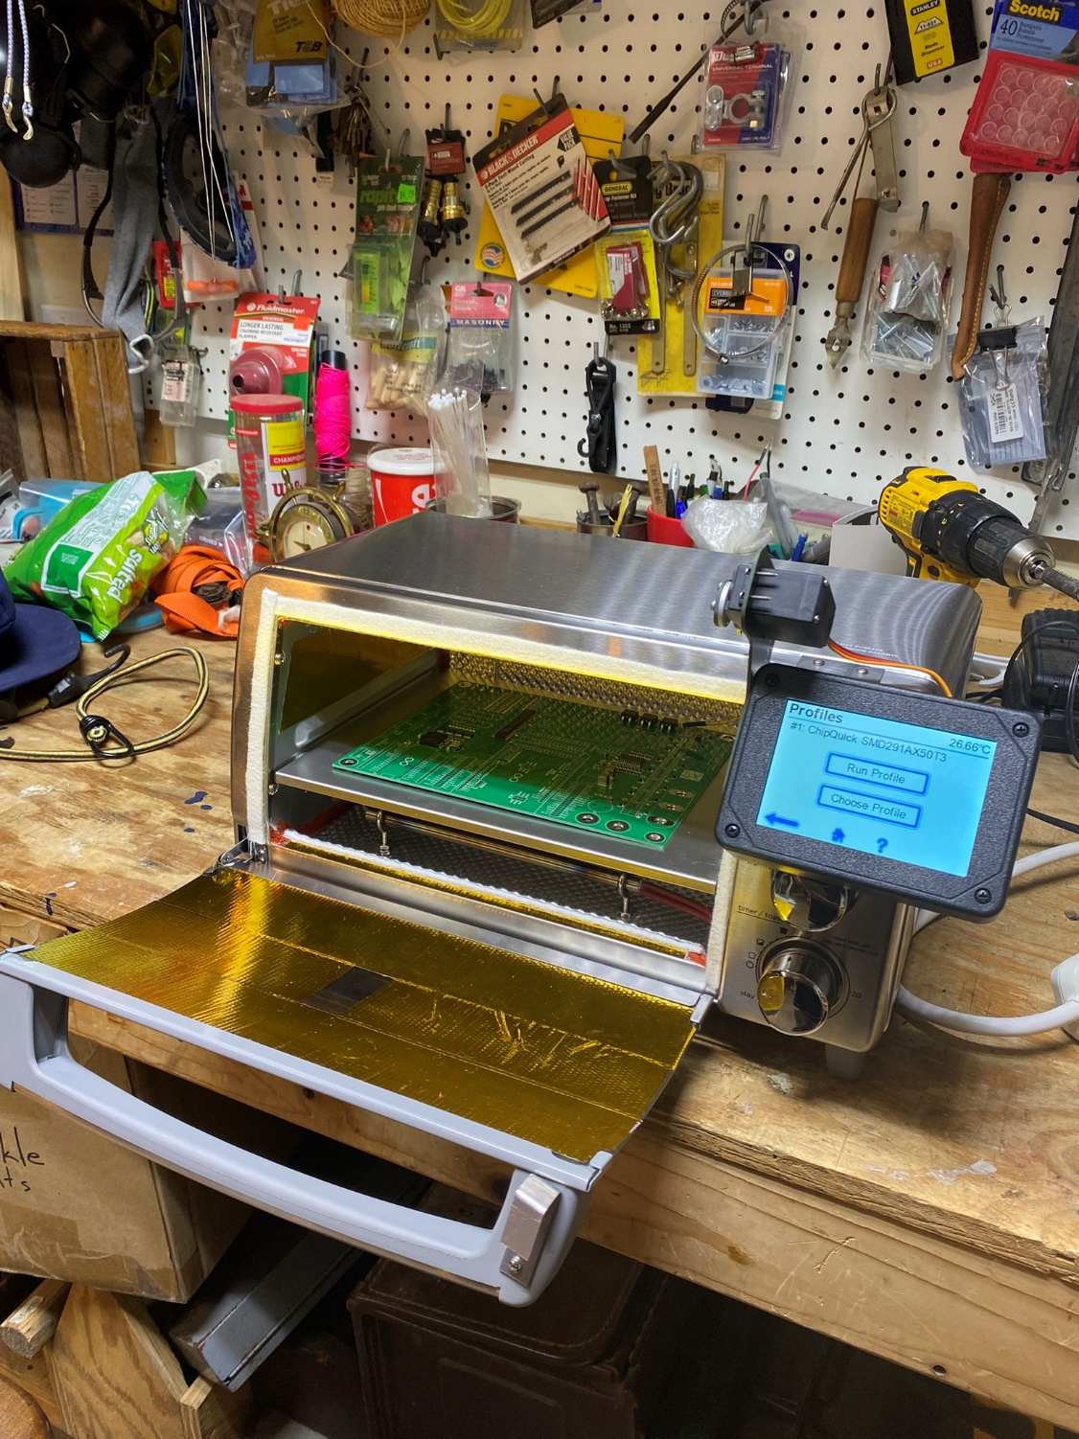

In total, 19 boards, consisting of hundreds of components, needed to be assembled. Many of the components on these boards were surface-mount and had extremely small pins or contacts. Some components, like the fully differential amplifier, had pads that were concealed underneath the chip package. For these reasons, not only would hand-soldering all the components be very slow, low quality, and high risk of damage, but in some cases, it would simply just be impossible. To speed up the process and to yield consistent, quality PCB assemblies, I built my own PCB reflow oven by making some major modifications to a toaster oven.

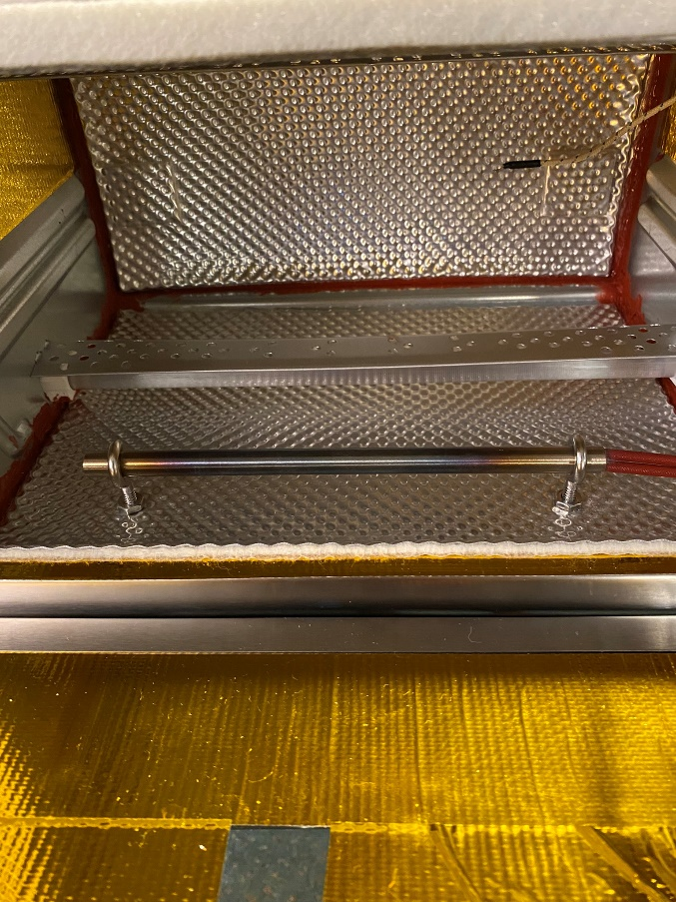

First, all seams and openings within the internal chamber of the toaster oven were sealed with high-temperature silicone gasket sealant. Next, thermal insulation made from a ceramic blanket lined with an ultra-reflective top-layer was mounted to interior walls of the internal chamber. A resistive heating element was then mounted to the floor of the internal chamber. The two quartz heating elements were left installed. A hole was drilled in the side wall and a thermocouple was fed through. The hole the thermocouple fed through was then sealed with the silicone gasket sealant.

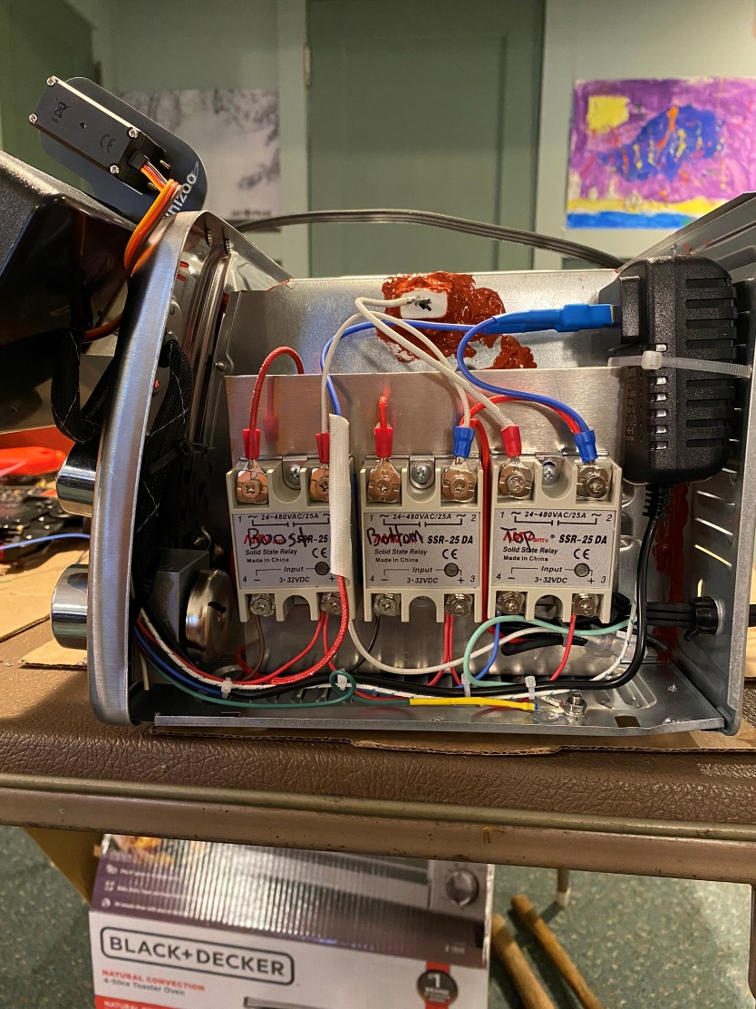

Three solid-state relays were then mounted to an aluminum plate. The cover of the toaster oven was then removed. The stock controller and wiring stripped out and gutted and the aluminum plate with the relays was installed in their place. A 12V wall adapter was installed beside the plate with the relays. The relays were wired to the three heating elements inside the internal chamber. The custom cables were spliced and crimped to service the 12V wall adapter to each relay. The control wires were bundled and fed through the front panel in place of a stock knob previously installed. A ceramic blanket was laid across the relays, over the top of the internal chamber, and down the opposite wall. The cover was then reinstalled, concealing the entire ceramic blanket within.

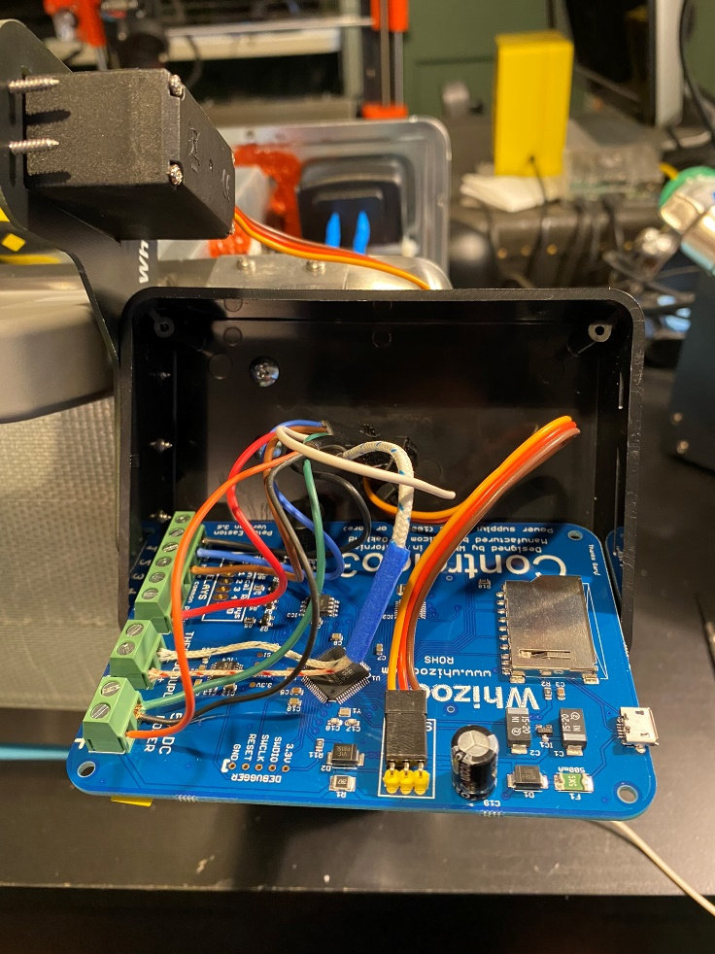

The bundle of control wires was then fed to a control panel and wired to a controller. A servo-motor with a hooked arm that was used to open and close the oven door was mounted to the control panel. A thermal reflow profile was then designed for the solder paste selected and uploaded to the controller. Sample breakouts were baked to gain-train PID gains for the oven’s controller. At this point, the reflow oven was ready to bake boards.

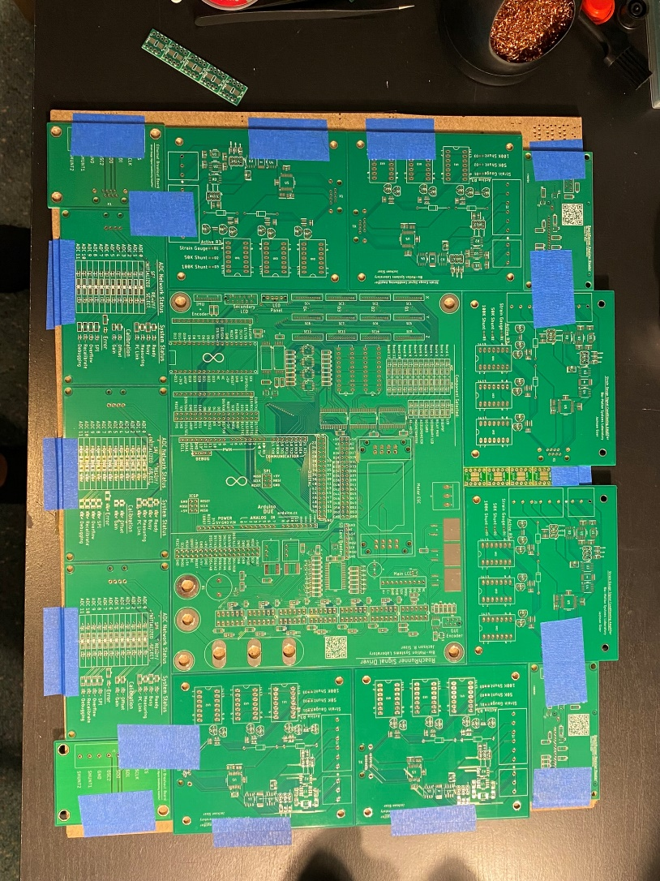

Once ready to start baking boards, the board that will be assembled is placed down on a tray and surrounded by scrap boards to make a template. All boards making up the template are taped down, whereas the board that will be baked is left unsecured so that it can easily be removed and replaced with the next board.

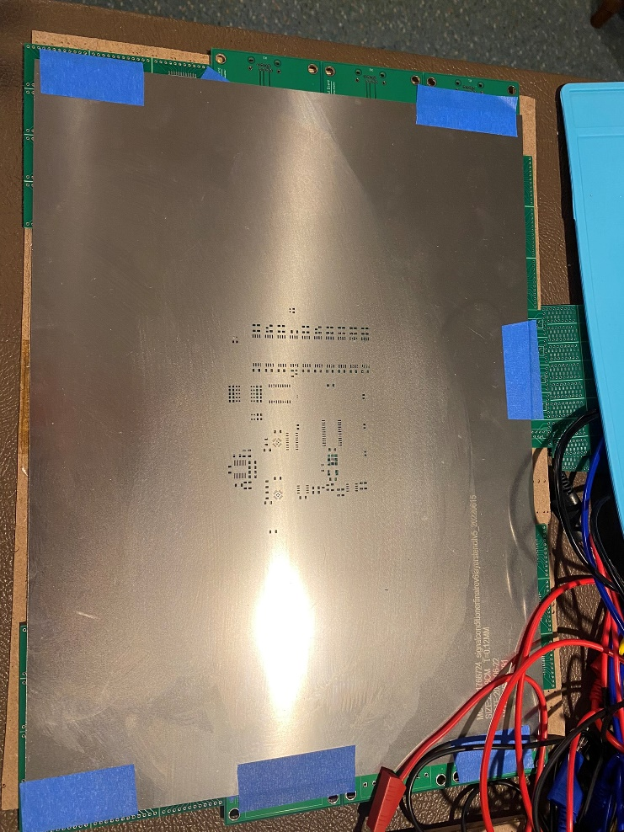

When generating the order for fabrication of the unpopulated PCBs from a PCB fab, like SeeedStudio, the layer for the SMD pads from the Gerber file should be used to generate a stainless steel stencil. Once the target PCB is framed in the template, this stencil is overlaid onto the board, aligning the stencil with the solder pads on the board. The stencil is then taped down firmly and solder paste is squeegeed over all the openings to cleanly coat each pad with an ideal quantity of solder paste.

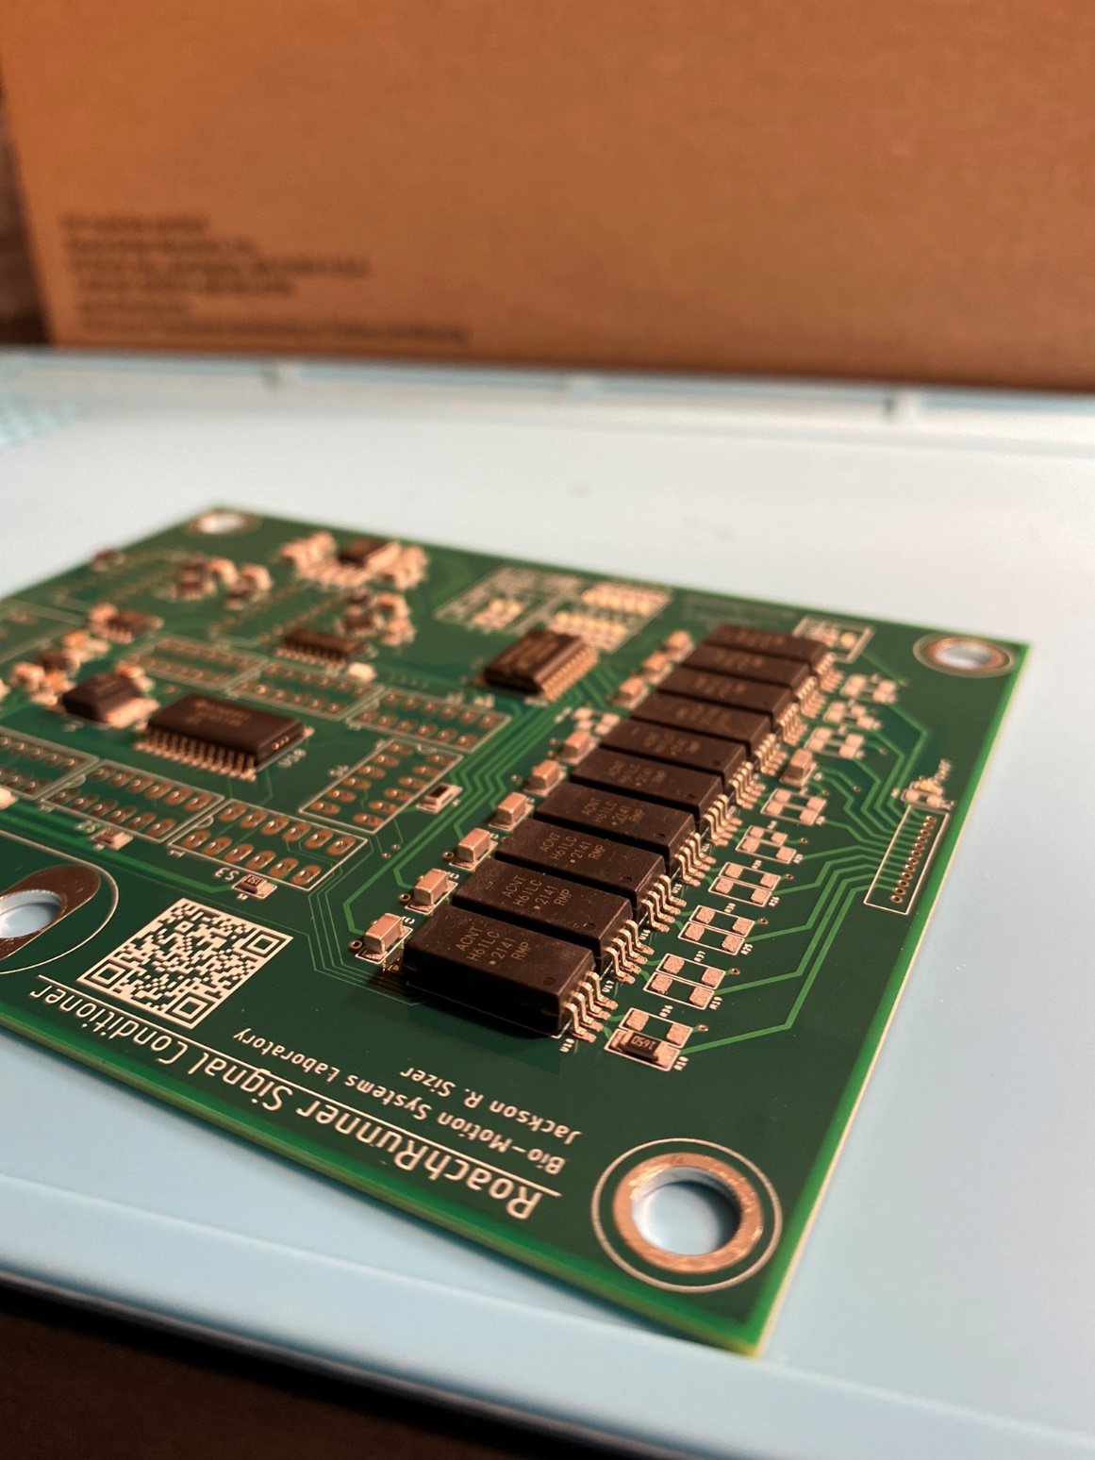

Once all the pads are coated in solder paste, each component is carefully placed by hand using tweezers. All components must be placed in less than 30 minutes or the solder paste will dry up, preventing it from reflowing properly, leading to cold solder joints. When designing, no component package smaller than 0402 was allowed to be incorporated into design to ensure that all components could be placed by a human. Related to package footprints: in early design stages, an issue was encountered where manufacturers associated incorrect footprints with their components, leading to failed boards. This included incorrect pin mapping as well as incorrect pad geometries. As a response to this, I made a design rule that footprints from manufacturers were strictly forbidden and all footprints and symbols for components used in Eagle (ECAD software) must be designed by myself. I generated a personal library of approved footprints and symbols that I used for all my PCB designs. This will be made available on the GitHub repository linked in <Appendix ?>.

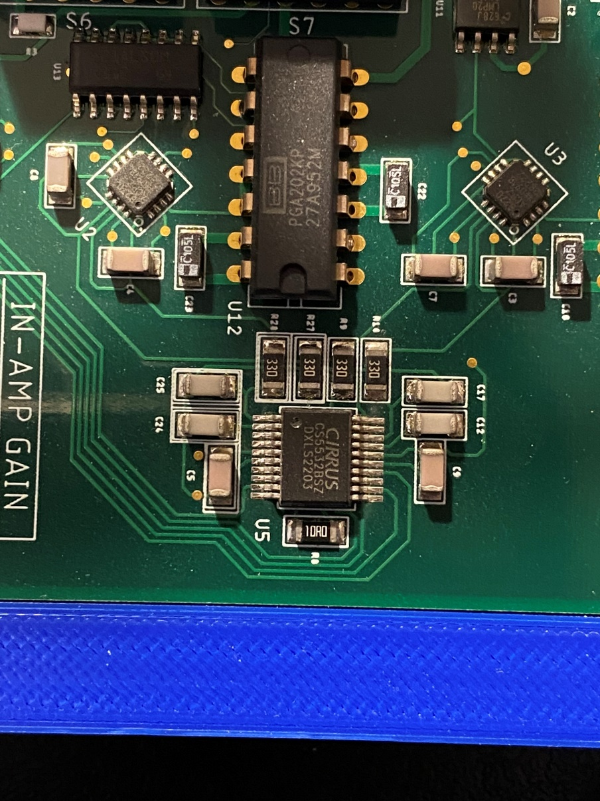

Once all components are placed on the beds of solder, the board can be baked by placing it in the oven and selecting the desired reflow profile. The oven must be operated outdoors because it outgasses highly cancerous fumes. Once the reflow profile completes and the board has cooled down, it can be inspected and cleaned up of any flux residue that may be left on the pads. At this point, all the through-hole components can be inserted, taped down with Kapton tape, and hand-soldered with a soldering iron. Finally, the board can be mounted, wired, and booted up! It’s ready to integrate with the electronic network!

# Chapter 6. CONCLUSIONS AND FUTURE WORK

At this point, all structural, mechanical, and electronic components and devices are resolved to satisfactory releases. All software elements are developed, tested, and functional, aside from the internal flash module described in section 3.3.2. This single module is the only element of the entire machine that is currently unsolved. Although this internal flash module is a small detail in comparison to the rest of the work completed, every component and feature plays a critical role to the combined functionality of the entire machine. Even trailer hitch is incapable of towing its load without a simple locking pin. All this project is waiting for now is the next student to find and place that final puzzle piece.

When the next brave student does choose to pick up my work and closes this last remark, the next phase should be testing and qualification. After these performance metrics are qualified to meet the specified requirements, this tool will be certified to use for conducting future research. Calibration procedures have already been drafted and loosely implemented, but these need to be debugged and refined into physically validated procedures. Reference data generated via real world measurements and procedures should be used to inform high level calibration stages. From there, procedural methods can be built from that baseline to extend deeper into the level of accuracy and precision this system was designed for through careful and logical layering of calibrations and validations. The procedures that shall be refined and approved include the following:

1. Prescribed Strain Conversion
2. Force Plane Normalization
3. Triaxial Force Discretization and Triangulation
4. Natural Frequency Estimation
5. Spectral Analysis: Vibrations, Noise, and Harmonic Resonance
6. EMI and Magnetic Flux Assessment
7. Live Specimen Testing: The Golden Dataset

**Prescribed Strain Conversion**

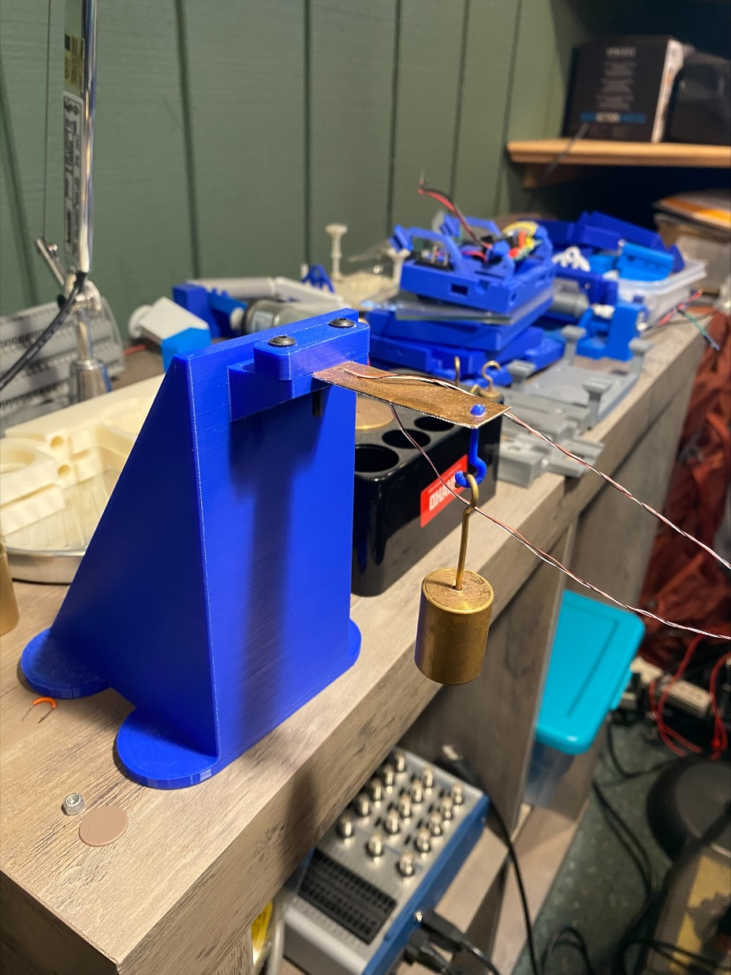

Using a known mass set and a simple cantilevered beam constructed out of a homogenous material with an exactly known stress-strain response, calculated force values from ADC conversion should be recorded at each mass increment. By cross-referencing the calculated force against the actual force, correction gain and offset coefficients can be empirically generated to align the ADC conversion equation with accurate force values. This acts as a “Coarse Calibration” to be performed on each board used for establishing a baseline approximation. This will be done as a preliminary stage prior to wiring the transducer arms to the Signal Conditioner boards. Once the transducer arms are wired to the Signal Conditioner boards, they will remain wired as such and this baseline calibration will not be performed again, unless a new board is added.

**Force Plane Normalization**

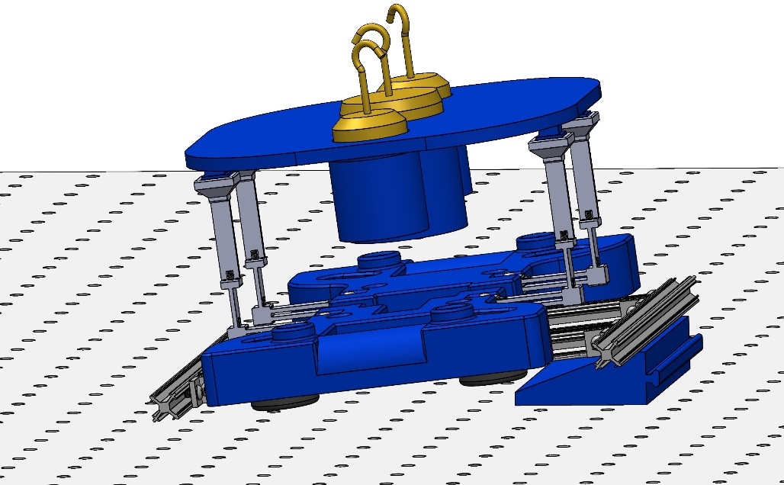

This calibration builds off of the “Prescribed Strain Conversion” calibration procedure, acting as a mid-level calibration between “coarse” and “fine”. First, the treadmill is removed from the transducer arms. The brackets used for mounting the transducer hub and frame to the steel plate of the test stand should also be removed. Ensuring that the normal vector generated from the accelerometer is within 1° of the Z-axis, force readings are then collected. Next, the calibration mass insert is placed on the transducer arms and the masses are added. Keeping the assembly in the same orientation, force readings are then collected again. The difference between the two is used to determine the perceived force, providing baseline error. The ADCs are then zeroed. This is to setup a simulated case of small forces being applied while the sensors arms are already under load from the treadmill. Zeroing the ADCs sets this loaded state as baseline so that additional forces will be perceived as external stimuli.

Once zeroed, sequentially, but not simultaneously, the angle-offset wedge is inserted under the front and right sides of the transducer hub such that the normal vector reports a rotation of 10° about the appropriate axis. A gain calibration is performed on the ADCs experiencing load (Y ADCs when rotating about X, X ADCs when rotating about Y). This sets the upper bound for the ADC. The transducer hub is then rotated in each direction again using the wedge, but this time only generating a 5° rotation. Accelerometer readings are stored at each tested point and used to calculate a unit vector representing the normal vector of the force plane. The components of these unit vectors are multiplied by the nominal force observed at the zero point to scale the true force at each known measurement point. These discretized force components are then crossed referenced to the force readout from the ADC to generate correction coefficients to align each ADCs output to the true triaxial force vector. These corrected conversion equations become the core conversion equations that the fine calibration adjustments are later stacked on top of. Together, the mid-range calibration and fine-calibration results combine to yield a trustworthy conversion equation that can be used for force measurements taken during live specimen trials.

**Triaxial Force Discretization and Triangulation**

This is the third and final stage of calibration: the “fine” calibration. This calibration does not modify the ADC the way the prior calibration does. The prior calibration overwrites the gain and offset registers of each ADC to pair the conversion range of each ADC to a known force range, and the unit-normal vector of the force plane is used to estimate the known force values the ADC gain and offset registers are being tied to. This calibration uses another calibration insert, but in this case, the calibration insert features a wide, flat platform marked with targets. In this procedure, a set of various size masses are sequentially placed at the center of each target, recording force readings at each placement. The coordinates of each target are known. Using this populated matrix of forces and coordinates, the combined force readings across similar axes sensors are used to triangulate the point of force application. Cross-referencing the true force-position matrix against the measured allows scalars to be generated for the contributed input of each sensor towards their joint conversion equations. The benefit of this calibration is twofold: 1) this balances each arm’s contribution towards the estimate of the total force along the sensed axis, 2) this populates the coefficients for the triangulation estimation algorithm, allowing not only magnitudes of forces to be measured, but the point of application as well.

**Natural Frequency Estimation**

An important property of the treadmill for reducing vibration induced crosstalk and noise is ensuring that the natural frequency modes of the assembly are sufficiently higher than the stride frequency of the specimen. While the base natural frequency modes of the transducer arms can be modeled relatively easily for the case where the arms are free-standing and are not coupled to a load, the frequency modes of the full assembly become much more complicated to evaluate once the treadmill is placed on top of the transducer arms. Although extensive dynamic modelling is useful, it is much easier and faster to just hit the carefully assembled machine with a hammer.

This should be done in two ways: coupled and uncoupled. First, the three primary natural frequency modes of oscillation of the bare, uncoupled transducer arms should be found empirically by tapping each arm in each axis lightly with a soft hammer or mallet while collecting a continuous force trace. The direction the strike is applied isn’t terribly important, so long as each axis is stimulated to oscillate with high enough magnitude that it can be observed. This test should be performed again to find the coupled natural frequency of the treadmill assembly by placing the treadmill on the transducer arms, then giving the treadmill a very light tap along each axis while collecting a continuous force trace on all sensors. An FFT Spectral Analysis should be performed on these collected datasets to identify dominant frequencies. A validation should be made that each identified natural frequency mode is sufficiently higher than the specimen’s stride frequency such that it can be filtered out via a Low-Pass Filter.

**Spectral Analysis: Vibrations, Noise, and Harmonic Resonance**

Prior to live specimen trials, a baseline characterization of noise content should be established. The prior action of estimating natural frequency modes of the system is related to this task, but is not directly representative of performance in the way that this task is. Accurately estimating the natural frequency modes of the system is helpful for anticipating potential peak frequencies, but knowing these frequencies alone does not provide a full representation of the actual amplitude of these frequencies introduced to the system. Additionally, there are many other components of the signal noise content that are better represented through experimentation than through expectation. These are noise components such as common mode noise from power supplies, vibrations from the belt slipping on the rollers, vibration from rotation of the rollers, vibration from the rotation of each gear within the gearhead of the motor, and many other noise sources.

This is the step where the unexpected sources of error show their face. These are found by running the system as one would when running a live specimen trial, but without a specimen present. Force readings are collected for an extended period, after which an FFT Spectral Analysis is performed. This will identify all the dominant frequencies of noise as well as their amplitude as seen by the system under normal operation. The user should validate that all these frequencies are higher than the stride frequency of the specimen and that the amplitude of the noise floor is lower than the expected amplitude of the forces exerted by the limbs of the specimen.

After establishing these baseline metrics, a Low-Pass Filter with adequately placed cutoff frequency (or Band-Pass Filter containing expected stride frequency, only to be used if absolutely necessary due to presence of unexpected dominant noise frequency lower than stride frequency) can be designed to filter out all the identified noise components. Once this filter is designed and implemented, this procedure should be repeated with the filter in place to characterize the attenuated noise content and assess the performance of the filter.

**EMI Induced Gaussian and Magnetic Flux Assessment**

While many of the pitfalls of DC motors are avoided since a brushless motor is used, rather than a brush commutated DC, there is still an inescapable layer of interference that will be generated. Because of this, it is necessary to evaluate the magnitude of interference and whether or not the magnitude is so great that a Faraday shield will be required.

In the case of brush commutated DC motors, there is an inherent magnetic field generated by the permanent magnets that can, and likely will, create eddy currents in signal wires and PCB traces and planes. Additionally, the micro-arcs that occur from the brush contacting the stator generate massive levels of EMI that are fairly low frequency and could potentially fully obfuscate readings. Additionally, the friction forces generated by dragging the brush across the stator contributes noticeable amplitude vibrations.

These factors were a major deciding factor to select a brushless electrically commutated DC motor over a brush commutated DC motor. With a brushless DC motor, most of the issues previously listed are present, such as the dragging induced vibrations or the micro-arcing between brush contacts and stator. Regardless, there are still electric and magnetic fields generated by the motor that could cause interference. However, due to the high-frequency switching of the coils and the high-speed rotation of the stator, the electric and magnetic fields generated will likely oscillate at a high enough frequency that they can easily be filtered out via the Low-Pass Filter designed in the prior procedure. This is purely speculative though and must be confirmed through data.

Two tasks can be enacted to perform this assessment. For the first, the magnetometer onboard the IMU can be sampled with and without the motor running to detect presence of additional magnetic field generated by the motor. The second task would be to disconnect the belt from the treadmill and collect forces with and without the motor running. Comparing these two should reveal the additional noise contributed by the electric field and the magnetic field produced by the motor. If the amplitude of noise contributed obfuscates sensor readings, even with filtering, implementation of a Faraday shield should be considered in depth.

**Live Specimen Testing: The Golden Dataset**

The Final Test, the Grand Finale, the Cherry on Top, that will be performed prior to RoachRunner’s Maiden Voyage will be a recreation of the “Golden Dataset”. This Golden Dataset is the first Ground Reaction Force profile representing running gait patterns of Blaberus discoidalis collected, stitched together from countless trials using Norman Heglund’s original force plate design [?]. Once all these calibrations have been performed, all the metrics baselined, all the scalars fine-tuned, every board powered, screw tightened, bearing lubricated, belt tensioned, box checked, cockroach fed, and all systems are GO, we are finally ready to put a cockroach on a treadmill. The rest, beyond this point, is up to you. This design is modular and intended to be recursive, so expand it, modify it, make whatever adjustments you see fit. Tailor it to your needs, improve it where you can. Good luck to whomever chooses to use this tool. I hope RoachRunner helps you to solve problems not yet even thought of.

Thank you.



# Appendix A: A Closer Look - System Decomposition

 

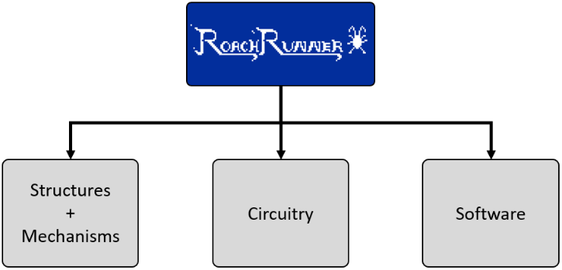  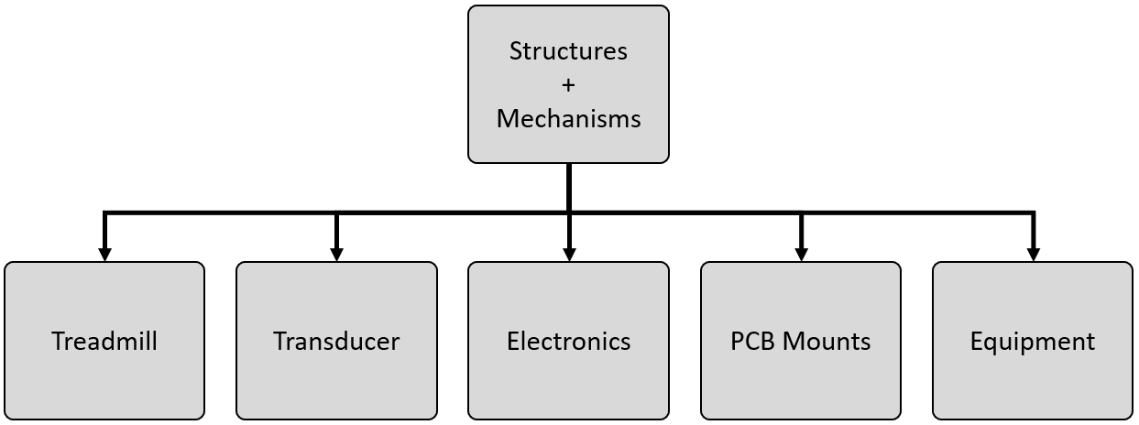      

    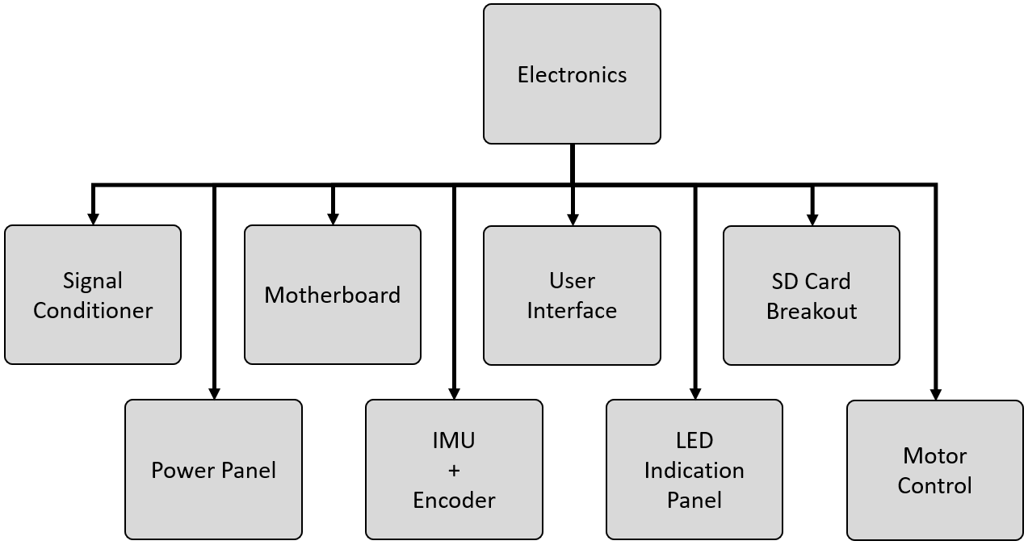  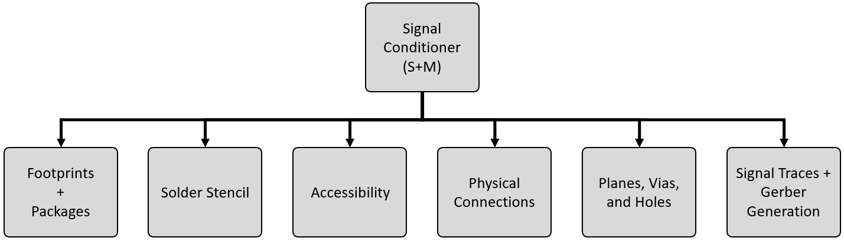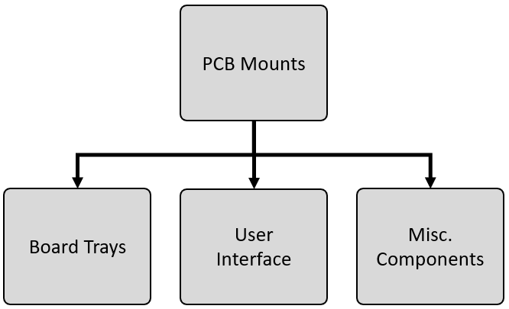  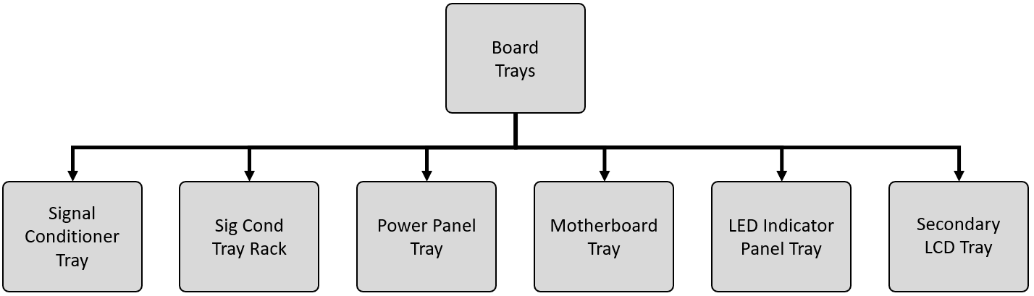  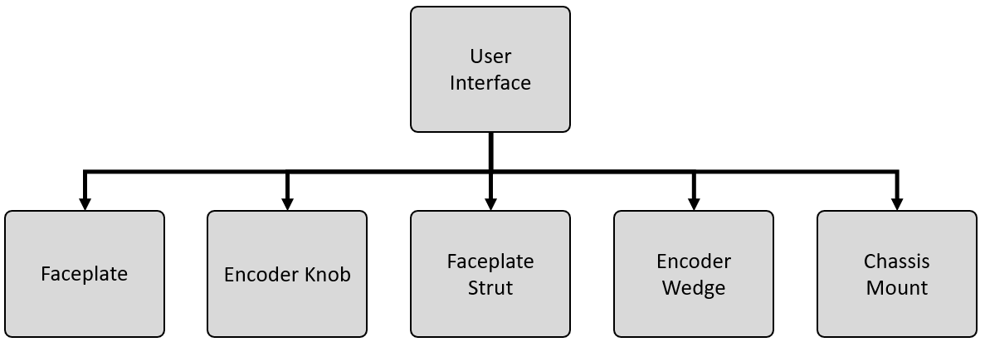  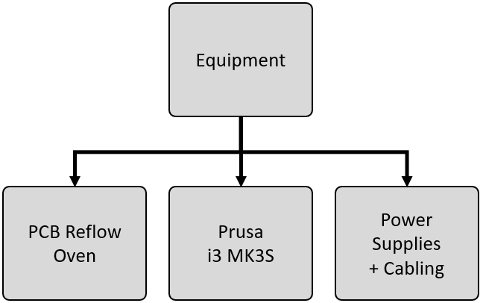

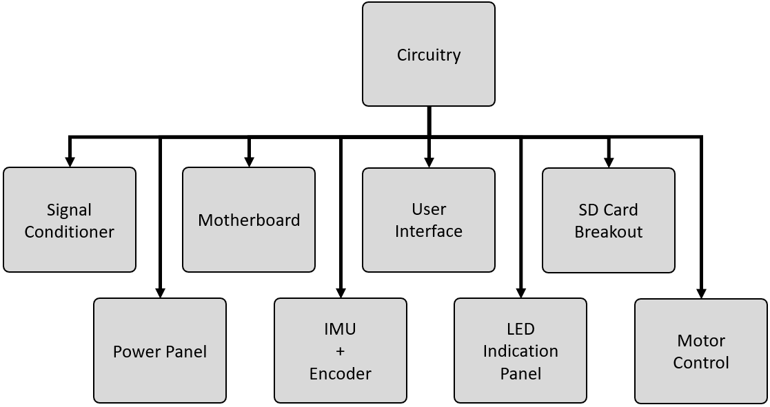  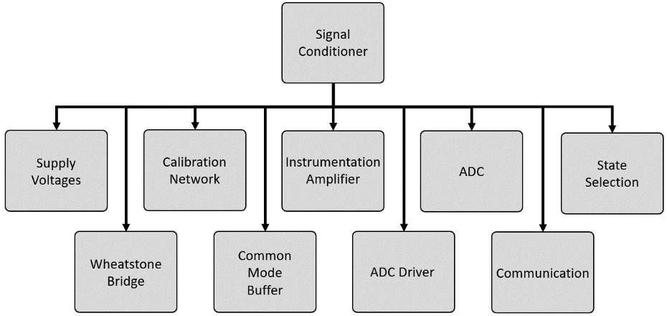  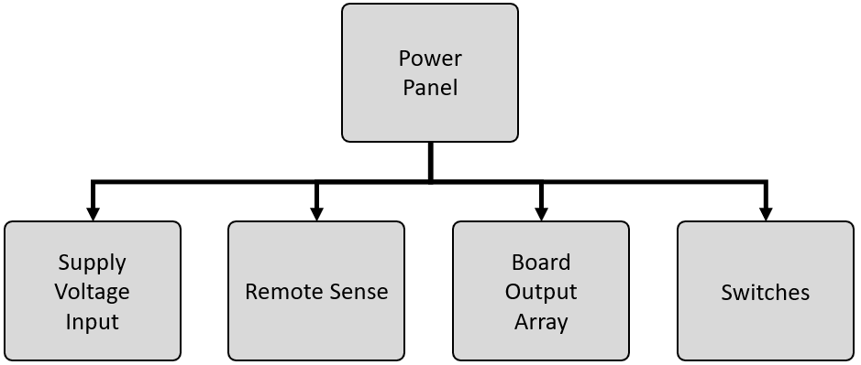  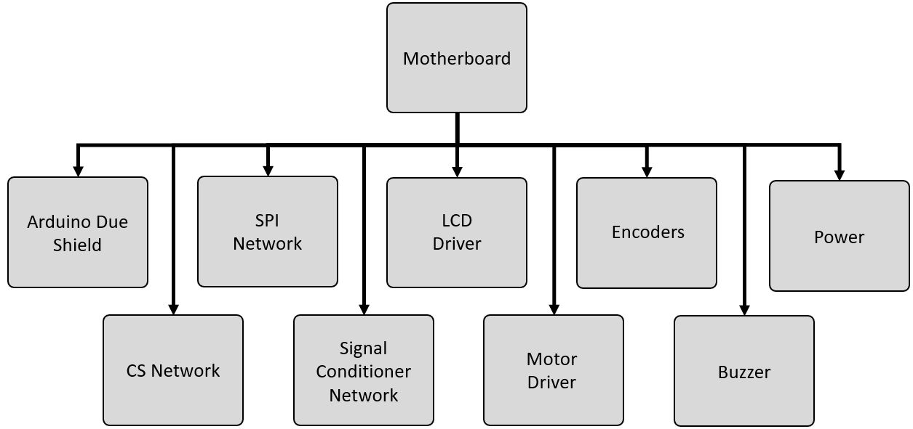

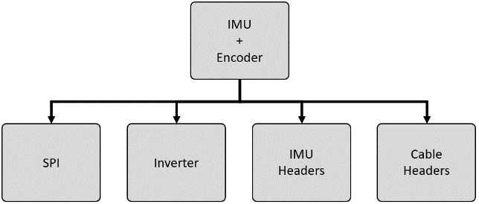  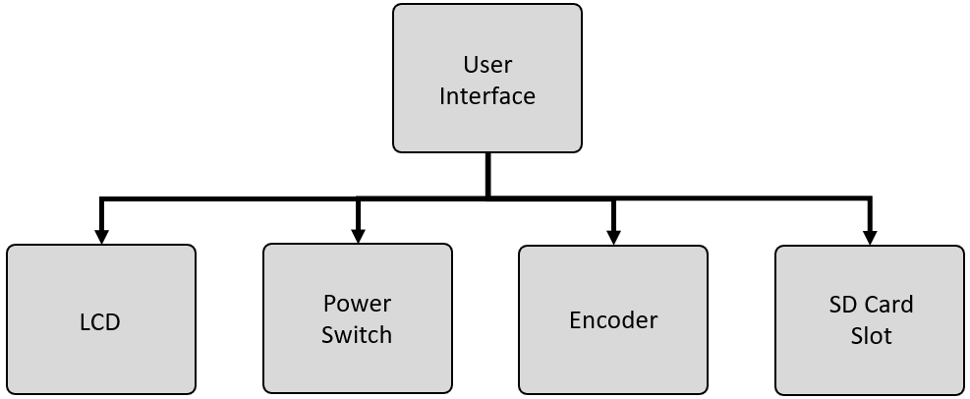  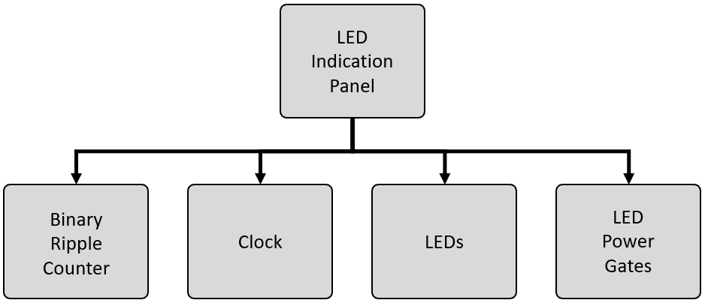  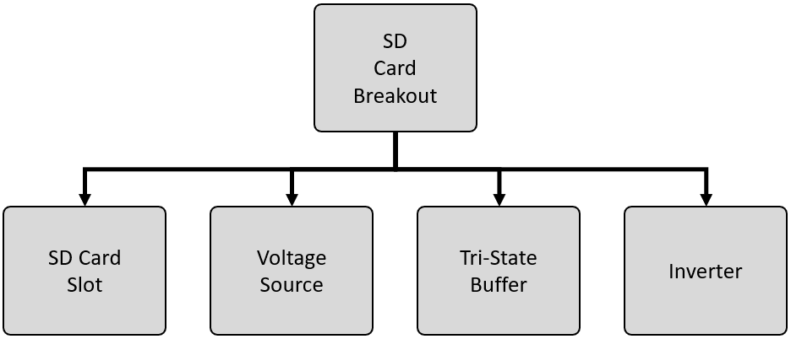

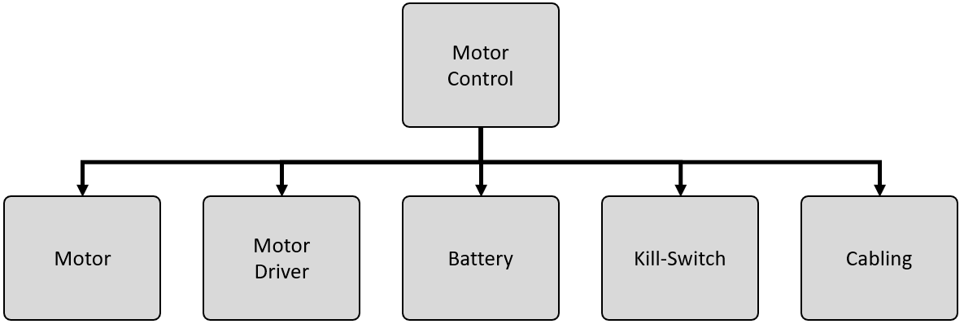 

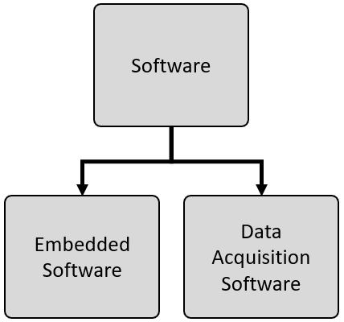 

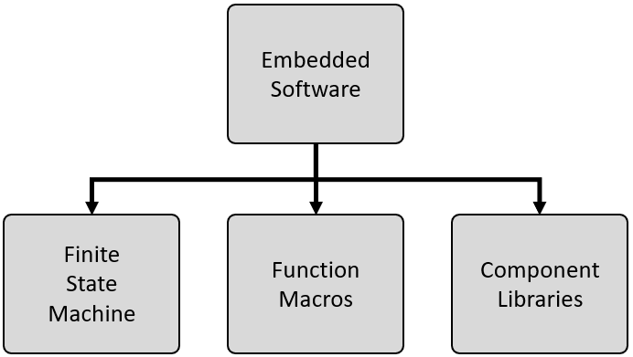  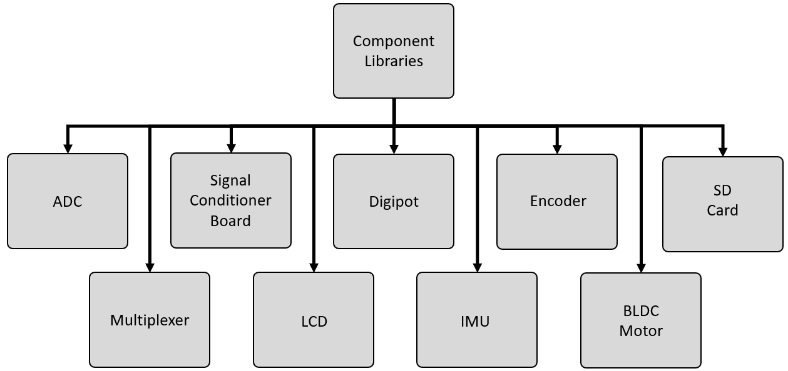

# Appendix B: Bill of Materials (3D Printing)

# Appendix C: Bill of Materials (Mechanical Parts)

# Appendix D: Bill of Materials (PCB Components)

# Appendix E: Bill of Materials (Equipment)

# Appendix F: Finite State Machine Flowchart

# Appendix G: Signal Conditioner Schematic

# Appendix H: Motherboard Schematic

# Appendix I: Links to Code and Additional Resources

# Bibliography

[1] S. Sponberg and R. J. Full, “Neuromechanical response of musculo-skeletal structures in cockroaches during rapid running on rough terrain,” *Journal of Experimental Biology*, 2008, doi: 10.1242/jeb.012385.

[2] J. M. Mongeau *et al.*, “Rapid inversion: Running animals and robots swing like a pendulum under ledges,” *PLoS One*, 2012, doi: 10.1371/journal.pone.0038003.

[3] J. T. Watson, R. E. Ritzmann, S. N. Zill, and A. J. Pollack, “Control of obstacle climbing in the cockroach, Blaberus discoidalis. I. Kinematics,” *J Comp Physiol A Neuroethol Sens Neural Behav Physiol*, 2002, doi: 10.1007/s00359-002-0277-y.

[4] K. Jayaram, J. M. Mongeau, A. Mohapatra, P. Birkmeyer, R. S. Fearing, and R. J. Full, “Transition by head-on collision: mechanically mediated manoeuvres in cockroaches and small robots,” *J R Soc Interface*, vol. 15, no. 139, 2018, doi: 10.1098/rsif.2017.0664.

[5] M. H. Dickinson, C. T. Farley, R. J. Full, M. A. R. Koehl, R. Kram, and S. Lehman, “How animals move: An integrative view,” *Science*. 2000. doi: 10.1126/science.288.5463.100.

[6] R. J. Full and D. E. Koditschek, “Templates and anchors: Neuromechanical hypotheses of legged locomotion on land,” *Journal of Experimental Biology*, 1999.

[7] R. Altendorfer *et al.*, “RHex: A biologically inspired hexapod runner,” *Auton Robots*, 2001, doi: 10.1023/A:1012426720699.

[8] P. Birkmeyer, K. Peterson, and R. S. Fearing, “DASH: A dynamic 16g hexapedal robot,” in *2009 IEEE/RSJ International Conference on Intelligent Robots and Systems, IROS 2009*, 2009. doi: 10.1109/IROS.2009.5354561.

[9] J. E. Clark *et al.*, “Biomimetic design and fabrication of a hexapedal running robot,” *Proc IEEE Int Conf Robot Autom*, 2001, doi: 10.1109/ROBOT.2001.933183.

[10] M. J. Spenko *et al.*, “Biologically inspired climbing with a hexapedal robot,” *J Field Robot*, 2008, doi: 10.1002/rob.20238.

[11] R. Blickhan and R. J. Full, “Similarity in multilegged locomotion: Bouncing like a monopode,” *Journal of Comparative Physiology A*. 1993. doi: 10.1007/BF00197760.

[12] J. E. Seipel, P. J. Holmes, and R. J. Full, “Dynamics and stability of insect locomotion: A hexapedal model for horizontal plane motions,” *Biol Cybern*, 2004, doi: 10.1007/s00422-004-0498-y.

[13] D. I. Goldman, T. S. Chen, D. M. Dudek, and R. J. Full, “Dynamics of rapid vertical climbing in cockroaches reveals a template,” *Journal of Experimental Biology*, vol. 209, no. 15, pp. 2990–3000, Aug. 2006, doi: 10.1242/jeb.02322.

[14] J. Brown, D. Peterson, J. Schmitt, N. Gravish, and J. E. Clark, “Impact of slope on dynamics of running and climbing,” *Bioinspir Biomim*, Sep. 2019, doi: 10.1088/1748-3190/ab4467.

[15] N. Heglund, “A Simple Design For a Force-Plate to Measure Ground Reaction Forces,” *J Exp Biol*, 1981.

[16] R. J. Full and M. S. Tu, “Mechanics of six-legged runners.,” *J Exp Biol*, 1990.

[17] H. T. Lin and B. A. Trimmer, “A new bi-axial cantilever beam design for biomechanics force measurements,” *J Biomech*, 2012, doi: 10.1016/j.jbiomech.2012.06.005.

[18] A. Ji *et al.*, “A force-measuring and behaviour-recording system consisting of 24 individual 3D force plates for the study of single limb forces in climbing animals on a quasi-cylindrical tower,” *Bioinspir Biomim*, 2019, doi: 10.1088/1748-3190/ab1d11.

[19] L. Reinhardt and R. Blickhan, “Ultra-miniature force plate for measuring triaxial forces in the micronewton range,” *Journal of Experimental Biology*, 2013, doi: 10.1242/jeb.094177.

[20] R. Kram, “Treadmill mounted force platform,” *J Biomech*, 1989, doi: 10.1016/0021-9290(89)90332-1.

[21] R. Kram, T. M. Griffin, J. M. Donelan, and Y. H. Chang, “Force treadmill for measuring vertical and horizontal ground reaction forces,” *J Appl Physiol*, 2017, doi: 10.1152/jappl.1998.85.2.764.

[22] G. Paolini, U. Della Croce, P. O. Riley, F. K. Newton, and D. Casey Kerrigan, “Testing of a tri-instrumented-treadmill unit for kinetic analysis of locomotion tasks in static and dynamic loading conditions,” *Med Eng Phys*, 2007, doi: 10.1016/j.medengphy.2006.04.002.

[23] M. W. Bundle, M. O. Powell, and L. J. Ryan, “Design and testing of a high-speed treadmill to measure ground reaction forces at the limit of human gait,” *Med Eng Phys*, 2015, doi: 10.1016/j.medengphy.2015.04.009.

[24] PalmIsleSkateShop, “4 Essential Accessories for Your Skateboard,” 2020. https://www.palmisleskateshop.com/en/blogs/blog/4-essential-accessories-for-your-skateboard/ (accessed Apr. 11, 2023).